jefferson lab
Version
1.1
Data Acquisition Group
JEventViewer
User’s Guide
Jefferson Lab Data acquisition group
JEventViewer User’s Guide

Carl Timmer
timmer@jlab.org

3-Feb-2015

© Thomas Jefferson National Accelerator Facility
12000 Jefferson Ave
Newport News, VA 23606
Phone 757.269.7365 • Fax 757.269.6248

Table of Contents

1. Evio Event Viewing i
1.1 Features ii
2. File Data Viewing 4
2.1 Searching 5
2.1.1 By Value 5
2.1.2 By Location 5
2.1.3 By Page 5
2.1.4 By Evio Block Header 6
2.1.5 By Evio Event 6
2.1.6 By Evio Faults 6

Evio Event Viewing
Section
1

This manual describes a graphical user interface for looking at EVIO format files event-by-event, although it can also look at any file as a list of 32 bit integer (words). To run it simply execute:
java org.jlab.coda.eventViewer.EventTreeFrame

Make sure that the EventTreeFrame class or the jar file JEventViewer-1.x.jar in is your CLASSPATH environment variable. The following is a screen shot of the gui.

Figure 1.1: Event-viewing gui

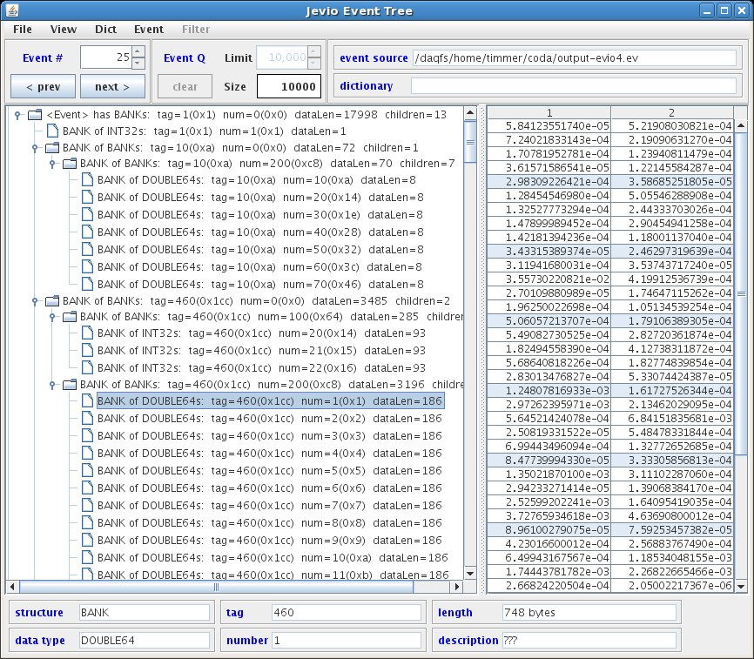

Features
Here’s a quick list of the main features:
- Valid event sources are files, cMsg messages, and ET buffers
- Fast compare ability for data from different events
- When receiving events through cMsg or ET, they can be filtered based on their CODA event type (physics, control, etc.) and trigger type if physics event
- View integer data as hex or decimal
- Select dictionary from event source or from separate file containing dictionary
- View the dictionary being used
- Export any evio file in xml format
- Add or remove data columns
- View the contents of any file as 32 bit hex integers and search for values, evio structures, or evio errors

Starting with the middle of the gui first, the left side shows a tree structure diagram of the whole, single evio event being viewed. Notice that the type of each evio structure is given (bank, segment, tagsegment), along with the type of data it contains, tag, num, size, and # of children. Tag and num are shown in decimal and hex. If a dictionary is being used, the dictionary name is displayed instead of the corresponding structure type, data type, tag, and num values.
The right side, on the other hand, shows the data of any selected bank, segment, or tagsegment that contains a primitive data type. The number of columns can be set in the “View” menu. Integers can be displayed in hex or decimal.
A fast compare feature is able to compare data from different events. If the current event is changed while viewing the data of its selected structure, and if the new event has a structure with the same hierarchy of tags that the previous selection had, it too is automatically selected. This facilitates comparing the same structure in each successive event by simply hitting the “next” event button.
A dictionary can be loaded from a separate xml format file, or it can come embedded in an evio format file or buffer (cMsg, ET). The viewer allows the user to switch, in the “Dict” menu, between the different dictionaries if more than one is available. Any dictionary being used can be displayed instead of the data.
Selecting an ET system or a cMsg server as an event source, in the “Event” menu, brings up other menus to allow the proper connections to be created and maintained. The only assumptions made are that in a cMsg message, the evio data is contained in the byteArray field. Any dictionary is first looked for in the evio data and if none is found, it is looked for in a String payload item called “dictionary”.
The box in the upper left (under the row of menu buttons), “Event #”, shows the event currently selected (in this case 25) and allows the user to navigate to the desired event.
The box to its right, “Event Q”, shows different things depending on if the data source is a file, cMsg message, or ET event. For files it shows the total number of events (in this case 10,000). For cMsg messages and ET events, on the other hand, events are continually arriving. In this case, “Size” shows the number of events currently in an internal queue. “Limit” allows the user to set the size of this internal queue, while “Clear” will remove all events currently in the queue. Once this queue is full, nothing else is added. The “Event #” controls can be used to switch between events in the queue.
Switching between the different event sources can be done in the “Event” menu item. When selecting a cMsg or ET source, the “Filter” menu is enabled. With this menu, the user can choose to look at control, partially-built physics, physics events, or any combination as well as the selecting the run type of interest.
Notice that above the data, there are boxes containing the event and dictionary sources. Beneath the data are boxes containing information about the selected data structure.

File Data Viewing
Section
2

The following figure is a screen shot of a particular file’s data obtained by selecting the “View File Bytes” option of the “File” menu of the initial screen shown previously.

Figure 2.1: Data-viewing gui

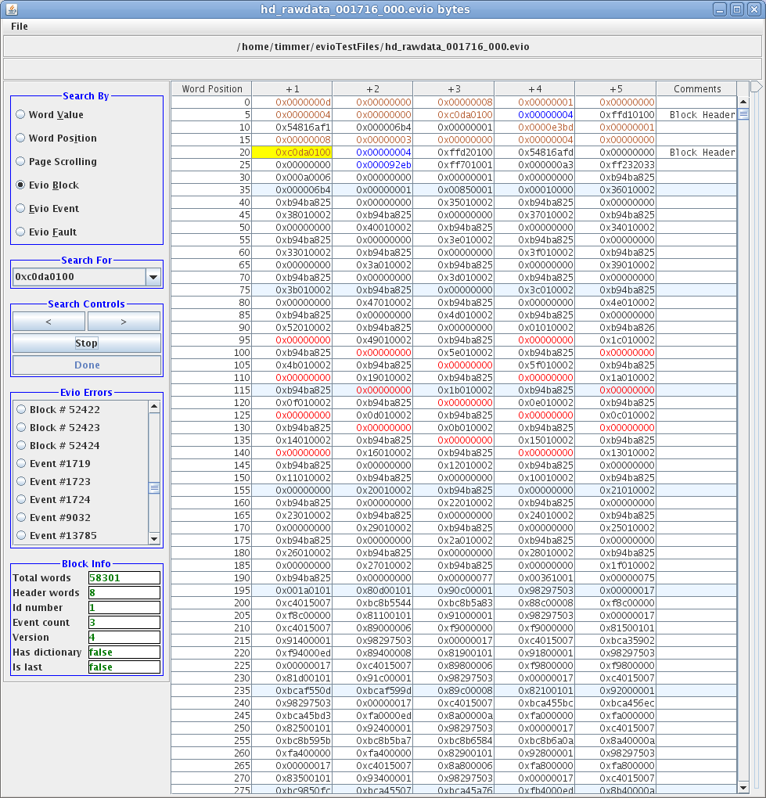

There are occasions when one wants to examine the raw bytes in a file. This tool will allow one to do just that. Each cell of the table contains 32 bits worth of data displayed in hex. Data can be switched between big and little endian under the “File” menu. The table contains 200MB worth of data at one time. For larger files, the next or previous 200MB are loaded when required while scanning through it. On the very far right of the gui is a slider which indicates where the current view is in relation to the total length of the file.

Searching

In order to facilitate finding the data of interest, there are a number of different ways to hunt through it. The control panel on the left has “Search By” radio buttons allowing one to select whether to search by:

- Looking for a given value
- Jumping to a given position in the file
- Scrolling page by page
- Jumping from one evio block header to the next
- Jumping from one evio event to the next
- Scanning the whole file for evio faults or errors

By Value
Look for a given value by selecting the “Word Value” radio button, typing the value into the “Search For” widget, and then hit the forward or backward search button under “Search Controls”. The “Stop” button will be activated since searching a large file (say 20GB) may take serious time. If a search is stopped, the view position stays where it was when the search was started. If stopped, starting another search starts from the same location. A progress bar is there to estimate how much of the file has been searched.
When a value is found, it is highlighted in red. Hit the search button again to find the next or previous value. Highlights can be cleared under the “File” menu.

By Location
Look at a given location in the file by selecting the “Word Position” button, typing the position into the “Search For” widget, and then hitting the “Go” button. The view jumps to the given location and the value is selected (but not highlighted). The first position starts at 1, not 0. You can read the position from the table by taking the number in the far left column and adding the number of the heading at the very top of the column.

By Page
The “Page Scrolling” button activates the forward and backward buttons which hop through the file view by view.

By Evio Block Header
Look for an evio format block header by selecting the “Evio Block” button. The program first looks for the last word – the magic # 0xc0da0100 - of an evio block header. If found, it checks that the previous word is 0 and the one before that has the least significant 8 bits equal to 4 (the evio version). If so, it highlights all 8 words in orange. All the information contained in that header is also displayed on the left in a panel called “Block Info” which can be seen in the figure above.
This type of searching is useful when dealing with corrupted data files as it can home in on an area of the file whose format can be checked and can give information about what data should come following. Hint, if no block header is found in a scan, switch the data endianness and try another one.

By Evio Event
Look for an evio event by selecting the “Evio Event” button. This is less straightforward than looking for block headers since there is no universal signature to look for. There are two ways to do the search. The first way is start the search immediately upon loading the file’s data or to first select the “0” position (far left column before any data). Then hit the forward button. It is smart enough to hop over any block header encountered and uses the length found in the event’s header to be able to find the next when the forward button is clicked again. The first word of each event found in this way is highlighted in blue and the header information is displayed on the left in a panel called “Event Info” (see figure below).
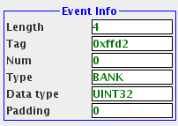
2.2 Event information panel

The second way to search is to select the known first word of an event with the mouse. Hit the forward button to find subsequent events. Hint, the word immediately after a block header is the first word of an event.

By Evio Faults
Look for faults or errors in the evio format by selecting the “Evio Fault” button. This program scans the file from beginning to end and lists any errors in a panel to the left called “Evio Errors” (which can be seen in figure 2.1). The algorithm used to find these errors assumes that if a block header length does not equal the sum of the lengths of all the events it contains, then the block header is correct and the events are in error. It tries to continue scanning for the next error and stops if it encounters an unrecoverable error or makes it to the end of the file.
The errors come in two varieties: block and event. All blocks in which there are problems are listed as are any events in which errors are found. These errors are listed as buttons. Click one and it hops to the location of the error with either the first block or event word selected. Its corresponding error message is also displayed at the top of the gui (not pictured).

