Nuclear Physics Division
Fast Electronics Group

SSP Manual

Benjamin Raydo

14 January 2014

Table of Contents

Section Title Page

1 Introduction 3

2 Purpose of Module 3

3 Function Description 4

4 Specifications 6

5 PCB Layout View 7

6 VSCM Readout Data Format 8

7 VME Registers 11

Document Revision History 31

1 Introduction

The Subsystem Processor (SSP) module participates in the Level 1 trigger logic for the new 12GeV experimental halls at Jefferson Lab. The SSP module receives Level 1 data streams from up to 8 crates (from the Crate Trigger Processor, CTP) for a single detector subsystem (multiple SSP modules can handle multiple detector subsystems). The SSP module processes the multiple Level 1 data streams to produce a single output stream that is passed directly to the Global Trigger Processor (GTP). Multiple SSP modules can be used to accommodate subsystems with more than 8 crates (in this case the GTP may need to perform a final computation to combine the multiple SSP streams). Figure 1a shows where this module sits along with some of the critical signals that it distributes to the various modules in the system. The Global Trigger Crate supports up to 8 SSP modules.

Figure 1a: SSP in the Global Trigger Crate

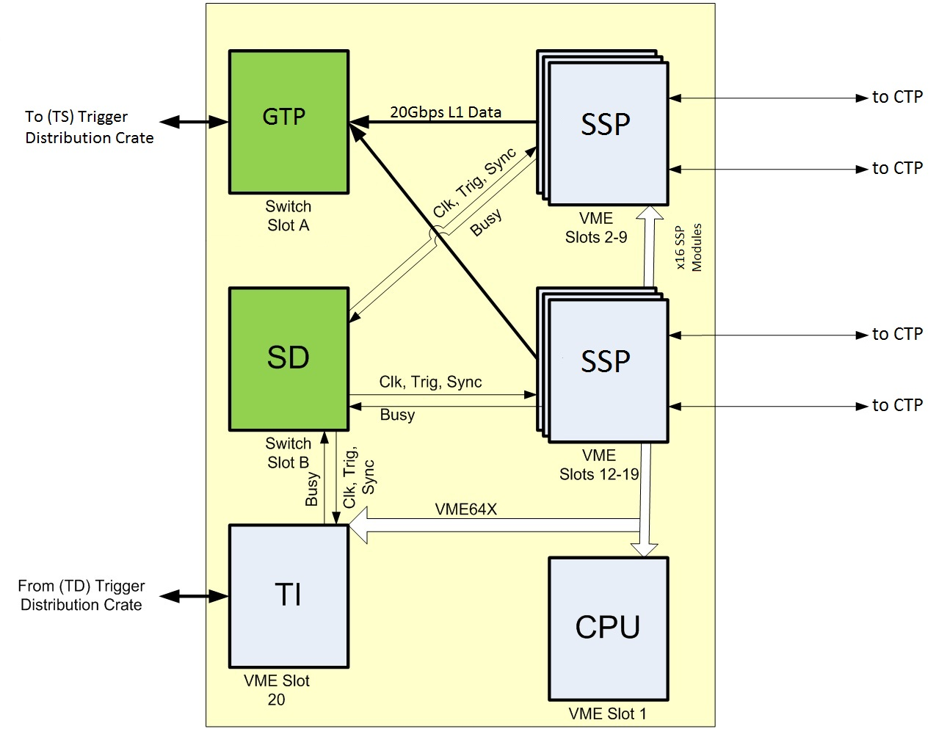

2. Purpose of the module

The SSP module communicates with the GTP and CTP using high speed serial links (2 lanes at 5Gbps for the GTP, 4 lanes at 2.5GBps for the CTP). For the CTP to SSP link a 4 lane full duplex fiber optic link is used to support the high data rate and long distance transmission (up to 150meters). The SSP to GTP link uses a 2 lane full duplex copper link over the VXS backplane. The links, after encoding, provide effectively 32bits of data every 4ns that can be used to transfer data that form the L1 trigger. The information sent on this link is specific to the experiment and detector which will be discussed in a separate document.

3. Functional Description

In Figure 3a the block diagram of the SSP is shown. The TX150T FPGA performs most of the work providing the VME interface, event building, event buffer logic, L1 trigger logic, SDRAM controller, and SerDes for fiber and VXS. In terms of the L1 trigger processing, data flows into the FPGA from the fiber transceivers and is processed then passed to the GTP through the VXS SWA port.

Figure 3a: SSP Hardware Block Diagram
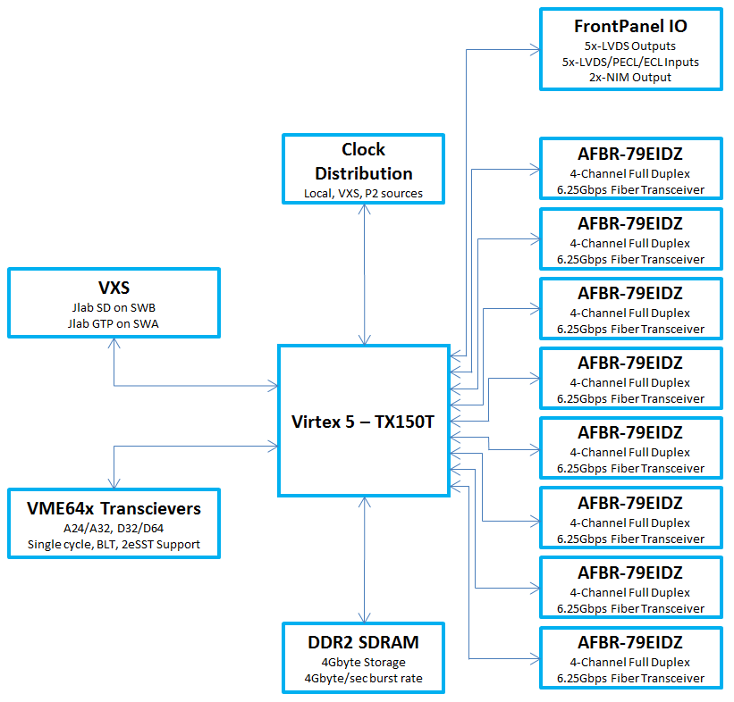

3.1 VME Interface
The VME interface is used to provide access to configuration registers on the SSP, bridge access to the fiber registers, and provide a high bandwidth interface to the CPU for event readout.
The A32 address space is dedicated to the event builder FIFO which is only used on some experiments where the SSP trigger data is used to tag each event read out. Depending on the application the FIFO exists inside the FPGA if it is relatively small or can exist in external SDRAM for very large buffers. Data can be read from the FIFO using single-cycle and block transfer VME protocols. Typically block transfer protocols will be used for event readout and specifically the 2eSST is intended for use to maximize performance. The 2eSST protocols provides nearly 200MB/s sustained transfer rate and supports the proprietary Jlab token-passing scheme that allows a single DMA operation on the CPU to transfer data from all SSP modules in a sequential manner eliminating overhead compared to individual board transfers.
The A24 address space is reserved for board register access. This address range does not support block transfer modes. Register access details will be provided in the board register description section discussed later.

3.2 VXS/Front Panel I/O

The VXS connection is used to interface to the trigger system without the need for loose cabling. This interface provides the following signals:

Signal | Description | Direction | Signal Type
Clock | 250MHz System Synchronous Clock | Input | LVPECL
Trig1 | L1 accept trigger bit, synchronous to clock | Input | LVPECL
Trig2 | L1 accept trigger bit, synchronous to clock | Input | LVPECL
Sync | L1 synchronization bit, synchronous to clock | Input | LVPECL
Busy | Module busy signal | Output | LVTTL
Token In | Used in VME 2eSST token passing scheme | Input | LVDS
Token Out | Used in VME 2eSST token passing scheme | Output | LVDS
Trigger Out | Module trigger bit | Output | LVDS
SD Link | Undefined serial link to SD | Output | LVDS
L1 Trigger | 5Gbps per lane (4) used to generate L1 trigger | Input/Output | CML

Clock
This clock signal is derived from the TI or Trigger Distribution Crate and is used to allow synchronous operation across multiple modules within a crate as well as across multiple crates.

Trig1, Trig2
These trigger bits tell the module when to capture and store an event.

Sync
The sync signal is used to align/start board timers at the same time as other boards in the crate and system.

Busy
Busy is normal held low, but if the SSP module event buffers become close to full the busy signal can be set high to signal that the trigger supervisor must stop sending triggers so the module buffers to not overflow. If buffer an overflow happens event synchronization from this module to another is lost.

Token In/Token Out
These are used by the VME interface when performing 2eSST transfers with token passing.

SDLink
Currently a undefined serial link to the Signal Distribution board.

L1 Trigger
This is a high speed serial link to the GTP using the Aurora streaming protocol.

4. Specifications
MECHANICAL
- Single width VITA 41 Payload Module

HIGH SPEED SERIAL P0 INPUTS/OUTPUTS:
- 250MHz LVPECL Clock
- Trig 1, Trig 2, Sync LVPECL Inputs
- 4x 5Gbps Lanes to GTP (only 2 used for GTP)

Front Panel INPUTS/OUTPUTS:
- Ribbon-Fiber Optic transceiver
  - AFBR-79EIDZ
- 2x NIM LEMO Outputs
- 5x LVDS Outputs
- 5x AnyLevel Differential Inputs (LVPECL, ECL, LVDS)

INDICATORS: (Front Panel)
- Power OK – Great LED
- VME DTACK – Red LED
- Status – Yellow LED

EVENT BUILDER:
- Large event FIFO
- High trigger rate capable >200kHz
- 8µs maximum trigger latency

PROGRAMMING:
- On board JTAG Port, VME

POWER REQUIREMENTS:
- +5.0v @ 7A Typ, 10A Peak

ENVIRONMENT:
- Commercial grade components (70 Celsius)
- Force air cooling required: TBD
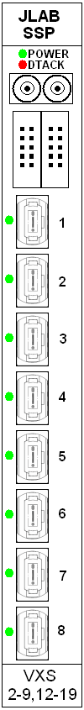

5. PCB Assembly View

The SSP PCB is an 18-layer impedance controlled FR-370HR stackup

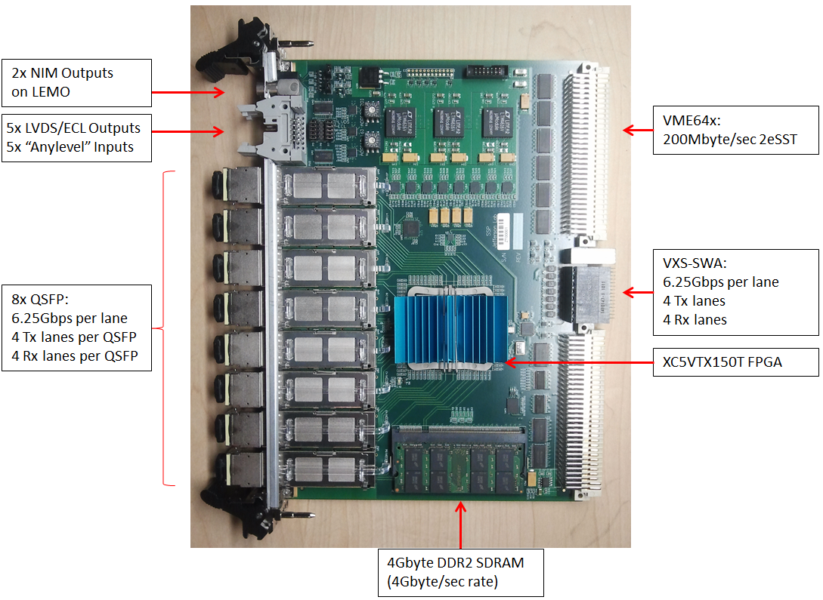

6. SSP Readout Data Format

The SSP readout data format utilizes the same encoding scheme defined for the JLAB FADC250. The word length for the readout data is 32bits. The event length is variable and depends on several factors (detector occupancy, headers, trailers, filler words).

Data Word Categories
Data words from the module are divided into two categories: Data Type Defining (bit 31 = 1) and Data Type Continuation (bit 31 = 0). Data Type Defining words contain a 4-bit data type tag (bits 30 - 27) along with a type dependent data payload (bits 26 - 0). Data Type Continuation words provide additional data payload (bits 30 – 0) for the last defined data type. Continuation words permit data payloads to span multiple words and allow for efficient packing of various data types spanning multiple data words. Any number of Data Type Continuation words may follow a Data Type Defining word.

Data Type List
0 Block Header
1 Block Trailer
2 Event Header
3 Trigger Time
4 Reserved
5 Reserved
6 Reserved
7 Reserved
8 Reserved
9 Reserved
10 Reserved
11 Reserved
12 Reserved
13 Reserved
14 Data Not Valid (empty module)
15 Filler Word (non-data)

Data Type: Block Header
Type: 0x0
Size: 1 word
Description: Indicates the beginning of a block of events. (High-speed readout of a board or a set of boards is done in blocks of events)
31 | 30 | 29 | 28 | 27 | 26 | 25 | 24
1 | 0 | 0 | 0 | 0 | SLOTID
23 | 22 | 21 | 20 | 19 | 18 | 17 | 16
SLOTID |  | NUM_EVENTS
15 | 14 | 13 | 12 | 11 | 10 | 9 | 8
NUM_EVENTS |  |  |  |  | BLOCK_NUMBER
7 | 6 | 5 | 4 | 3 | 2 | 1 | 0
BLOCK_NUMBER

BLOCK_NUMBER:
Event block number (used to align blocks when building events)
NUM_EVENTS:
Number of events in block
SLOTID:
Slot ID (set by VME64x backplane)

Data Type: Block Trailer
Type: 0x1
Size: 1 word
Description: Indicates the end of a block of events. The data words in a block are bracketed by the block header and trailer.
31 | 30 | 29 | 28 | 27 | 26 | 25 | 24
1 | 0 | 0 | 0 | 1 | SLOTID
23 | 22 | 21 | 20 | 19 | 18 | 17 | 16
SLOTID |  | NUM_WORDS
15 | 14 | 13 | 12 | 11 | 10 | 9 | 8
NUM_WORDS
7 | 6 | 5 | 4 | 3 | 2 | 1 | 0
NUM_WORDS

NUM_WORDS:
Total number of words in block of events
SLOTID:
Slot ID (set by VME64x backplane)

Data Type: Event Header
Type: 0x2
Size: 1 word
Description: Indicates the start of an event. The included trigger number is useful to ensure proper alignment of event fragments when building events. The 27bit trigger number (134M count) is not a limitation, as it will be used to distinguish events within event blocks, or among events that are concurrently being built or transported.
31 | 30 | 29 | 28 | 27 | 26 | 25 | 24
1 | 0 | 0 | 1 | 0 | TRIGGER_NUMBER
23 | 22 | 21 | 20 | 19 | 18 | 17 | 16
TRIGGER_NUMBER
15 | 14 | 13 | 12 | 11 | 10 | 9 | 8
TRIGGER_NUMBER
7 | 6 | 5 | 4 | 3 | 2 | 1 | 0
TRIGGER_NUMBER

TRIGGER_NUMBER:
Accepted event/trigger number

Data Type: Trigger Time
Type: 0x3
Size: 2 words
Description: Time of trigger occurrence relative to the most recent global reset. The time is measured by a 48bit counter that is clocked from the 125MHz system clock. The assertion of the global reset clears the counter. The de-assertion of global reset enables counter and thus sets t=0 for the module. The trigger time is necessary to ensure system synchronization and is useful in aligning event fragments when building events.
Word 1:
31 | 30 | 29 | 28 | 27 | 26 | 25 |  | 24
1 | 0 | 0 | 1 | 1 | 0 |  | 0 | 0
23 | 22 | 21 | 20 | 19 | 18 | 17 |  | 16
TRIGGER_TIME_H
15 | 14 | 13 | 12 | 11 | 10 | 9 |  | 8
TRIGGER_TIME_H
7 | 6 | 5 | 4 | 3 | 2 | 1 |  | 0
TRIGGER_TIME_H

TRIGGER_TIME_H:
This is the upper 24bits of the trigger time

Word 2:
31 | 30 | 29 | 28 | 27 | 26 | 25 |  | 24
0 | 0 | 0 | 0 | 0 | 0 |  | 0 | 0
23 | 22 | 21 | 20 | 19 | 18 | 17 |  | 16
TRIGGER_TIME_L
15 | 14 | 13 | 12 | 11 | 10 | 9 |  | 8
TRIGGER_TIME_ L
7 | 6 | 5 | 4 | 3 | 2 | 1 |  | 0
TRIGGER_TIME_ L

TRIGGER_TIME_L:
This is the lower 24bits of the trigger time

Data Type: Data Not Valid
Type: 0x14
Size: 1 word
Description: Module has no data available for readout. This can if the module is being read out too quickly after receiving (event building is in process and no data words have been put into the buffer yet) a trigger or if the module doesn’t have any events to report.
31 | 30 | 29 | 28 | 27 | 26 | 25 | 24
1 | 1 | 1 | 1 | 0 | UNDEFINED
23 | 22 | 21 | 20 | 19 | 18 | 17 | 16
UNDEFINED
15 | 14 | 13 | 12 | 11 | 10 | 9 | 8
UNDEFINED
7 | 6 | 5 | 4 | 3 | 2 | 1 | 0
UNDEFINED

Data Type: Filler Word
Type: 0x15
Size: 1 word
Description: Non-data word appended to the block of events. This is used to force the total number of 32-bit words read out of a module to be a multiple of 2 or 4 when
31 | 30 | 29 | 28 | 27 | 26 | 25 | 24
1 | 1 | 1 | 1 | 1 | UNDEFINED
23 | 22 | 21 | 20 | 19 | 18 | 17 | 16
UNDEFINED
15 | 14 | 13 | 12 | 11 | 10 | 9 | 8
UNDEFINED
7 | 6 | 5 | 4 | 3 | 2 | 1 | 0
UNDEFINED

7. VME Registers
All SSP board registers can be accessed through the VME bus in the following mode:
- A24: single cycle accesses, 32bit aligned read or write access (register specific)
Event readout can be access through the VME bus in the following modes:
- A32: single cycle, BLT, MBLT, 2eVME, 2eSST
- Note: transfer rate for 2eSST is 200MB/s

Register Summary:
Register Name | Description | Address Offset
SspCfg peripheral (offset 0x0000)
BoardId | Board identification | 0x0000
FirmwareRev | Firmware revision | 0x0004
SpiCtrl | Non-volatile flash control | 0x0008
SpiStatus | Non-volatile flash status | 0x000C
ICapCtrl | FPGA configuration interface | 0x0010
ICapDataWr | FPGA configuration interface | 0x0014
ICapDataRd | FPGA configuration interface | 0x0018
ICapStatus | FPGA configuration interface | 0x001C
Clk peripheral (offset 0x0100)
Ctrl | Clock control | 0x0000
Status | Clock status | 0x0004
Sd peripheral (offset 0x0200)
SrlSel[] | Signal muxing | 0x0000
PulserPeriod | Pulser Period | 0x0080
PulserLowCycles | Pulser low cycles | 0x0084
PulserNPulses | Pulser pulse count | 0x0088
PulserStart | Pulser start | 0x008C
PulserDone | Pulser status | 0x0090
ScalerLatch | Latch scalers | 0x0100
Scalers[] | Scalers | 0x0104
Trg peripheral (offset 0x0400)
Ctrl | Trigger control | 0x0000
SumHistThr | Sum histogram threshold | 0x0014
SumHistWindow | Sum histogram integral window | 0x0018
SumHistData | Sum histogram bin data | 0x0024
Serdes peripheral (0x1000, 0x1100, 0x1200, 0x1300, 0x1400,0x1500,0x1600,0x1700,0x1800,0x1900)
Ctrl | Control | 0x0000
CtrlTile0 | Tile 0 control | 0x0004
CtrlTile1 | Tile 1 control | 0x0008
DrlCtrl | Drp control | 0x000C
Status | Status | 0x0010
DrpStatus | Drp status | 0x0014
ErrTile0 | Tile 0 rx bit errors | 0x0018
ErrTile1 | Tile 1 rx bit errors | 0x001C
MonCtrl | Monitor control | 0x0030
MonStatus | Monitor status | 0x0034
MonMask[] | Monitor mask | 0x0040
MonVal[] | Monitor match values | 0x0060
MonThr[] | Monitor thresholds | 0x0080
MonData[] | Monitor capture data | 0x0090

7.1 SspCfg Peripheral Registers Section
Basic board information registers can be used to verify that this board is the SSP and check for the software revision, which should be checked for compatibility. Reprogramming the SSP firmware is also possible through these registers.

Register: BoardId
Address Offset: 0x0000
Size: 32bits
Reset State: 0x53535020
31 | 30 | 29 | 28 | 27 | 26 | 25 | 24
BOARD_ID
23 | 22 | 21 | 20 | 19 | 18 | 17 | 16
BOARD_ID
15 | 14 | 13 | 12 | 11 | 10 | 9 | 8
BOARD_ID
7 | 6 | 5 | 4 | 3 | 2 | 1 | 0
BOARD_ID

BOARD_ID (RO):
0x53535020 = “SSP ” in ASCII

Register: FirmwareRev
Address Offset: 0x0004
Size: 32bits
Reset State: 0xXXXXXXXX
31 | 30 | 29 | 28 | 27 | 26 | 25 | 24
- | - | - | SLOTID
23 | 22 | 21 | 20 | 19 | 18 | 17 | 16
TEST | SSPTYPE
15 | 14 | 13 | 12 | 11 | 10 | 9 | 8
FIRMWARE_REV_MAJOR
7 | 6 | 5 | 4 | 3 | 2 | 1 | 0
FIRMWARE_REV_MINOR

SLOTID(RO):
VME slot id

TEST(RO):
‘1’ indicates this firmware version is a test release. There can be many releases with this same version when this flag is set.
‘0’ indicates this firmware version is a controlled release. “There can be only one”

SSPTYPE(RO):
Firmware build type [0x00 to 0x7F]

Defined types:
0x01 HallD

FIRMWARE_REV_MAJOR (RO):
Major firmware revision number

FIRMWARE_REV_MINOR (RO):
Minor firmware revision number

Register: SpiCtrl
Address Offset: 0x0008
Size: 32bits
Reset State: 0x00000080
31 | 30 | 29 | 28 | 27 | 26 | 25 | 24
- | - | - | - | - | - | - | -
23 | 22 | 21 | 20 | 19 | 18 | 17 | 16
- | - | - | - | - | - | - | -
15 | 14 | 13 | 12 | 11 | 10 | 9 | 8
- | - | - | - | - | START | NCS_CLR | NCS_SET
7 | 6 | 5 | 4 | 3 | 2 | 1 | 0
TX_DATA

TX_DATA (RW):
SPI tx data
NCS_SET (WO):
Sets the NCS line of the SPI flash memory
NCS_CLEAR (WO):
Clears the NCS line of the SPI flash memory
START (WO):
Begins a SPI transfer. Check SpiStatus DONE bit to determine when transaction is finished.

Notes:
- This interface is used for firmware updates and general non-volatile parameter storage.

Register: SpiStatus
Address Offset: 0x000C
Size: 32bits
Reset State: 0xXXXXXXXX
31 | 30 | 29 | 28 | 27 | 26 | 25 | 24
- | - | - | - | - | - | - | -
23 | 22 | 21 | 20 | 19 | 18 | 17 | 16
- | - | - | - | - | - | - | -
15 | 14 | 13 | 12 | 11 | 10 | 9 | 8
- | - | - | - | DONE | - | - | -
7 | 6 | 5 | 4 | 3 | 2 | 1 | 0
RX_DATA

RX_DATA (RO):
SPI rx data
DONE (RO):
‘0’ - SPI transfer in progress
‘1’ - SPI transfer is complete

Register: ICap
Address Offset: 0x0010
Size: 32bits
Reset State: 0xXXXXXXXX

Notes:
- This interface provides direct access to the FPGA configuration interface. Only intended use is for a VME based FPGA reload after new firmware has been programmed into flash memory.

Register: ICapDataWr
Address Offset: 0x0014
Size: 32bits
Reset State: 0x00000000

Notes:
- This interface provides direct access to the FPGA configuration interface. Only intended use is for a VME based FPGA reload after new firmware has been programmed into flash memory.

Register: ICapDataRd
Address Offset: 0x0018
Size: 32bits
Reset State: 0xXXXXXXXX

Notes:
- This interface provides direct access to the FPGA configuration interface. Only intended use is for a VME based FPGA reload after new firmware has been programmed into flash memory.

Register: ICapStatus
Address Offset: 0x001C
Size: 32bits
Reset State: 0xXXXXXXXX

Notes:
- This interface provides direct access to the FPGA configuration interface. Only intended use is for a VME based FPGA reload after new firmware has been programmed into flash memory.

7.2 Clk Peripheral Registers Section
Clock selection, reset, and status can be access through the following registers.

Register: Ctrl
Address Offset: 0x0000
Size: 32bits
Reset State: 0x00000000
31 | 30 | 29 | 28 | 27 | 26 | 25 | 24
CLKRST | - | - | - | CLK_LOGIC |  | CLK_SERDES
23 | 22 | 21 | 20 | 19 | 18 | 17 | 16
- | DRP_DEN | DRP_WE | DRP_ADDR
15 | 14 | 13 | 12 | 11 | 10 | 9 | 8
DRP_DI
7 | 6 | 5 | 4 | 3 | 2 | 1 | 0
DRP_DI

DRP_DI (RW):
DRP data input.
DRP_ADDR (RW):
DRP data address.
DRP_WE (RW):
DRP data write enable.
DRP_DEN (RW):
DRP data enable.
CLK_SERDES (RW):
Clock mux input selection:
“00” – disabled clock
“01” – VXS SWB SD clock
“10” – P2 clock
“11” – local clock
CLK_LOGIC (RW):
Clock mux input selection:
“00” – disabled clock
“01” – VXS SWB SD clock
“10” – P2 clock
“11” – local clock
CLKRST (RW):
Write ‘1’ to this bit to reset clock PLL whenever clock source is changed (either due to register changes to signal loss). Write ‘0’ to release reset once input clock source is stable.

Register: Status
Address Offset: 0x0004
Size: 32bits
Reset State: 0x00000000
31 | 30 | 29 | 28 | 27 | 26 | 25 | 24
- | - | - | - | - | - | - | -
23 | 22 | 21 | 20 | 19 | 18 | 17 | 16
- | - | - | - | - | - | LOCKED | DRP_RDY
15 | 14 | 13 | 12 | 11 | 10 | 9 | 8
DRP_DO
7 | 6 | 5 | 4 | 3 | 2 | 1 | 0
DRP_DO

DRP_DO (RO):
DRP data output.
DRP_RDY (RO):
‘1’ – DRP_DO is valid
‘0’ – DRP_DO invalid
LOCKED (RO):
‘1’ – SSP Global clock PLL is locked
‘0’ – SSP Global clock PLL not locked

7.3 Sd Peripheral Registers Section
Pulser setup and trigger, sync, general purpose I/O muxing are setup through the the following registers.

Register: SrcSel[]
Address Offset: 0x0000 + 4*SD_SRC_x
Size: 32bits
Reset State: 0x00000000
31 | 30 |  | 29 |  | 28 | 27 | 26 | 25 | 24
- | - |  | - |  | - | - | - | - | -
23 | 22 |  | 21 |  | 20 | 19 | 18 | 17 | 16
- | - |  | - |  | - | - | - | - | -
15 | 14 |  | 13 |  | 12 | 11 | 10 | 9 | 8
- | - | - |  | - |  | - | - | - | -
7 | 6 |  | 5 |  | 4 | 3 | 2 | 1 | 0
- | - | - |  | SRC

SRC (RW):
Selects the signal source for the output signal (output signal is indicated by the index into SrcSel[])

The SD_SRC_x ID map is used to determine which index in the SrcSel register array to use:
SD_SRC_x ID NAME | Index in SrcSel | Description
SD_SRC_LVDSOUT0 | 0 | Front Panel LVDS/ECL output #0
SD_SRC_LVDSOUT1 | 1 | Front Panel LVDS/ECL output #1
SD_SRC_LVDSOUT2 | 2 | Front Panel LVDS/ECL output #2
SD_SRC_LVDSOUT3 | 3 | Front Panel LVDS/ECL output #3
SD_SRC_LVDSOUT4 | 4 | Front Panel LVDS/ECL output #4
SD_SRC_GPIO0 | 5 | Front Panel NIM output #0
SD_SRC_GPIO1 | 6 | Front Panel NIM output #1
SD_SRC_P2_LVDSOUT0 | 7 | P2 LVDS output#0
SD_SRC_P2_LVDSOUT1 | 8 | P2 LVDS output#1
SD_SRC_P2_LVDSOUT2 | 9 | P2 LVDS output#2
SD_SRC_P2_LVDSOUT3 | 10 | P2 LVDS output#3
SD_SRC_P2_LVDSOUT4 | 11 | P2 LVDS output#4
SD_SRC_P2_LVDSOUT5 | 12 | P2 LVDS output#5
SD_SRC_P2_LVDSOUT6 | 13 | P2 LVDS output#6
SD_SRC_P2_LVDSOUT7 | 14 | P2 LVDS output#7
SD_SRC_TRIG | 15 | SSP internal trigger
SD_SRC_SYNC | 16 | SSP internal sync

Possible values for SRC contents of register:
SD_SRC_SEL_x | Value | Source Signal Description
SD_SRC_SEL_0 | 0 | Drive constant ‘0’
SD_SRC_SEL_1 | 1 | Drive constant ‘1’
SD_SRC_SEL_SYNC | 2 | VXS SWB Sync
SD_SRC_SEL_TRIG1 | 3 | VXS SWB Trig1
SD_SRC_SEL_TRIG2 | 4 | VXS SWB Trig2
SD_SRC_SEL_LVDSIN0 | 5 | Front panel LVDS input#0
SD_SRC_SEL_LVDSIN1 | 6 | Front panel LVDS input#1
SD_SRC_SEL_LVDSIN2 | 7 | Front panel LVDS input#2
SD_SRC_SEL_LVDSIN3 | 8 | Front panel LVDS input#3
SD_SRC_SEL_LVDSIN4 | 9 | Front panel LVDS input#4
SD_SRC_SEL_P2LVDSIN0 | 10 | P2 LVDS input#0
SD_SRC_SEL_P2LVDSIN1 | 11 | P2 LVDS input#1
SD_SRC_SEL_P2LVDSIN2 | 12 | P2 LVDS input#2
SD_SRC_SEL_P2LVDSIN3 | 13 | P2 LVDS input#3
SD_SRC_SEL_P2LVDSIN4 | 14 | P2 LVDS input#4
SD_SRC_SEL_P2LVDSIN5 | 15 | P2 LVDS input#5
SD_SRC_SEL_P2LVDSIN6 | 16 | P2 LVDS input#6
SD_SRC_SEL_P2LVDSIN7 | 17 | P2 LVDS input#7
SD_SRC_SEL_PULSER | 18 | Pulser output
SD_SRC_SEL_BUSY | 19 | Event builder busy
SD_SRC_SEL_TRIGGER0 | 20 | SSP firmware specific trigger signal#0
SD_SRC_SEL_TRIGGER1 | 21 | SSP firmware specific trigger signal#1
SD_SRC_SEL_TRIGGER2 | 22 | SSP firmware specific trigger signal#2
SD_SRC_SEL_TRIGGER3 | 23 | SSP firmware specific trigger signal#3
SD_SRC_SEL_TRIGGER4 | 24 | SSP firmware specific trigger signal#4
SD_SRC_SEL_TRIGGER5 | 25 | SSP firmware specific trigger signal#5
SD_SRC_SEL_TRIGGER6 | 26 | SSP firmware specific trigger signal#6
SD_SRC_SEL_TRIGGER7 | 27 | SSP firmware specific trigger signal#7

Register: PulserPeriod
Address Offset: 0x0080
Size: 32bits
Reset State: 0x00000000
31 | 30 | 29 | 28 | 27 | 26 | 25 | 24
PERIOD
23 | 22 | 21 | 20 | 19 | 18 | 17 | 16
PERIOD
15 | 14 | 13 | 12 | 11 | 10 | 9 | 8
PERIOD
7 | 6 | 5 | 4 | 3 | 2 | 1 | 0
PERIOD

PERIOD (R/W):
Defines number of 4ns ticks for the pulser period

Register: PulserLowCycles
Address Offset: 0x0084
Size: 32bits
Reset State: 0x00000000
31 | 30 | 29 | 28 | 27 | 26 | 25 | 24
LOW_CYCLES
23 | 22 | 21 | 20 | 19 | 18 | 17 | 16
LOW_CYCLES
15 | 14 | 13 | 12 | 11 | 10 | 9 | 8
LOW_CYCLES
7 | 6 | 5 | 4 | 3 | 2 | 1 | 0
LOW_CYCLES

LOW_CYCLES (R/W):
Defines number of 4ns ticks of the pulser period the output stays low.

Register: PulserNPulses
Address Offset: 0x0088
Size: 32bits
Reset State: 0x00000000
31 | 30 | 29 | 28 | 27 | 26 | 25 | 24
COUNT
23 | 22 | 21 | 20 | 19 | 18 | 17 | 16
COUNT
15 | 14 | 13 | 12 | 11 | 10 | 9 | 8
COUNT
7 | 6 | 5 | 4 | 3 | 2 | 1 | 0
COUNT

COUNT (R/W):
0x00000000: disable pulser output
0x00000001 to 0xFFFFFFFE: number of periods to deliver pulser output
0xFFFFFFFF: infinite cycle count for pulser output
Notes:
- When using fixed count of pulses the pulser must be trigger to start by writing to the PulserStart register

Register: PulserStart
Address Offset: 0x008C
Size: 32bits
Reset State: 0x00000000
31 | 30 | 29 | 28 | 27 | 26 | 25 | 24
PULSER_START
23 | 22 | 21 | 20 | 19 | 18 | 17 | 16
PULSER_START
15 | 14 | 13 | 12 | 11 | 10 | 9 | 8
PULSER_START
7 | 6 | 5 | 4 | 3 | 2 | 1 | 0
PULSER_START

PULSER_START (WO):
Write any value to start pulser operation. The pulse number counter is cleared.

Register: PulserDone
Address Offset: 0x0090
Size: 32bits
Reset State: 0x00000000
31 | 30 | 29 | 28 | 27 | 26 | 25 | 24
- | - | - | - | - | - | - | -
23 | 22 | 21 | 20 | 19 | 18 | 17 | 16
- | - | - | - | - | - | - | -
15 | 14 | 13 | 12 | 11 | 10 | 9 | 8
- | - | - | - | - | - | - | -
7 | 6 | 5 | 4 | 3 | 2 | 1 | 0
- | - | - | - | - | - | - | DONE

DONE (RO):
‘0’ – pulser is still delivering pulses as defined in PulserNPulses
‘1’ – pulser is is not active (either disabled or has finished fixed pulse count)

Register: ScalerLatch
Address Offset: 0x0100
Size: 32bits
Reset State: 0x00000000
31 | 30 | 29 | 28 | 27 | 26 | 25 | 24
- | - | - | - | - | - | - | -
23 | 22 | 21 | 20 | 19 | 18 | 17 | 16
- | - | - | - | - | - | - | -
15 | 14 | 13 | 12 | 11 | 10 | 9 | 8
- | - | - | - | - | - | - | -
7 | 6 | 5 | 4 | 3 | 2 | 1 | 0
- | - | - | - | - | - | - | DISABLE

DISABLE (RW):
‘1’ – disables non-buffered scalers. Do this prior to reading out scalers
‘0’ – enables non-buffered scalers. Do this after readout is complete. This will also reset the scaler contents to 0.

Register: Scalers[]
Address Offset: 0x0104
Size: 32bits
Reset State: 0x00000000
31 | 30 | 29 | 28 | 27 | 26 | 25 | 24
SCALER
23 | 22 | 21 | 20 | 19 | 18 | 17 | 16
SCALER
15 | 14 | 13 | 12 | 11 | 10 | 9 | 8
SCALER
7 | 6 | 5 | 4 | 3 | 2 | 1 | 0
SCALER

SCALER (RO):
32bit scaler value. Refer to map index to determine what signal is mapped to which offset in Scalers[]. Scalers will stop counting once 0xFFFFFFFF is reached – this value can be considered an indicator of overflow.

Scaler Name | Index in Scalers[] | Description
SD_SCALER_SYSCLK | 0 | 50MHz counts since latch latch. Use for Reference.
SD_SCALER_GCLK | 1 | 250MHz global clock. May not always be on.
SD_SCALER_SYNC | 2 | VXS SWB Sync input edges
SD_SCALER_TRIG1 | 3 | VXS SWB Trig1 input edges
SD_SCALER_TRIG2 | 4 | VXS SWB Trig2 input edges
SD_SCALER_GPIO0 | 5 | FP NIM output#0 edges
SD_SCALER_GPIO1 | 6 | FP NIM output#1 edges
SD_SCALER_LVDSIN0 | 7 | FP LVDS input#0 edges
SD_SCALER_LVDSIN1 | 8 | FP LVDS input#1 edges
SD_SCALER_LVDSIN2 | 9 | FP LVDS input#2 edges
SD_SCALER_LVDSIN3 | 10 | FP LVDS input#3 edges
SD_SCALER_LVDSIN4 | 11 | FP LVDS input#4 edges
SD_SCALER_LVDSOUT0 | 12 | FP LVDS output#0 edges
SD_SCALER_LVDSOUT1 | 13 | FP LVDS output#1 edges
SD_SCALER_LVDSOUT2 | 14 | FP LVDS output#2 edges
SD_SCALER_LVDSOUT3 | 15 | FP LVDS output#3 edges
SD_SCALER_LVDSOUT4 | 16 | FP LVDS output#4 edges
SD_SCALER_BUSY | 17 | Busy assertion edges seen
SD_SCALER_BUSYCYCLES | 18 | Number of 50MHz cycles busy was high
SD_SCALER_P2_LVDSIN0 | 19 | P2 LVDS input#0 edges
SD_SCALER_P2_LVDSIN1 | 20 | P2 LVDS input#1 edges
SD_SCALER_P2_LVDSIN2 | 21 | P2 LVDS input#2 edges
SD_SCALER_P2_LVDSIN3 | 22 | P2 LVDS input#3 edges
SD_SCALER_P2_LVDSIN4 | 23 | P2 LVDS input#4 edges
SD_SCALER_P2_LVDSIN5 | 24 | P2 LVDS input#5 edges
SD_SCALER_P2_LVDSIN6 | 25 | P2 LVDS input#6 edges
SD_SCALER_P2_LVDSIN7 | 26 | P2 LVDS input#7 edges
SD_SCALER_P2_LVDSOUT0 | 27 | P2 LVDS output#0 edges
SD_SCALER_P2_LVDSOUT1 | 28 | P2 LVDS output#1 edges
SD_SCALER_P2_LVDSOUT2 | 29 | P2 LVDS output#2 edges
SD_SCALER_P2_LVDSOUT3 | 30 | P2 LVDS output#3 edges
SD_SCALER_P2_LVDSOUT4 | 31 | P2 LVDS output#4 edges
SD_SCALER_P2_LVDSOUT5 | 32 | P2 LVDS output#5 edges
SD_SCALER_P2_LVDSOUT6 | 33 | P2 LVDS output#6 edges
SD_SCALER_P2_LVDSOUT7 | 34 | P2 LVDS output#7 edges

7.4 Trg Peripheral Registers Section
The following registers setup the trigger processing of the SSP.

Register: Ctrl
Address Offset: 0x0000
Size: 32bits
Reset State: 0x00000000
31 | 30 | 29 | 28 | 27 | 26 | 25 | 24
- | - | - | - | - | - | - | -
23 | 22 | 21 | 20 | 19 | 18 | 17 | 16
- | - | - | - | - | - | - | -
15 | 14 | 13 | 12 | 11 | 10 | 9 | 8
GTP_SRC
7 | 6 | 5 | 4 | 3 | 2 | 1 | 0
FIBER_EN

FIBER_EN (R/W):
Bit x:
‘1’ enabled fiber port x in trigger processor.
‘0’ disables fiber port x in trigger processor.

GTP_SRC (R/W):
Determines the trigger data sent to the GTP over the VXS backplane:
0 – Fiber port 0 data
1 – Fiber port 1 data
2 – Fiber port 2 data
3 – Fiber port 3 data
4 – Fiber port 4 data
5 – Fiber port 5 data
6 – Fiber port 6 data
7 – Fiber port 7 data
8 – Sum of all fiber ports enabled by FIBER_EN bits

Register: SumHistThr
Address Offset: 0x0014
Size: 32bits
Reset State: 0x00000000
31 | 30 | 29 | 28 | 27 | 26 | 25 | 24
THR
23 | 22 | 21 | 20 | 19 | 18 | 17 | 16
THR
15 | 14 | 13 | 12 | 11 | 10 | 9 | 8
THR
7 | 6 | 5 | 4 | 3 | 2 | 1 | 0
THR

THE (R/W):
Threshold applied to Sum trigger data. When Sum trigger data go above this threshold the histogrammer will integrate a window (defined by SumHistWindow) and incrememt the bin corresponding to this integral value.

Register: SumHistWindow
Address Offset: 0x0018
Size: 32bits
Reset State: 0x00000000
31 | 30 | 29 | 28 | 27 | 26 | 25 | 24
- | - | - | - | - | - | - | -
23 | 22 | 21 | 20 | 19 | 18 | 17 | 16
NSA
15 | 14 | 13 | 12 | 11 | 10 | 9 | 8
- | - | - | - | - | - | - | -
7 | 6 | 5 | 4 | 3 | 2 | 1 | 0
NSB

NSA(R/W):
The number of samples to integrate the Sum trigger data after it crosses threshold
NSB(R/W):
The number of samples to integrate the Sum trigger data before it crosses threshold

Register: SumHistData
Address Offset: 0x0024
Size: 32bits
Reset State: 0x00000000
31 | 30 | 29 | 28 | 27 | 26 | 25 | 24
DATA
23 | 22 | 21 | 20 | 19 | 18 | 17 | 16
DATA
15 | 14 | 13 | 12 | 11 | 10 | 9 | 8
DATA
7 | 6 | 5 | 4 | 3 | 2 | 1 | 0
DATA

DATA(R/O):
Read this register 32 times after the histogram has been disabled. The 1st data corresponds to bin 0, the 512th read corresponds to bin 31.The bins are scaled log₂ to maintain a large dynamic range over the range of pulse energy than may be obtained.

7.5 Serdes Peripheral Registers Section
The following registers setup/monitor each of the Serdes (Fiber and VXS) of the SSP.

Register: Ctrl
Address Offset: 0x0000
Size: 32bits
Reset State: 0x00000203
31 | 30 | 29 | 28 | 27 | 26 | 25 | 24
- | - | - | - | - | - | - | -
23 | 22 | 21 | 20 | 19 | 18 | 17 | 16
- | - | - | - | - | - | - | -
15 | 14 | 13 | 12 | 11 | 10 | 9 | 8
- | - | - | - | ERR_EN | ERR_RST | RESET | TXENPRBS
7 | 6 | 5 | 4 | 3 | 2 | 1 | 0
TXENPRBS | RXENPRBS |  | LOOPBACK |  |  | GTRESET | PWRDN

PWRDN (R/W):
‘1’ disable power of the transceiver
‘0’ enable power of the transceiver
GTRESET (R/W):
‘1’ reset transceiver
‘0’ release reset of transceiver
LOOPBACK (R/W):
“000” – keep at this value
RXENPRBS (R/W):
“00” – keep at this value
TXENPRBS (R/W):
“00” – keep at this value
RESET (R/W):
‘1’ reset link
‘0’ release reset of link
ERR_RST (R/W):
‘1’ reset error counts
‘0’ release reset error counts
ERR_EN (R/W):
‘1’ enable error counts
‘0’ disable error counts (error counters should be disabled when read)

Register: CtrlTile0
Address Offset: 0x0004
Size: 32bits
Reset State: 0x05420542
31 | 30 | 29 | 28 | 27 | 26 | 25 | 24
- | - | - | - | TXDIFFCTRL1 |  |  | TXBUFDIFFCTRL1
23 | 22 | 21 | 20 | 19 | 18 | 17 | 16
TXBUFDIFFCTRL1 |  | TXPREEMPHASIS1 |  |  |  | RXEQMIX1
15 | 14 | 13 | 12 | 11 | 10 | 9 | 8
- | - | - | - | TXDIFFCTRL0 |  |  | TXBUFDIFFCTRL0
7 | 6 | 5 | 4 | 3 | 2 | 1 | 0
TXBUFDIFFCTRL0 |  | TXPREEMPHASIS0 |  |  |  | RXEQMIX0

Do not modify values on this register.

Register: CtrlTile1
Address Offset: 0x0008
Size: 32bits
Reset State: 0x05420542
31 | 30 | 29 | 28 | 27 | 26 | 25 | 24
- | - | - | - | TXDIFFCTRL1 |  |  | TXBUFDIFFCTRL1
23 | 22 | 21 | 20 | 19 | 18 | 17 | 16
TXBUFDIFFCTRL1 |  | TXPREEMPHASIS1 |  |  |  | RXEQMIX1
15 | 14 | 13 | 12 | 11 | 10 | 9 | 8
- | - | - | - | TXDIFFCTRL0 |  |  | TXBUFDIFFCTRL0
7 | 6 | 5 | 4 | 3 | 2 | 1 | 0
TXBUFDIFFCTRL0 |  | TXPREEMPHASIS0 |  |  |  | RXEQMIX0

Do not modify values on this register.

Register: DrpCtrl
Address Offset: 0x000C
Size: 32bits
Reset State: 0x00000000
31 | 30 |  | 29 | 28 | 27 | 26 | 25 | 24
- | - |  | - | - |  | DEN_TILE1 | DEN_TILE0 | DWE
23 | 22 |  | 21 | 20 | 19 | 18 | 17 | 16
- |  | DRP_ADDR
15 | 14 |  | 13 | 12 | 11 | 10 | 9 | 8
DRP_DIN
7 | 6 |  | 5 | 4 | 3 | 2 | 1 | 0
DRP_DIN

Do not modify values on this register.

Register: Status
Address Offset: 0x0010
Size: 32bits
Reset State: 0x00000000
31 | 30 | 29 | 28 | 27 | 26 | 25 | 24
- | - | - | - | - | - | - | -
23 | 22 | 21 | 20 | 19 | 18 | 17 | 16
-
15 | 14 | 13 | 12 | 11 | 10 | 9 | 8
 | SRCRDYN | TXLOCK | CHUP | RXPOL3 | RXPOL2 | RXPOL1 | RXPOL0
7 | 6 | 5 | 4 | 3 | 2 | 1 | 0
LANEUP3 | LANEUP2 | LANEUP1 | LANEUP0 | HARDERR3 | HARDERR2 | HARDERR1 | HARDERR0

HARDERRx (RO):
‘0’ – no hard error on lane x
‘1’ – hard error occurred on lane x. Reset is required.
LANEUPx (RO):
‘0’ – lane x is down.
‘1’ – lane x is up
RXPOLx (RO):
‘0’ – rx polarity is normal
‘1’ – rx polarity is inverted
CHUP (RO):
‘0’ – channel is down
‘1’ – channel is up
TXLOCK (RO):
‘0’ – TX PLL not locked (likely due to missing 250MHz global clock)
‘1’ – TX PLL is locked
SRCRDYN (RO):
‘0’ – Data is current being received over channel
‘1’ – Data is not being received over channel

Register: CrateId
Address Offset: 0x0020
Size: 32bits
Reset State: 0x00000000
31 | 30 | 29 | 28 | 27 | 26 | 25 | 24
- | - | - | - | - | - | - | -
23 | 22 | 21 | 20 | 19 | 18 | 17 | 16
- | - | - | - | - | - | - | -
15 | 14 | 13 | 12 | 11 | 10 | 9 | 8
CRATEID
7 | 6 | 5 | 4 | 3 | 2 | 1 | 0
CRATEID

CRATEID (RO):
The first lower 16bit word received on the transceiver which has
been defined to be the CrateId. This is updated any time the link goes from ILDE->DATA (normally only when the system SYNC goes low)

Register: MonCtrl
Address Offset: 0x0030
Size: 32bits
Reset State: 0x00000000
31 | 30 | 29 | 28 | 27 | 26 | 25 | 24
- | - | - | - | - | - | - | -
23 | 22 | 21 | 20 | 19 | 18 | 17 | 16
- | - | - | - | - | - | - | -
15 | 14 | 13 | 12 | 11 | 10 | 9 | 8
- | - | - | - | - | - | - | -
7 | 6 | 5 | 4 | 3 | 2 | 1 | 0
- | - | - | - | - | - | - | ID_RESET

ID_RESET (RW):
‘0’ – does nothing
‘1’ – resets CrateId to 0 (this is an auto-clearing bit)

Register: MonStatus
Address Offset: 0x0034
Size: 32bits
Reset State: 0x00000000
31 | 30 | 29 | 28 | 27 | 26 | 25 | 24
LATENCY
23 | 22 | 21 | 20 | 19 | 18 | 17 | 16
LATENCY
15 | 14 | 13 | 12 | 11 | 10 | 9 | 8
- | - | - | - | CRCOK3 | CRCOK2 | CRCOK1 | CRCOK0
7 | 6 | 5 | 4 | 3 | 2 | 1 | 0
- | - | - | - | - | - | - | RDY

RDY (RO):
‘0’ – serdes data monitor has not triggered
‘1’ – serdes data monitor has triggered and data is ready for readout
CRCx (RO):
‘0’ – lane x has failed CRC verification during last sync frame
‘1’ – lane x has passed CRC verification during last sync frame
LATENCY (RO):
Latency, in 4ns ticks, from SYNC to receipt of first trigger word on serdes

Register: MonMask
Address Offset: 0x0040,…
Size: 32bits
Reset State: 0x00000000

Used for debugging.

Register: MonVal
Address Offset: 0x0060,…
Size: 32bits
Reset State: 0x00000000

Used for debugging.

Register: MonThr
Address Offset: 0x0080,…
Size: 32bits
Reset State: 0x00000000

Used for debugging.

Register: MonData
Address Offset: 0x0090,…
Size: 32bits
Reset State: 0x00000000

Used for debugging.

Appendix A: Alternate use – front-end readout mode

OM3 ribbon fiber length can easily be 100meter
LC -> LC fiber patch cables
MTP -> LC
breakout box/cable
50/125μm
OM3 ribbon fiber
Up to 32 full-duplex fiber links per SSP
Custom controller/front-end
Custom controller/front-end
Custom controller/front-end
Custom controller/front-end
MTP -> 4 LC
MTP -> 4 LC
MTP -> 4 LC
MTP -> 4 LC
MTP -> 4 LC
MTP -> 4 LC
MTP -> 4 LC
MTP -> 4 LC

General Notes:

- SSP has 32 full-duplex fiber links that can operate at up to 6.25Gbps. These could be partitioned in a few different ways. Shown above would allow each SSP to connect to 32 different controllers; however, if higher bandwidth is needed it may make more sense to deliver the full MTP connection to each controller (in which case only 8 controllers per SSP would be supported, but at >20Gbps per controller).

- Listed lines rates would be reduced to 80% for usable data transfer rates after 8b/10b encoding rules have been applied (to satisfy maximum run length/AC coupling requirements).

- If the fiber optic links deliver enough bandwidth, all front-end data could be stream to the SSP where the readout data trigger matching, data suppression, and event building could be performed. This option would minimize the new hardware developments. Alternatively much of this work could be performed on the front-end boards and the fiber links would be for delivering trigger and synchronization signals in one direction, and triggered data and status in the other direction.

- A synchronizing clock will likely be needed and could be derived from the SSP fiber links. This approach has a few potential problems for the front-end sampling:
  - Recovered SerDes clock will be jittery (on the order of 10’s of ps RMS jitter). This can be reduced/filtered by a jitter cleaning PLL.
  - The recovered SerDes clock will have phase variations each time a link is established. This would result in a timing uncertainty of the recovered clock period, typically 6.4ns at 3.125Gbps (depending on the SerDes it could be a few times higher though). This can be reduced by with some tricks in a configurable SerDes to achieve sub-nanosecond stability, but requires firmware development and testing to quantify the achievable stability.

Document Revision History

8/15/2013 (V2.0 firmware):
- Initial document released with Hall D firmware features implemented.

1/13/2014 (V2.1 firmware):
SD Peripheral:
- Updated Pulser clock source to use the 250MHz global clock (as registers indicated, 50MHz local clock was incorrectly used before)
- ScalerLatch changed to R/W. Must be set to enable scalers to count, disabled to stop scalers so they can be read. This includes histograms

Clk Peripheral:
- Changed clock selection bits register Ctrl. These changes also provide readable values so clock source can be read back.

Cfg Peripheral
- added ICapDataWr, ICapDataRd, ICapStatus registers for full FPGA ICAP primitive support to allow FPGA reconfiguration via VME registers.

Serdes Peripheral
- In Serdes peripheral: added CrateId registers for fiber transceiver ports

Trg Peripheral
- In Trigger peripheral: SumHistWindow NSA/NSB changed to 8bit values
- Removed SumHistCtrl: histogram is now controlled by Sd->ScalerLatch
- Removed SumHistTime: histogram is now controlled by Sd->ScalerLatch, so Sd clk scalers can be used for histogram normalization
- SumHistData changed from 512bins to 32bins (bin 0 =2^0, bin 1= 2^1, ...bin 31 = 2^31)

Cfg Peripheral
- Changed FirmwareRev register to shirnk SSPTYPE to 8bits and add the VME SLOTID.

2/14/2014 (V2.2 firmware):
Changed configuration clock from 35MHz to 20MHz nominal.

5/5/2014 (V1.4 firmware):
- Note: firmware versions had bug where 1.0-1.2 were showing up as 2.0-2.2…
- Fixed SPI interface access error that happened on first access.
- Added test version flag to firmware revision register (SspCfg->FirmwareRev)
- Added Ser[].MonCtrl register to support reset of CrateId

