Front Panel Signal Distribution Module for the F1TDC

Ed Jastrzembski
Data Acquisition Group
5/12/09

Summary

The signal distribution module supports a set of up to five F1TDC modules through their front panel interfaces. Common CLOCK, START, TRIGGER, and SYNC_RESET signals are distributed with low skew to each of the F1TDC boards. BUSY signals from the F1TDC modules are collected and ORed together.

The signal distribution module can serve as the source of the common 40 MHz system CLOCK, or an external CLOCK signal can be accepted. The module can also generate a local SYNC_RESET pulse instead of using the external SYNC_RESET input. The programmer has access to the current BUSY status of the set of connected F1TDC modules.

The module requires a VME64x backplane.

Input/Output Signals

Figure 1 identifies the front panel connectors. Tables 1 - 4 describes the signals carried and their pin assignments.

Table 1. Connector A signal definition. (Pin 1 is lower-right.)

Signal name Direction Level Pin # (Q(+), /Q(-))

EXT CLOCK input LVPECL 14, 13
---------- -------- ----------- 12, 11
CLOCK output LVPECL 10, 9
CLOCK output LVPECL 8, 7
CLOCK output LVPECL 6, 5
CLOCK output LVPECL 4, 3
CLOCK output LVPECL 2, 1

Table 2. Connector B signal definition. (Pin 1 is lower-right.)

Signal name Direction Level Pin # (Q(+), /Q(-))

EXT START input NECL 10, 9
EXT SYNC_RESET input NECL 8, 7
EXT TRIGGER input NECL 6, 5
(Ground) ------ (0 V) 4, 3
OR BUSY output NECL 2, 1

Table 3. Connector C-F signal definition. (C-F: top-to-bottom Lemo connectors.)

Signal name Direction Level Connector

EXT START input NIM C
EXT SYNC_RESET input NIM D
EXT TRIGGER input NIM E
OR BUSY output NIM F

Table 4. Connector 1-5 signal definition. (Pin 1 is lower-right.)

Signal name Direction Level Pin # (Q(+), /Q(-))

START output NECL 10, 9
SYNC_RESET output NECL 8, 7
TRIGGER output NECL 6, 5
-------- -------- -------- 4, 3
BUSY input NECL 2, 1

Note: Inputs with the same name on connectors B & C-E are ORed together.

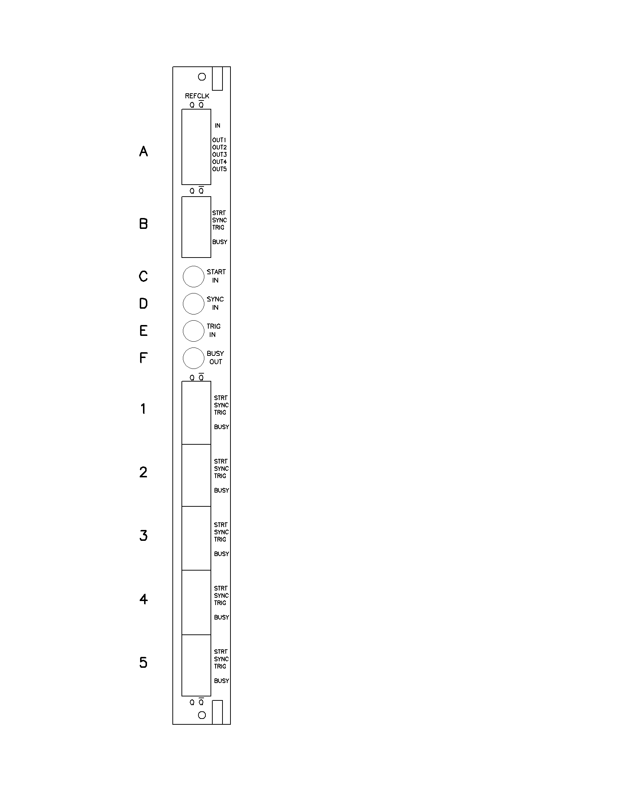
Figure 1. Front panel layout
Module Registers

The module is programmed by the user through VMEbus protocols (ANSI/IEEE STD1014-1987). The device meets all VMEbus standards. The module is categorized as an A16-D16 VME64x slave. All storage locations can be accessed as both Short Supervisory and Short Non-privileged data.

The base address (A15 – A4) is selected by DIP switches on the board. An open switch element represents a ‘1’. The module occupies 16 bytes of VME address space organized in eight 2-byte registers. Two registers are currently defined. The remaining space is reserved for testing and future use.

1. CONTROL/STATUS REGISTER (CSR) [addr = 0]

(0) CLOCK SELECT (R/W) – ‘0’ = external, ‘1’ = internal.

(1) SYNC_RESET SELECT (R/W) – ‘0’ = external, ‘1’ = internal.

(2) – (6) – not used (read as ‘0’)

(7) BUSY STATUS (R) – state of the BUSY output of the module (‘1’ = BUSY asserted = ‘OR’ of all connected F1TDC modules).

(8) – (15) – not used (read as ‘1’).

2. CONTRL (CTRL) (Write only) [addr = 2]

(0) INITIALIZE (W) – writing a ‘1’ to this bit resets the board to the power-up state.

(1) PULSE SYNC_RESET (W) – writing a ‘1’ to this bit generates a pulse on the SYNC_RESET outputs if CSR(1) = 1.

(2) – (15) – not used.

Notes: (1) Power-up / initialize state: CSR = 0.
(CSR = 0 => use external CLOCK and external SYNC_RESET inputs.)

