16-Channel Discriminator/Scaler VME Module

Revision D

Jefferson Lab
Fast Electronics Group
Feb 11th, 2011

Overview

The 16-Channel Discriminator/Scaler Board contains 16 non-updating dual-threshold discriminators, programmable digital delays, and two 32-bit scalers per discriminator and threshold. The discriminator pulses are output as differential ECL logic levels through two front-panel headers. One group of outputs will connect to a TDC and the other group can be used as input to trigger logic. Both TDC and trigger output channels can individually be enabled/disabled with outputs widths and delays being user programmable. All programming is done through VME registers.

All discriminators and logic reside on a 6U VME64x mainboard. Each channel contains two analog receiver fast comparators (discriminator), and pulsers. Each discriminator channel has 2 programmable thresholds which can be programmed from VME. The output pulse width is also programmable from VME, but is common to the TDC and trigger discriminator channels separately. The TDC output is driven from the discriminator channel and not routed through the FPGA to minimize jitter and delays. The trigger (TRG) output is the second threshold per discriminator and is routed through the FPGA. The TRG output can be individually delayed in 4ns steps up to 1020ns and the pulse reshaped in the FPGA to provide a 4 to 1024ns pulse width. A TRG output delay setting of zero bypasses delay and pulse reshaping logic. The TRG output of the discriminator can also select which discriminator threshold source to use in the case a single threshold is desired for the TDC and TRG outputs.

Each discriminator output pulse is recorded by two 32 bit counters (scaler). For each channel an external gate (NIM) is applied to one scaler while the other scaler is free running. Scalers can be latched, read, and cleared through VME. There is a “OR” (NIM level) ouput that is the logical OR of all the unmasked discriminator outputs.

Discriminator outputs are provided as dECL levels on the front panel for interfacing with TDCs and trigger logic.

The VME64x interface is A32/A24/D32/D64/BLT32/BLT64/2eVME/2eSST with support for interrupts.

Table of Contents
Overview 1
Discriminator/Scaler Block Diagram 3
Specifications 4-5
PCB Overview 6
Front Panel 7
VME Accessible Registers 8
Module Performance 27
Signal Jitter 27
Slew Rate Dispersion 27
Channel Isolation 28
Maximum Rate 28
Scaler Event Readout 29
Firmware Revision History 33
- Discriminator/Scaler Block Diagram

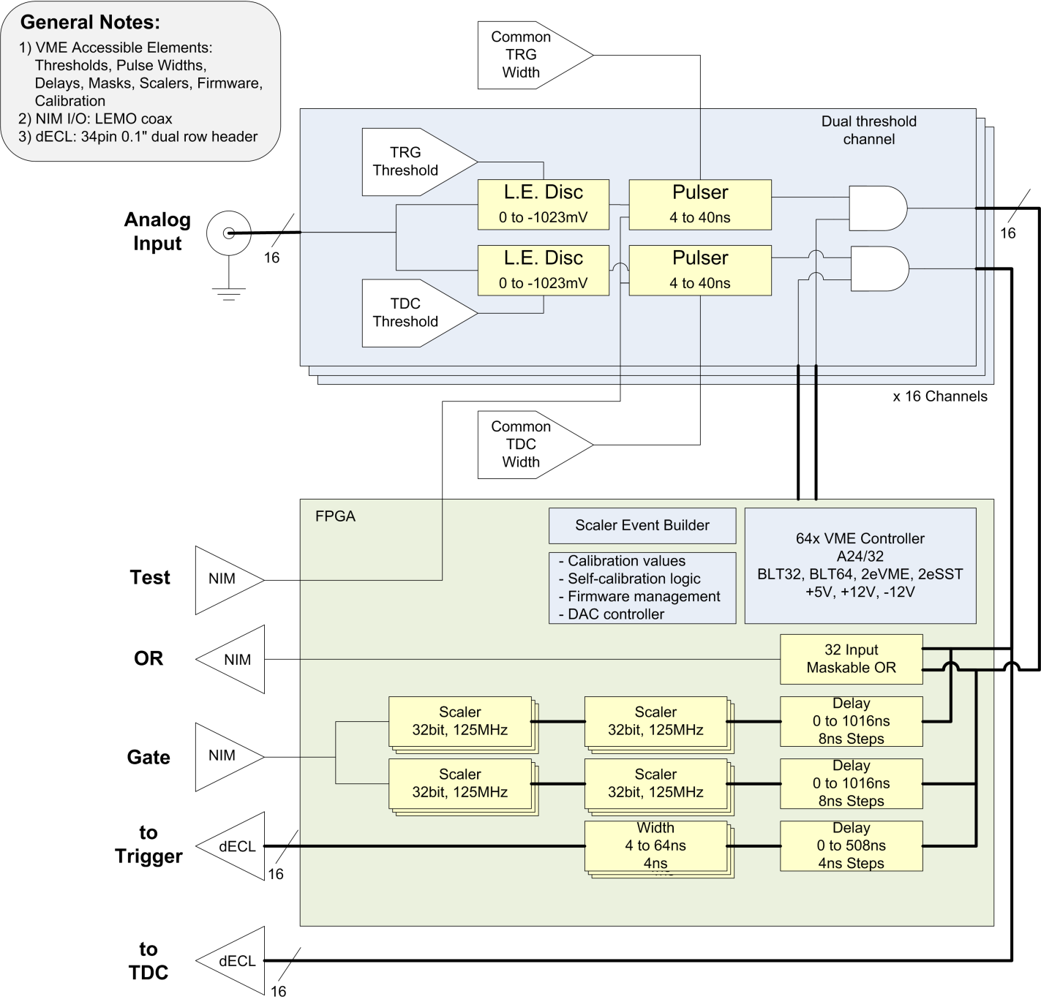
Delay
0 to 1020ns
4ns step
Delay
0 to 1020ns
4ns step
Delay
0 to 1020ns
4ns step
Width
4 to 1024ns
4ns step

Note: due to FPGA firmware updates, the above block diagram may not fully reflect all of the available functionality of the module. See the register description section below for updated details.

- Specifications

General | Spec
Power consumption | +/-12v, 500mA; +5v, 5.0A (30W typ.)
Fuses | +/-12v, 1.0A; +5v, 10.0A
Dimensions | 6U VME, Single-wide; 160mm card depth
Front Panel I/O | Input Signals: 16 LEMO  Gate Input: 1 LEMO  Test Input: 1 LEMO  Dual dECL Output: 2x34 Header  OR Output: 1 LEMO
Onboard connectors | JTAG: 2x7pin 2mm Xilinx
LEDs | Green: VME Activity/Power  Yellow: TDC Discriminator OR  Red: TRG Discriminator OR
Analog Inputs | From PMT or coaxial detector signals
Channels | 16
Signal Level | +/-1.5v, DC-coupled, clamped
Termination | 50ohm
Gate Input | Gates scalers (NIM, 50ohm termination jumper selectable)
Test Input | Pulses Discriminator Outputs (NIM, 50ohm termination jumper selectable)
OR Output | 1 (NIM)
Discriminator Channels
Dual threshold control | 0 to -1023mV Threshold  (for each TDC and TRG output)
Pulser | Non-updating
Pulser Width control | 4ns to 40ns width +/-1ns accuracy
Pulser dead-time | ~4ns w/8ns Pulse Width, ~10ns w/40ns Pulse Width
Maximum rate | 80MHz w/8ns pulse setting
Channel-Channel Crosstalk | >65dB Isolation
Input Hysteresis | ~5mV
Input Noise band | <2mV RMS, 1.3mV RMS typ.
Offset Error | <3mV max, <1mV typ.
dECL Outputs
Channels | Dual 16 channel output
Connector | 34pin header in LeCroy ECL format
1st group of 16 (TDC output) | Fast discriminator output
 | Common pulser width: 4 to 40ns
 | Programmable mask register
2nd group of 16 (TRG output) | Common pulser width 4 to 40ns  Individual digital reshaped pulse width 4ns to 1us  Individual digital delay: 4ns to 1us
 | Programmable mask register
Channel Threshold Control | 10bit 1mV step (0 to -1023mV, +2048mV to -2047mV with firmware update)
Digital Delays | Trigger Out | Scaler/Gate
Delay step size | 4ns | 8ns
Delay range | 0 to 1020ns | 0 to 4086ns
Uncertainty | 4ns | 8ns
Input/Gate timing alignment | With 20ns
Scalers
Quantity | 2 per threshold
Width | 32bit
Input source | Digital delay
Gating | External, internal, & free run scalers
Maximum Count rate | 125MHz
Readout dead-time | None
Control | VME latch, read, clear, overflow, event build
VME Interface
Protocols | A32/A24,D32/D64/BLT32/BLT64/2eVME/2eSST
Address space | 64kbyte
Misc
EEPROM | 2Mbyte
Firmware Upgradable | Using VME
Delays
Input -> TDC Output | <6ns, <4.5ns typ.
Input-> TRG Output | 15ns typ.

- PCB Overview

FR406 substrate, 1/16” Thickness, 8 Layers (4 signal, 4 plane)
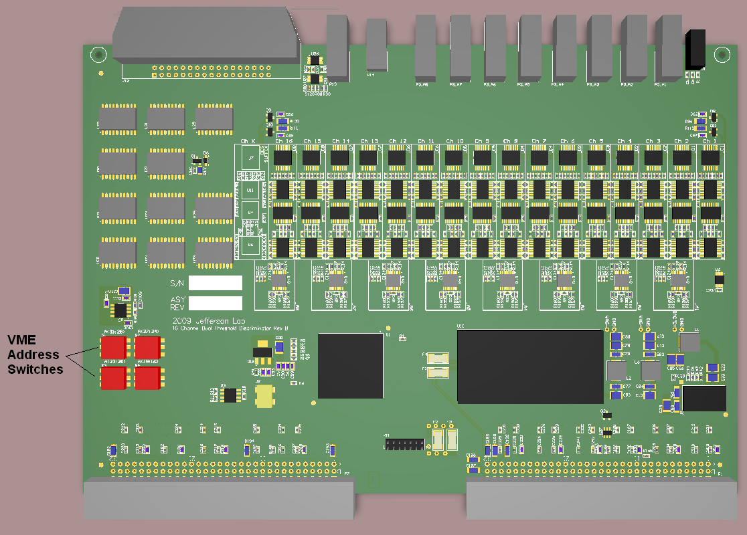

Front Panel | dECL Output Connector J1  (To TDC)  Pin Function Pin Function  1 Ch 1 + 2 Ch 1 -  3 Ch 2 + 4 Ch 2 -  5 Ch 3 + 6 Ch 3 -  7 Ch 4 + 80 Ch 4 -  9 Ch 5 + 10 Ch 5 -  11 Ch 6 + 12 Ch 6 -  13 Ch 7 + 14 Ch 7 -  15 Ch 8 + 16 Ch 8 -  17 Ch 9 + 18 Ch 9 -  19 Ch 10 + 20 Ch 10 -  21 Ch 11 + 22 Ch 11 -  23 Ch 12 + 24 Ch 12 -  25 Ch 13 + 26 Ch 13 -  27 Ch 14 + 28 Ch 14 -  29 Ch 15 + 30 Ch 15 -  31 Ch 16 + 32 Ch 16 -  33 No Connect 34 No Connect  dECL Output Connector J2  (To Trigger Input)  Pin Function Pin Function  1 Ch 1 + 2 Ch 1 -  3 Ch 2 + 4 Ch 2 -  5 Ch 3 + 6 Ch 3 -  7 Ch 4 + 80 Ch 4 -  9 Ch 5 + 10 Ch 5 -  11 Ch 6 + 12 Ch 6 -  13 Ch 7 + 14 Ch 7 -  15 Ch 8 + 16 Ch 8 -  17 Ch 9 + 18 Ch 9 -  19 Ch 10 + 20 Ch 10 -  21 Ch 11 + 22 Ch 11 -  23 Ch 12 + 24 Ch 12 -  25 Ch 13 + 26 Ch 13 -  27 Ch 14 + 28 Ch 14 -  29 Ch 15 + 30 Ch 15 -  31 Ch 16 + 32 Ch 16 -  33 No Connect 34 No Connect
- VME Accessible Registers

All discriminator board registers can be accessed through the VME bus in the following modes:
- A24: single cycle accesses
- 32bit aligned read or write access (register specific)

Event readout can be access through the VME bus in the following modes:
- A32: single cycle, BLT, MBLT, 2eVME, 2eSST
- Note: transfer rate for 2eSST is 200MB/s

Register Summary:
Register | Description: | Address Offset-Range:
A_THRESHOLD_CH0 | Threshold Control Ch0 | 0x0000
… | Threshold Control ChX | …
A_THRESHOLD_CH15 | Threshold Control Ch15 | 0x003C
A_TRGOUT_CH0 | Trigger Out Control Ch0 | 0x0040
… | Trigger Out Control ChX | …
A_TRGOUT_CH15 | Trigger Out Control Ch15 | 0x007C
A_PULSEWIDTH | Pulse Width Control | 0x0080
A_CH_ENABLE | Channel Control | 0x0088
A_OR_MASK | OR Output Control | 0x008C
A_DELAY | Input/Output Delays | 0x0090
A_TEST | Test Input Control | 0x0094
A_SCALER_LATCH_GRP1 | Group 1 Scaler Latch | 0x009C
A_SCALER_LATCH_GRP2 | Group 2 Scaler Latch | 0x0098
A_SCALER_GATE_GRP1 | Group 1 Scaler Gate Control | 0x00BC
A_SCALER_GATE_GRP2 | Group 2 Scaler Gate Control | 0x00B8
A_ADR32 | A32 VME Base Address | 0x00A4
A_INTERRUPT | VME Interrupt Control | 0x00A8
A_INTERRUPT_ACK | VME Interrupt Ack | 0x00AC
A_GEO | VME Geographic Address | 0x00B0
A_IO | Input/Output Control/Status | 0x00B4
A_PULSER_PERIOD | Pulser Period Ticks | 0x00C0
A_PULSER_LOW | Pulser Low Ticks | 0x00C4
A_PULSER_NPULSES | Pulser Pulse Count | 0x00C8
A_PULSER_START | Pulser Start | 0x00CC
A_PULSER_STATUS | Pulser Status | 0x00D0
A_SERIAL_NUM | Assembly Serial Number | 0x0408
A_SERIAL_MFG | Assembly Manufacturer | 0x040C
A_TRG_SCALER_GRP1_CH0 | Group 1 Trigger Scaler Ch0 | 0x0100
… | Group 1 Trigger Scaler ChX | …
A_TRG_SCALER_ GRP1_CH15 | Group 1 Trigger Scaler Ch15 | 0x013C
A_TDC_SCALER_GRP1_CH0 | Group 1 TDC Scaler Ch0 | 0x0140
… | Group 1 TDC Scaler ChX | …
A_TDC_SCALER_GRP1_CH15 | Group 1 TDC Scaler Ch15 | 0x017C
A_TRG_SCALER_GRP2_CH0 | Group 2 Trigger Scaler Ch0 | 0x0180
… | Group 2 Trigger Scaler ChX | …
A_TRG_SCALER_GRP2_CH15 | Group 2 Trigger Scaler Ch15 | 0x01BC
A_TDC_SCALER_GRP2_CH0 | Group 2 TDC Scaler Ch0 | 0x01C0
… | Group 2 TDC Scaler ChX | …
A_TDC_SCALER_GRP2_CH15 | Group 2 TDC Scaler Ch15 | 0x01FC
A_REF_SCALER_GRP1 | Group 1 Ref Scaler | 0x0204
A_REF_SCALER_GRP2 | Group 2 Ref Scaler | 0x0200
A_FIRMWARE_REV | Firmware Revision | 0x0400
A_BOARDID | Board Identifier | 0x0404
A_READOUT_CLEAR | Clear Event Builder FIFO | 0x0500
A_READOUT_START | Trigger Event Builder | 0x0504
A_READOUT_CFG | Event Builder Config | 0x0508
A_READOUT_PULSER | Event Builder Pulser | 0x050C
A_MEM_ARRAY | Embedded CPU Shared Memory | 0x8000-0x87FF
A_MEM_EXECUTE | Notify Embedded CPU | 0x9000

Analog Discriminator Control Registers

The 16 analog front panel inputs are fed into individual discriminator/pulser circuits as shown in the following figure. The registers are shown that control the features of these channels. Note that the TDC pulse width and TRG pulse width is common to all channels of the discriminator board, while all thresholds and enable masks are individually controllable for each channel.

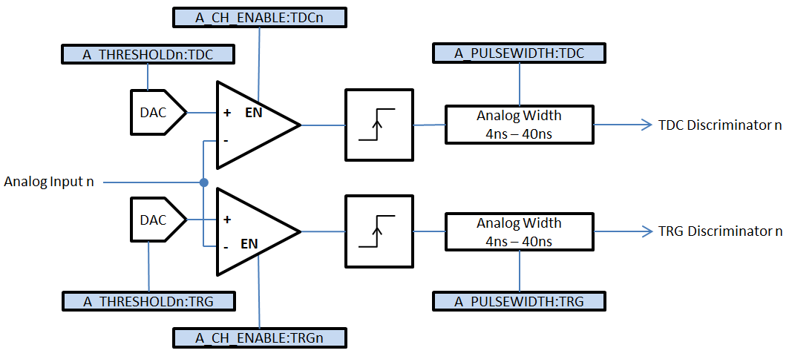

Register: A_THREHOLD_CH0 -> A_THRESHOLD_CH15
Address Offset: 0x0000, 0x0004, …0x003C
Size: 32bits
Reset State: 0x03FF000A
31 | 30 | 29 | 28 | 27 | 26 | 25 | 24
- | - | - | - | - | - | TRG Threshold
23 | 22 | 21 | 20 | 19 | 18 | 17 | 16
TRG Threshold
15 | 14 | 13 | 12 | 11 | 10 | 9 | 8
- | - | - | - | - | - | TDC Threshold
7 | 6 | 5 | 4 | 3 | 2 | 1 | 0
TDC Threshold

TDC Threshold (R/W):
TDC CHx Threshold (in -1mV units)
TRG Threshold (R/W):
TRG CHx Threshold (in -1mV units)
Notes:
- TRG threshold should be >25mV above TDC threshold (for same channel) to avoid introducing jitter onto timing sensitive TDC comparator. If same threshold for both outputs are desired, see A_TRGOUT_CHx registers to route TDC output to TRGOUT signals and set TRG thresholds out of range so they do not fire.

Register: A_PULSEWIDTH
Address Offset: 0x0080
Size: 32bits
Reset State: 0x00280028
31 | 30 | 29 | 28 | 27 | 26 | 25 | 24
- | - | - | - | - | - | - | -
23 | 22 | 21 | 20 | 19 | 18 | 17 | 16
- | - | TRG Pulser Width
15 | 14 | 13 | 12 | 11 | 10 | 9 | 8
- | - | - | - | - | - | - | -
7 | 6 | 5 | 4 | 3 | 2 | 1 | 0
- | - | TDC Pulser Width

TDC Pulser Width (R/W):
Controls pulser width (in units ns) for all TDC channels. Will be calibrated from 4ns to 40ns (~1ns accuracy). Values outside this range are not guaranteed to be calibrated.
TRG Pulser Width (R/W):
Controls pulser width (in units ns) for all TRG channels. Will be calibrated from 4ns to 40ns (~1ns accuracy). Values outside this range are not guaranteed to work.

Register: A_CH_ENABLE
Address Offset: 0x0088
Size: 32bits
Reset State: 0xFFFFFFFF
31 | 30 | 29 | 28 | 27 | 26 | 25 | 24
TRG15EN | TRG14EN | TRG13EN | TRG12EN | TRG11EN | TRG10EN | TRG9EN | TRG8EN
23 | 22 | 21 | 20 | 19 | 18 | 17 | 16
TRG7EN | TRG6EN | TRG5EN | TRG4EN | TRG3EN | TRG2EN | TRG1EN | TRG0EN
15 | 14 | 13 | 12 | 11 | 10 | 9 | 8
TDC15EN | TDC14EN | TDC13EN | TDC12EN | TDC11EN | TDC10EN | TDC9EN | TDC8EN
7 | 6 | 5 | 4 | 3 | 2 | 1 | 0
TDC7EN | TDC6EN | TDC5EN | TDC4EN | TDC3EN | TDC2EN | TDC1EN | TDC0EN

TDCENx (R/W):
‘0’ – TDC channel x disabled
‘1’ – TDC channel x enabled
TRGENx (R/W):
‘0’ – TRG channel x disabled
‘1’ – TRG channel x enabled
Notes:
- A disabled TDC or TRG channel will prevent discriminator comparator and pulser from firing by using out of range thresholds.

Trigger Output Control Registers

There are 32 ECL outputs from the discriminator. The first 16 are grouped into 1 connector and are directly fed from the TDC threshold discriminators. These 16 TDC outputs are only programmable at the discriminator channel level (threshold, enable mask, analog formed pulse width). The second group of 16 channels come from the FPGA and has several programmable features as outlined in the following figure. Each bit of the 16 channel output corresponds to a specific discriminator channel (TRG Output bit ‘n’ comes from Discriminator channel ‘n’). The TRG output can select which discriminator threshold to use: TRG or TDC. The selected source can then be fed directly to the TRG output to minimize jitter and delay. Alternatively the selected source can pass through a digital pulse width block and digital delay block. By passing through the digital width/delay sections a ~4ns jitter and additional propagation delay are added to the TRG output. Each of the 16bits are separately controllable.

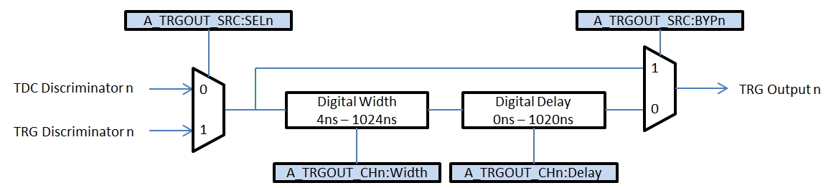

Register: A_TRGOUT_CH0 -> A_ TRGOUT _CH15
Address Offset: 0x0040, 0x0044, …0x007C
Size: 32bits
Reset State: 0x03FF000A
31 | 30 | 29 | 28 | 27 | 26 | 25 | 24
- | - | - | - | - | - | - | -
23 | 22 | 21 | 20 | 19 | 18 | 17 | 16
- | - | - | - | - | - | - | -
15 | 14 | 13 | 12 | 11 | 10 | 9 | 8
TRGOUT Width
7 | 6 | 5 | 4 | 3 | 2 | 1 | 0
TRGOUT Delay

TRGOUT Width (R/W):
Pulse width in 4ns steps (0-255): width = 4ns * (TRGOUTWidth+1)
TRGOUT Delay (R/W):
Pulse delay in 4ns steps (0-255): delay = 4ns * (TRGOUTDelay)
Notes:
- A_TRGOUT_SRC register allows option to bypass the width reshaping & delay elements. In this case, the pulse width will be defined by A_PULSEWIDTH register and the delay will be as fast as possible (<15ns)

Register: A_TRGOUT_SRC

Address Offset: 0x00A0
Size: 32bits
Reset State: 0x0000FFFF
31 | 30 | 29 | 28 | 27 | 26 | 25 | 24
BYP15 | BYP14 | BYP13 | BYP12 | BYP11 | BYP10 | BYP9 | BYP8
23 | 22 | 21 | 20 | 19 | 18 | 17 | 16
BYP7 | BYP6 | BYP5 | BYP4 | BYP3 | BYP2 | BYP1 | BYP0
15 | 14 | 13 | 12 | 11 | 10 | 9 | 8
SEL15 | SEL14 | SEL13 | SEL12 | SEL11 | SEL10 | SEL9 | SEL8
7 | 6 | 5 | 4 | 3 | 2 | 1 | 0
SEL7 | SEL6 | SEL5 | SEL4 | SEL3 | SEL2 | SEL1 | SEL0

BYPx (R/W):
‘0’ – Delay and pulse width reshaper for TRGOUT channel x defined by A_TRGOUT_CHx
‘1’ – Bypasses delay and pulse width reshaper for TRGOUT channel x
SELx (R/W):
‘0’ – Select TDC threshold for TRGOUT source
‘1’ – Select TRG threshold for TRGOUT source

Register: A_OR_MASK
Address Offset: 0x008C
Size: 32bits
Reset State: 0xFFFFFFFF
31 | 30 | 29 | 28 | 27 | 26 | 25 | 24
TRG15EN | TRG14EN | TRG13EN | TRG12EN | TRG11EN | TRG10EN | TRG9EN | TRG8EN
23 | 22 | 21 | 20 | 19 | 18 | 17 | 16
TRG7EN | TRG6EN | TRG5EN | TRG4EN | TRG3EN | TRG2EN | TRG1EN | TRG0EN
15 | 14 | 13 | 12 | 11 | 10 | 9 | 8
TDC15EN | TDC14EN | TDC13EN | TDC12EN | TDC11EN | TDC10EN | TDC9EN | TDC8EN
7 | 6 | 5 | 4 | 3 | 2 | 1 | 0
TDC7EN | TDC6EN | TDC5EN | TDC4EN | TDC3EN | TDC2EN | TDC1EN | TDC0EN

TDCxEN (R/W):
‘0’ – TDC channel x not used in front-panel OR output
‘1’ – TDC channel x used in front-panel OR output
TRGxEN (R/W):
‘0’ – TRG channel x not used in front-panel OR output
‘1’ – TRG channel x used in front-panel OR output
Notes:
- All TDC channels enabled in the above MASK are used to display the TDC front-panel LED
- All TRG channels enabled in the above MASK are used to display the TRG front-panel LED

Register: A_DELAY
Address Offset: 0x0090
Size: 32bits
Reset State: 0x00080008
31 | 30 | 29 | 28 | 27 | 26 | 25 | 24
- | - | - | - | - | - | ScalerDelayGrp2
23 | 22 | 21 | 20 | 19 | 18 | 17 | 16
ScalerDelayGrp2
15 | 14 | 13 | 12 | 11 | 10 | 9 | 8
- | - | - | - | - | - | ScalerDelayGrp1
7 | 6 | 5 | 4 | 3 | 2 | 1 | 0
ScalerDelayGrp1

ScalerDelayGrp1 (R/W):
Discriminator input delays for scaler group 1. 0-1023 count (in 8ns ticks)

ScalerDelayGrp2 (R/W):
Discriminator input delays for scaler group 2. 0-1023 count (in 8ns ticks)

Register: A_TEST
Address Offset: 0x0094
Size: 32bits
Reset State: 0x00000001
31 | 30 | 29 | 28 | 27 | 26 | 25 | 24
TEST | - | - | - | - | - | - | -
23 | 22 | 21 | 20 | 19 | 18 | 17 | 16
- | - | - | - | - | - | - | -
15 | 14 | 13 | 12 | 11 | 10 | 9 | 8
- | - | - | - | - | - | - | -
7 | 6 | 5 | 4 | 3 | 2 | 1 | 0
- | - | - | - | - | - | TestSrc

TEST (WO):
‘0’ – Does nothing
‘1’ – Software test pulse is sent
TestSrc (R/W):
bit 0: ‘1’ – routes front-panel IN1 to test input of discriminator channels
bit 1: ‘1’ – routes front-panel IN2 to test input of discriminator channels
Notes:
- When front-panel IN1 or IN2 is enabled, a NIM logic level ‘1’ must be supplied to front-panel test input signal to test fire the discriminator channels.

Register: A_SCALER_GRP1_LATCH
Address Offset: 0x009C
Size: 32bits
Reset State: 0xXXXXXXXX
31 | 30 | 29 | 28 | 27 | 26 | 25 | 24
SCALER_GRP1_LATCH
23 | 22 | 21 | 20 | 19 | 18 | 17 | 16
SCALER_GRP1_LATCH
15 | 14 | 13 | 12 | 11 | 10 | 9 | 8
SCALER_GRP1_LATCH
7 | 6 | 5 | 4 | 3 | 2 | 1 | 0
SCALER_GRP1_LATCH

SCALER_GRP1_LATCH (WO):
Write any value to latch scaler group 1.
Notes:
- After latching scalers for readout, hardware scalers will be reset.

Register: A_SCALER_GRP2_LATCH
Address Offset: 0x0098
Size: 32bits
Reset State: 0xXXXXXXXX
31 | 30 | 29 | 28 | 27 | 26 | 25 | 24
SCALER_GRP2_LATCH
23 | 22 | 21 | 20 | 19 | 18 | 17 | 16
SCALER_GRP2_LATCH
15 | 14 | 13 | 12 | 11 | 10 | 9 | 8
SCALER_GRP2_LATCH
7 | 6 | 5 | 4 | 3 | 2 | 1 | 0
SCALER_GRP2_LATCH

SCALER_GRP2_LATCH (WO):
Write any value to latch scaler group 2.
Notes:
- After latching scalers for readout, hardware scalers will be reset.

Register: A_SCALER_GATE_GRP1
Address Offset: 0x00BC
Size: 32bits
Reset State: 0x00000004
31 | 30 | 29 | 28 | 27 | 26 | 25 | 24
- | - | - | - | - | - | - | -
23 | 22 | 21 | 20 | 19 | 18 | 17 | 16
- | - | - | - | - | - | - | -
15 | 14 | 13 | 12 | 11 | 10 | 9 | 8
- | - | - | - | - | - | - | -
7 | 6 | 5 | 4 | 3 | 2 | 1 | 0
- | - | - | - | GateSrc

GateSrc (R/W):
bit 0: ‘1’ – routes front-panel IN1 to gate for scaler group 1
bit 1: ‘1’ – routes front-panel IN2 to gate for scaler group 1
bit 2: ‘1’ – routes constant ‘1’ to gate for scaler group 1
bit 3: ‘1’ – routes pulser output to gate for scaler group 1

Register: A_SCALER_GATE_GRP2
Address Offset: 0x00B8
Size: 32bits
Reset State: 0x00000002
31 | 30 | 29 | 28 | 27 | 26 | 25 | 24
- | - | - | - | - | - | - | -
23 | 22 | 21 | 20 | 19 | 18 | 17 | 16
- | - | - | - | - | - | - | -
15 | 14 | 13 | 12 | 11 | 10 | 9 | 8
- | - | - | - | - | - | - | -
7 | 6 | 5 | 4 | 3 | 2 | 1 | 0
- | - | - | - | GateSrc

GateSrc (R/W):
bit 0: ‘1’ – routes front-panel IN1 to gate for scaler group 2
bit 1: ‘1’ – routes front-panel IN2 to gate for scaler group 2
bit 2: ‘1’ – routes constant ‘1’ to gate for scaler group 2
bit 3: ‘1’ – routes pulser output to gate for scaler group 2

Register: A_READOUT_CLEAR
Address Offset: 0x0500
Size: 32bits
Reset State: 0xXXXXXXXX
31 | 30 | 29 | 28 | 27 | 26 | 25 | 24
READOUT_CLEAR
23 | 22 | 21 | 20 | 19 | 18 | 17 | 16
READOUT_CLEAR
15 | 14 | 13 | 12 | 11 | 10 | 9 | 8
READOUT_CLEAR
7 | 6 | 5 | 4 | 3 | 2 | 1 | 0
READOUT_CLEAR

READOUT_CLEAR (WO):
Write any value to clear event building FIFO.

Register: A_READOUT_START
Address Offset: 0x0504
Size: 32bits
Reset State: 0xXXX0XX00
31 | 30 | 29 | 28 | 27 | 26 | 25 | 24
SWTRG | - | - | - | - | - | - | -
23 | 22 | 21 | 20 | 19 | 18 | 17 | 16
- | - | - | - | BUILDER_TRG_SRC
15 | 14 | 13 | 12 | 11 | 10 | 9 | 8
- | - | - | - | - | - | - | -
7 | 6 | 5 | 4 | 3 | 2 | 1 | 0
BUILDER_FLAG

BUILDER_FLAG (R/W):
bit 7: ‘1’ - latch scaler group 1 for event build. ‘0’ - do nothing.
bit 6: ‘1’ - latch scaler group 2 for event build. ‘0’ - do nothing.
bit 5: ‘1’ - write reference scaler group 2 for event build. ‘0’ - do nothing.
bit 4: ‘1’ - write reference scaler group 1 for event build. ‘0’ - do nothing.
bit 3: ‘1’ - write TDC scaler group 2 for event build. ‘0’ - do nothing.
bit 2: ‘1’ - write TRG scaler group 2 for event build. ‘0’ - do nothing.
bit 1: ‘1’ - write TDC scaler group 1 for event build. ‘0’ - do nothing.
bit 0: ‘1’ - write TRG scaler group 1 for event build. ‘0’ - do nothing.
BUILDER_TRG_SRC (R/W):
bit 3: ‘1’ - enables internal pulser roll-over as a trigger source
bit 2: ‘1’ - enables SWTRG VME as a trigger source
bit 1: ‘1’ - enables front-panel IN2 as a trigger source
bit 0: ‘1’ - enables front-panel IN1 as a trigger source
SWTRG (WO):
‘1’ – generates software trigger
‘0’ – do nothing
Notes:
- When trigger edge occurs, the scaler event builder executes and fills the readout FIFO with a scaler event as defined by the BUILDER_FLAG field

Register: A_PULSER_PERIOD
Address Offset: 0x00C0
Size: 32bits
Reset State: 0x 00000000
31 | 30 | 29 | 28 | 27 | 26 | 25 | 24
PULSER_PERIOD
23 | 22 | 21 | 20 | 19 | 18 | 17 | 16
PULSER_PERIOD
15 | 14 | 13 | 12 | 11 | 10 | 9 | 8
PULSER_PERIOD
7 | 6 | 5 | 4 | 3 | 2 | 1 | 0
PULSER_PERIOD

PULSER_PERIOD (R/W):
Range: 0 – 4294967295 cycles.
This pulser increments every 20 ns.

Register: A_PULSER_HIGH
Address Offset: 0x00C4
Size: 32bits
Reset State: 0x 00000000
31 | 30 | 29 | 28 | 27 | 26 | 25 | 24
PULSER_HIGH
23 | 22 | 21 | 20 | 19 | 18 | 17 | 16
PULSER_HIGH
15 | 14 | 13 | 12 | 11 | 10 | 9 | 8
PULSER_HIGH
7 | 6 | 5 | 4 | 3 | 2 | 1 | 0
PULSER_HIGH

PULSER_HIGH (R/W):
Range: 0 – 4294967295 cycles.
While pulser counter is <= PULSER_HIGH the output of the pulser is logic ‘1’, else ‘0’

Register: A_PULSER_NPULSES
Address Offset: 0x00C8
Size: 32bits
Reset State: 0x 00000000
31 | 30 | 29 | 28 | 27 | 26 | 25 | 24
PULSER_NPULSES
23 | 22 | 21 | 20 | 19 | 18 | 17 | 16
PULSER_NPULSES
15 | 14 | 13 | 12 | 11 | 10 | 9 | 8
PULSER_NPULSES
7 | 6 | 5 | 4 | 3 | 2 | 1 | 0
PULSER_NPULSES

PULSER_NPULSES (R/W):
0: Disables pulser
1-4294967294: Pulser will fire for this number of pulses after A_PULSER_START is written
4294967295: Pulser enable for continuous operation (NPULSES will be infinite)

Register: A_PULSER_START
Address Offset: 0x00CC
Size: 32bits
Reset State: 0x 00000000
31 | 30 | 29 | 28 | 27 | 26 | 25 | 24
PULSER_START
23 | 22 | 21 | 20 | 19 | 18 | 17 | 16
PULSER_START
15 | 14 | 13 | 12 | 11 | 10 | 9 | 8
PULSER_START
7 | 6 | 5 | 4 | 3 | 2 | 1 | 0
PULSER_START

PULSER_START (WO):
Writing any value will start pulser operation if A_PULSER_NPULSES is operating in finite pulse count mode.

Register: A_PULSER_STATUS
Address Offset: 0x00D0
Size: 32bits
Reset State: 0x 00000000
31 | 30 | 29 | 28 | 27 | 26 | 25 | 24
- | - | - | - | - | - | - | -
23 | 22 | 21 | 20 | 19 | 18 | 17 | 16
- | - | - | - | - | - | - | -
15 | 14 | 13 | 12 | 11 | 10 | 9 | 8
- | - | - | - | - | - | - | -
7 | 6 | 5 | 4 | 3 | 2 | 1 | 0
- | - | - | - | - | - | - | STATUS

STATUS (RO):
‘1’ indicates pulser is not active
‘0’ indicates pulser is active. This can be used to check when NPULSES have been delivered after START has been issued running in finite pulse mode.

Register: A_READOUT_CFG
Address Offset: 0x0508
Size: 32bits
Reset State: 0x0001FFFE
31 | 30 | 29 | 28 | 27 | 26 | 25 | 24
EVT_NUM
23 | 22 | 21 | 20 | 19 | 18 | 17 | 16
EVT_NUM_INT_LEVEL
15 | 14 | 13 | 12 | 11 | 10 | 9 | 8
EVT_WORD_INT_LEVEL
7 | 6 | 5 | 4 | 3 | 2 | 1 | 0
EVT_WORD_INT_LEVEL |  |  |  |  |  |  | BERREN

EVT_NUM (RO):
Indicates the number of built events residing in the FIFO ready for readout.
EVT_WORD_INT_LEVEL (R/W):
Range: 0 to 16383. Sets the 32bit word interrupt threshold for the event builder. If the number of 32bit event words inside the event builder FIFO is greater-than or equal to this value an interrupt will be generated if enabled by the A_INTERRUPT register.
EVT_NUM_INT_LEVEL (R/W):
Range: 0 to 255. Sets the event count interrupt threshold for the event builder. If the number of events inside the event builder FIFO is greater-than or equal to this value an interrupt will be generated if enabled by the A_INTERRUPT register.
BERREN (R/W):
‘0’ – disable VME bus error assertion for end-of-event signaling (user must know event size or parse readout contents to ensure event synchronization/alignment)
‘1’ – enables VME bus error assertion for end-of-event signaling

Register: A_ADR32
Address Offset: 0x00A4
Size: 32bits
Reset State: 0xXXXXXXX0
31 | 30 | 29 | 28 | 27 | 26 | 25 | 24
- | - | - | - | - | - | - | -
23 | 22 | 21 | 20 | 19 | 18 | 17 | 16
- | - | - | - | - | - | - | -
15 | 14 | 13 | 12 | 11 | 10 | 9 | 8
A32_BASE
7 | 6 | 5 | 4 | 3 | 2 | 1 | 0
A32_BASE | - | - | - | - | - | - | A32_EN

A32_BASE (R/W):
A32 base address (bits 31:23)
This field is initialized to the dip switch bits 31:24 on VME SYSRESET assertion.
A32_EN (R/W):
‘0’ – disables VME A32 addressing mode
‘1’ – enabled VME A32 addressing mode

Register: A_INTERRUPT
Address Offset: 0x00A8
Size: 32bits
Reset State: 0x00000000
31 | 30 | 29 | 28 | 27 | 26 | 25 | 24
INT_EN | - | - | - | - | - | - | -
23 | 22 | 21 | 20 | 19 | 18 | 17 | 16
- | - | - | - | - | - | - | -
15 | 14 | 13 | 12 | 11 | 10 | 9 | 8
 |  |  |  |  | INT_LEVEL
7 | 6 | 5 | 4 | 3 | 2 | 1 | 0
INT_ID

INT_ID (R/W):
VME bus interrupt ID
INT_LEVEL (R/W):
VME bus interrupt level
INT_EN (R/W):
VME bus interrupt enable

Register: A_INTERRUPT_ACK
Address Offset: 0x00AC
Size: 32bits
Reset State: 0xXXXXXXXX
31 | 30 | 29 | 28 | 27 | 26 | 25 | 24
- | - | - | - | - | - | - | -
23 | 22 | 21 | 20 | 19 | 18 | 17 | 16
- | - | - | - | - | - | - | -
15 | 14 | 13 | 12 | 11 | 10 | 9 | 8
- | - | - | - | - | - | - | -
7 | 6 | 5 | 4 | 3 | 2 | 1 | 0
- | - | - | - | - | - | - | -

Notes:
- Writing to this register will acknowledge any outstanding interrupt. This will allow further interrupt from this module to interrupt on the VME bus if any interrupting condition persists or occurs in the future.

Register: A_GEO
Address Offset: 0x00B0
Size: 32bits
Reset State: 0xXXXXXXXX
31 | 30 | 29 | 28 | 27 | 26 | 25 | 24
VME_ADDR
23 | 22 | 21 | 20 | 19 | 18 | 17 | 16
VME_ADDR
15 | 14 | 13 | 12 | 11 | 10 | 9 | 8
- | - | - | - | - | - | - | -
7 | 6 | 5 | 4 | 3 | 2 | 1 | 0
- | - | - | SLOTID

VME_ADDR (RO):
VME address switch settings. The lower 8 bits form the A24 base address. The upper 8 bits are not used in the firmware, but are available to the user for any purpose desired (for example, the user could read this and set the A32_BASE to this value to use dip switch controlled A32 VME addressing).
SLOTID (RO):
VME geographical addressing slot number. On parity error the value returned is 0x1E.
Notes:
- Geographical addressing is only support when module is used on aVME64X compatibly crate.

Register: A_IO
Address Offset: 0x00B4
Size: 32bits
Reset State: 0xXXXXXXX0
31 | 30 | 29 | 28 | 27 | 26 | 25 | 24
- | - | - | - | - | - | - | -
23 | 22 | 21 | 20 | 19 | 18 | 17 | 16
- | - | - | - | - | - | - | -
15 | 14 | 13 | 12 | 11 | 10 | 9 | 8
- | - | - | - | - | - | - | -
7 | 6 | 5 | 4 | 3 | 2 | 1 | 0
- | - | - | - | - | IN2 | IN1 | OR_OUT

OR_OUT (R/W):
‘0’ – software controlled ‘0’ or’d on OR front panel output
‘1’ - software controlled ‘1’ or’d on OR front panel output
IN1 (RO):
‘0’ – Front panel IN1 is NIM logic low
‘1’ – Front panel IN1 is NIM logic high
IN2 (RO):
‘0’ – Front panel IN2 is NIM logic low
‘1’ – Front panel IN2 is NIM logic high

Register: A_TRG_SCALER_GRP1_CH0 -> A_ TRG_SCALER_GRP1 _CH15
Address Offset: 0x0100, 0x0104, …0x013C
Size: 32bits
Reset State: 0xXXXXXXXX
31 | 30 | 29 | 28 | 27 | 26 | 25 | 24
TRG SCALER
23 | 22 | 21 | 20 | 19 | 18 | 17 | 16
TRG SCALER
15 | 14 | 13 | 12 | 11 | 10 | 9 | 8
TRG SCALER
7 | 6 | 5 | 4 | 3 | 2 | 1 | 0
TRG SCALER

TRG SCALER(RO):
Trigger threshold scaler for CHx.
Belongs to scaler group 1, which uses scaler gate 1 and latch 1 as control sources.
32bit value indicates an overflow when count is saturated (at 0xFFFFFFFF).

Notes:
- A scaler latch must be performed (by writing to register A_SCALER_GRP1_LATCH, or using event builder) to update these registers with current scaler counts

Register: A_TDC_SCALER_GRP1_CH0 -> A_ TDC_SCALER _GRP1_CH15
Address Offset: 0x0140, 0x0144, …0x017C
Size: 32bits
Reset State: 0xXXXXXXXX
31 | 30 | 29 | 28 | 27 | 26 | 25 | 24
TDC SCALER
23 | 22 | 21 | 20 | 19 | 18 | 17 | 16
TDC SCALER
15 | 14 | 13 | 12 | 11 | 10 | 9 | 8
TDC SCALER
7 | 6 | 5 | 4 | 3 | 2 | 1 | 0
TDC SCALER

TDC SCALER(RO):
Trigger threshold scaler for CHx.
Belongs to scaler group 1, which uses scaler gate 1 and latch 1 as control sources.
32bit value indicates an overflow when count is saturated (at 0xFFFFFFFF).
Notes:
- A scaler latch must be performed (by writing to register A_SCALER_GRP1_LATCH, or using event builder) to update these registers with current scaler counts

Register: A_TRG_SCALER_GRP2_CH0 -> A_ TRG_ SCALER _GRP2_CH15
Address Offset: 0x0180, 0x0184, …0x01BC
Size: 32bits
Reset State: 0xXXXXXXXX
31 | 30 | 29 | 28 | 27 | 26 | 25 | 24
TRG SCALER
23 | 22 | 21 | 20 | 19 | 18 | 17 | 16
TRG SCALER
15 | 14 | 13 | 12 | 11 | 10 | 9 | 8
TRG SCALER
7 | 6 | 5 | 4 | 3 | 2 | 1 | 0
TRG SCALER

TRG SCALER(RO):
Trigger threshold scaler for CHx.
Belongs to scaler group 2, which uses scaler gate 2 and latch 2 as control sources.
32bit value indicates an overflow when count is saturated (at 0xFFFFFFFF).

Notes:
- A scaler latch must be performed (by writing to register A_SCALER_GRP2_LATCH, or using event builder) to update these registers with current scaler counts

Register: A_TDC_SCALER_GRP2_CH0 -> A_ TDC_SCALER _GRP2_CH15
Address Offset: 0x01C0, 0x01C4, …0x01FC
Size: 32bits
Reset State: 0xXXXXXXXX
31 | 30 | 29 | 28 | 27 | 26 | 25 | 24
TDC SCALER
23 | 22 | 21 | 20 | 19 | 18 | 17 | 16
TDC SCALER
15 | 14 | 13 | 12 | 11 | 10 | 9 | 8
TDC SCALER
7 | 6 | 5 | 4 | 3 | 2 | 1 | 0
TDC SCALER

TDC SCALER(RO):
Trigger threshold scaler for CHx.
Belongs to scaler group 1, which uses scaler gate 2 and latch 2 as control sources.
32bit value indicates an overflow when count is saturated (at 0xFFFFFFFF).
Notes:
- A scaler latch must be performed (by writing to register A_SCALER_GRP2_LATCH, or using event builder) to update these registers with current scaler counts

Register: A_REF_SCALER_GRP1
Address Offset: 0x0204
Size: 32bits
Reset State: 0xXXXXXXXX
31 | 30 | 29 | 28 | 27 | 26 | 25 | 24
REF SCALER
23 | 22 | 21 | 20 | 19 | 18 | 17 | 16
REF SCALER
15 | 14 | 13 | 12 | 11 | 10 | 9 | 8
REF SCALER
7 | 6 | 5 | 4 | 3 | 2 | 1 | 0
REF SCALER

REF SCALER(RO):
Reference scaler, increments at 125MHz while gate source is high.
Belongs to scaler group 1, which uses scaler gate 1 and latch 1 as control sources.
32bit value indicates an overflow when count is saturated (at 0xFFFFFFFF).
Notes:
- A scaler latch must be performed (by writing to register A_SCALER_GRP1_LATCH, or using event builder) to update these registers with current scaler counts

Register: A_REF_SCALER_GRP2
Address Offset: 0x0200
Size: 32bits
Reset State: 0xXXXXXXXX
31 | 30 | 29 | 28 | 27 | 26 | 25 | 24
REF SCALER
23 | 22 | 21 | 20 | 19 | 18 | 17 | 16
REF SCALER
15 | 14 | 13 | 12 | 11 | 10 | 9 | 8
REF SCALER
7 | 6 | 5 | 4 | 3 | 2 | 1 | 0
REF SCALER

REF SCALER(RO):
Reference scaler, increments at 125MHz while gate source is high.
Belongs to scaler group 2, which uses scaler gate 2 and latch 2 as control sources.
32bit value indicates an overflow when count is saturated (at 0xFFFFFFFF).
Notes:
- A scaler latch must be performed (by writing to register A_SCALER_GRP2_LATCH, or using event builder) to update these registers with current scaler counts

Register: A_FIRMWARE_REV
Address Offset: 0x0400
Size: 32bits
Reset State: 0xXXXXXXXX
31 | 30 |  | 29 |  | 28 |  | 27 |  | 26 |  | 25 |  | 24
- |  | - |  | - |  | - |  | - |  | - |  | -
23 | 22 |  | 21 |  | 20 |  | 19 |  | 18 |  | 17 |  | 16
- |  | - |  | - |  | - |  | - |  | - |  | -
15 | 14 |  | 13 |  | 12 |  | 11 |  | 10 |  | 9 |  | 8
FIRMWARE_REV_MAJOR
7 | 6 |  | 5 |  | 4 |  | 3 |  | 2 |  | 1 |  | 0
FIRMWARE_REV_MINOR

FIRMWARE_REV_MAJOR(RO):
Major firmware revision
FIRMWARE_REV_MINOR(RO):
Minor firmware revision

Register: A_BOARDID
Address Offset: 0x0404
Size: 32bits
Reset State: 0x44534332
31 | 30 | 29 | 28 | 27 | 26 | 25 | 24
BOARD_ID
23 | 22 | 21 | 20 | 19 | 18 | 17 | 16
BOARD_ID
15 | 14 | 13 | 12 | 11 | 10 | 9 | 8
BOARD_ID
7 | 6 | 5 | 4 | 3 | 2 | 1 | 0
BOARD_ID

BOARD_ID(RO):
0x44534332 = “DSC2” in ASCII

Register: A_SERIAL_NUM
Address Offset: 0x0408
Size: 32bits
Reset State: 0x44534332
31 | 30 | 29 | 28 | 27 | 26 | 25 | 24
SERIAL_NUM
23 | 22 | 21 | 20 | 19 | 18 | 17 | 16
SERIAL_NUM
15 | 14 | 13 | 12 | 11 | 10 | 9 | 8
SERIAL_NUM
7 | 6 | 5 | 4 | 3 | 2 | 1 | 0
SERIAL_NUM

SERIAL_NUM(RO):
32bit serial number

Register: A_SERIAL_MFG
Address Offset: 0x040C
Size: 32bits
Reset State: 0x44534332
31 | 30 | 29 | 28 | 27 | 26 | 25 | 24
SERIAL_MFG
23 | 22 | 21 | 20 | 19 | 18 | 17 | 16
SERIAL_MFG
15 | 14 | 13 | 12 | 11 | 10 | 9 | 8
SERIAL_MFG
7 | 6 | 5 | 4 | 3 | 2 | 1 | 0
SERIAL_MFG

SERIAL_MFG (RO):
4 digit ASCII manufacturer ID

Register: A_MEM_ARRAY
Address Offset: 0x8000-0x87FF
Size: 32bits

Notes:
- This memory is reserved for testing, calibration, and firmware upgrade use.

Register: A_MEM_EXECUTE
Address Offset: 0x9000
Size: 32bits

Notes:
- This register is reserved for testing, calibration, and firmware upgrade use.

- Module Performance (Typical)

Measured signal jitter:
Input: 1Vpp, 1MHz square wave with an overdrive from 5mV to 500mV, and slew rate from 10mV/ns to 1000mV/ns. The following plot indicates measured performance.

Measured slew rate dispersion:
356mV, 30ns width negative pulse. Overdrive set to 100mV, edge rate varied from 250mV/ns to 20mV/ns, pulse rate 100Hz. Roughly a 20ps dispersion with respect to slew rate measured.
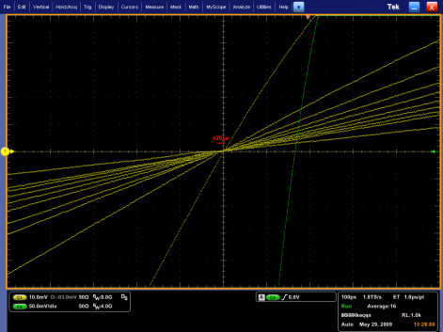
Measured channel isolation:
A 1V edge with slew rate 1V/ns injected into discriminator channel. The pickup measured on adjacent channels was less than 350μV (>69dB channel-channel isolation). Yellow trace below is measured induced voltage on victim channel.

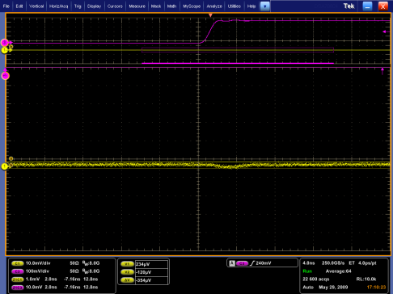

Measured maximum rates:
110MHz Rate w/4ns Output Pulse Width | 80MHz Rate w/8ns Output Pulse Width
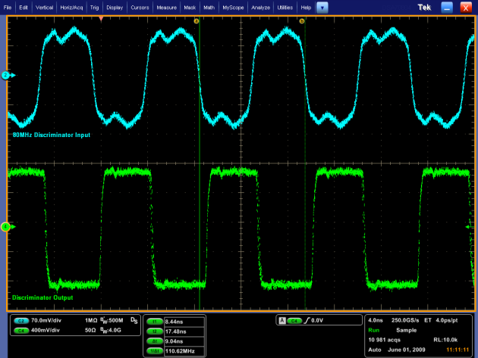 | 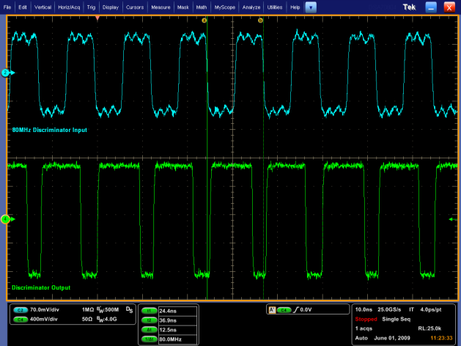

- Scaler Event Readout
Scaler event readout is performed by writing to the A_READOUT_START register with the appropriate flags set according to the user preference and then by generating a trigger from an appropriate source (either software, internal pulser, or external input). Each time a trigger is generated the internal event builder will write to the readout FIFO with the scaler event determined by the flags set. Events can be generated until the readout FIFO not longer contains enough space for a full event to be written. This guarantees that only full events are written and never partial events. The output buffer can store multiple events. Readout is performed by accessing the modules A32 VME address using any of the support VME protocols of this board.

Event Format:
The event format is compatible with the Jlab DAQ group’s proposed format for Jlab DAQ modules. There are a number of redundant bit fields in the readout format for the discriminator that may be eliminated in software after readout or can also be removed in the discriminator firmware based on request.

Data Word Categories
Data words from a module are divided into two categories: Data Type Defining
(bit 31 = 1) and Data Type Continuation (bit 31 = 0). Data Type Defining words contain
a 4-bit data type tag (bits 30 - 27) along with a type dependent data payload (bits 26 - 0).
Data Type Continuation words provide additional data payload (bits 30 – 0) for the last
defined data type. Continuation words permit data payloads to span multiple words and
allow for efficient packing of raw data. Any number of Data Type Continuation words
may follow a Data Type Defining word.

EXCEPTION: In order to allow full 32-bit User payload data for specific modules, the User may
create Data Type Defining Words (for the Data Types 4 – 13) that include the specific
number of 32 bit Continuation words that follow. In this way the full 32 bits for each
Continuation word may be used (and bit 31 is not required to be 0).

Data Type List
0 Block Header
1 Block Trailer
2 Event Header
3 Reserved
4 Scaler Header
5 Reserved
6 Reserved
7 Reserved
8 Reserved
9 Reserved
10 Reserved
11 Reserved
12 Reserved
13 Reserved
14 Data Not Valid (empty module)
15 Filler Word (non-data)

Data Type: Block Header
Type: 0x0
Size: 1 word
Description: Indicates the beginning of a block of events. (High-speed readout of a board or a set of boards is done in blocks of events)
31 | 30 | 29 | 28 | 27 | 26 | 25 |  | 24
1 | 0 | 0 | 0 | 0 | SLOTID
23 | 22 | 21 | 20 | 19 | 18 | 17 |  | 16
SLOTID |  | MODULEID |  |  |  |  | BLOCK_NUMBER
15 | 14 | 13 | 12 | 11 | 10 | 9 |  | 8
BLOCK_NUMBER
7 | 6 | 5 | 4 | 3 | 2 | 1 |  | 0
EVENT_COUNT

NUM_EVENTS:
Number of events in block
BLOCK_NUMBER:
Event block number (used to align blocks when building events)
MODULEID:
Discriminator Module ID (0x8)
SLOTID:
Slot ID (set by VME64x backplane)

Data Type: Block Trailer
Type: 0x1
Size: 1 word
Description: Indicates the end of a block of events. The data words in a block are bracketed by the block header and trailer.
31 | 30 | 29 | 28 | 27 | 26 | 25 | 24
1 | 0 | 0 | 0 | 1 | SLOTID
23 | 22 | 21 | 20 | 19 | 18 | 17 | 16
SLOTID |  | NUM_WORDS
15 | 14 | 13 | 12 | 11 | 10 | 9 | 8
NUM_WORDS
7 | 6 | 5 | 4 | 3 | 2 | 1 | 0
NUM_WORDS

NUM_WORDS:
Total number of words in block of events
SLOTID:
Slot ID (set by VME64x backplane)

Data Type: Event Header
Type: 0x2
Size: 1 word
Description: Indicates the start of an event. The included trigger number is useful to ensure proper alignment of event fragments when building events. The 27bit trigger number (134M count) is not a limitation, as it will be used to distinguish events within event blocks, or among events that are concurrently being built or transported.
31 | 30 | 29 | 28 | 27 | 26 | 25 | 24
1 | 0 | 0 | 1 | 0 | SLOTID
23 | 22 | 21 | 20 | 19 | 18 | 17 | 16
SLOTID |  | TRIGGER_NUMBER
15 | 14 | 13 | 12 | 11 | 10 | 9 | 8
TRIGGER_NUMBER
7 | 6 | 5 | 4 | 3 | 2 | 1 | 0
TRIGGER_NUMBER

TRIGGER_NUMBER:
Accepted event/trigger number
SLOTID:
Slot ID (set by VME64x backplane)

Data Type: Scaler Header
Type: 0x8
Size: 1+N words
Description: Scaler header. A field inside this word indicates how many 32bit scaler words are to follow.
31 | 30 | 29 | 28 | 27 | 26 | 25 |  | 24
1 | 0 | 1 | 0 | 0 | 0 |  | 0 | 0
23 | 22 | 21 | 20 | 19 | 18 | 17 |  | 16
0 | 0 | 0 | 0 | 0 | 0 |  | IN2 | IN1
15 | 14 | 13 | 12 | 11 | 10 | 9 |  | 8
BUILDER_FLAGS
7 | 6 | 5 | 4 | 3 | 2 | 1 |  | 0
SCALER_LEN

IN2:
Front panel input IN2 value at time of trigger.
IN1:
Front panel input IN1 value at time of trigger.
BUILDER_FLAGS:
These flags indicate the scaler data order that follows. Data types are prioritized in terms on the bit index: the lowest bit index in the BUILDER_FLAGS field has the higher priority which will be reported first. If the bit is ‘0’ then scalers corresponding to that bit flag are skipped by the event builder.

Bit 0: ‘1’ - Trigger threshold scaler group 1 are reported in ascending channel order (16 scalers)
Bit 1: ‘1’ – TDC threshold scaler group 1 are reported in ascending channel order (16 scalers)
Bit 2: ‘1’ - Trigger threshold scaler group 2 are reported in ascending channel order (16 scalers)
Bit 3: ‘1’ – TDC threshold scaler group 2 are reported in ascending channel order (16 scalers)
Bit 4: ‘1’ – Scaler group 1 125MHz reference (1 scaler)
Bit 5: ‘1’ – Scaler group 2 125MHz reference (1 scaler)
Bit 6: not defined
Bit 7: not defined

SCALER_LEN:
0-255: number of 32bit scaler data words to follow directly after this header. This data type is an exception to the normal “data continuation” bit 31 indicator so that full 32bit scaler data can be accommodated.

Data Type: Data Not Valid
Type: 0x14
Size: 1 word
Description: Module has no data available for readout. This can if the module is being read out too quickly after receiving (event building is in process and no data words have been put into the buffer yet) a trigger or if the module doesn’t have any events to report.
31 | 30 | 29 | 28 | 27 | 26 | 25 | 24
1 | 1 | 1 | 1 | 0 | UNDEFINED
23 | 22 | 21 | 20 | 19 | 18 | 17 | 16
UNDEFINED
15 | 14 | 13 | 12 | 11 | 10 | 9 | 8
UNDEFINED
7 | 6 | 5 | 4 | 3 | 2 | 1 | 0
UNDEFINED

Data Type: Filler Word
Type: 0x15
Size: 1 word
Description: Non-data word appended to the block of events. This is used to force the total number of 32-bit words read out of a module to be a multiple of 2 or 4 when
31 | 30 | 29 | 28 | 27 | 26 | 25 | 24
1 | 1 | 1 | 1 | 1 | UNDEFINED
23 | 22 | 21 | 20 | 19 | 18 | 17 | 16
UNDEFINED
15 | 14 | 13 | 12 | 11 | 10 | 9 | 8
UNDEFINED
7 | 6 | 5 | 4 | 3 | 2 | 1 | 0
UNDEFINED

- Firmware Revision History

V1.C 7/2/2013:
- Initial tracked release.

