Nuclear Physics Division
Fast Electronics Group

Description and Technical Information for the TIpcieUS (PCI Express Trigger Interface with Xilinx UltraScale+ FPGA)

J. William Gu (jgu@jlab.org)

First release: Nov. 2, 2020
Last updated: Mar. 31, 2021

Table of Contents

Section Title Page

1 | Introduction | 3
2 | Purpose of TIpcieUS Module | 4
3 | Function Description | 5
4 | Specifications | 10
5 | TIpcieUS operation | 11
6 | Programming Requirements | 13
7 | Connector Pin out tables | 25
8  9 | TIpcieUS Operation examples  Citation | 28  29
Appendix A | Schematics | 30
Appendix B | Fabrication Drawing | 43
Appendix C | Bill of Materials | 44
Appendix D | Glossary | 47
Appendix E | TIpcieUS data format | 48
Appendix F | Revision history | 50

1 Introduction

The Trigger Interface (TI) module was designed for the Jefferson Lab 12GeV upgrade, mainly for Hall-D and Hall-B, with other experimental Halls compatibility. The VXS TI boards are located in data acquisition frontend crates, and are responsible for providing a low-jitter system clock, system sync signals and fixed latency trigger signals for the Front-end readout boards in the crates. The modules also merge the front-end crate status and generate a BUSY signal to request the Trigger Supervisor (TS) to pause the trigger. For the detailed description, refer to the Trigger Distribution system design document [Trigger Distribution]. The PCI express TI (TIpcie) board is based on the VXS TI board. Instead of VME64x, the TIpcie board is plugged into a PCI express slot in a computer, communicates through PCI express. Figure 1 shows the placement of the TI modules in the global trigger distribution scheme in experiment setup.
Figure 1 Trigger/Clock/Sync distribution system

The TIpcieV5 was produced in 2014 based on the Xilinx XC5VLX30T FPGA, the same as the VXS/VME TI board, with just one QSFP optic link. The TIpcieV5 was used in various experiments and test stands, but with some limitations, which also motivated the TIpcieUS design. The major limitations are, first, the Virtex-5 PCI express IP core is not compatible with the Intel CPU (Xeon) PCI express, so that the TIpcieV5 can only fit in some certain computers/servers with a PCIexpress bridge, not the direct link with the Xeon CPU; second, there is only one optic transceiver port, which severely limited its functionality and usefulness.
The TIpcieUS board uses the Xilinx UltraScalePlus Kintex FPGA, which is four generations newer than the virtex-5 FPGA, and capable of PCI express gen3. Two QSFP optic transceiver ports are implemented on the TIpcieUS, and still in the low profile and half-size PCI express format. The TIpcieUS is designed with the full functionalities of the VXS/VME TI with two optic transceivers, which corresponding to VME TI fiber#1 and fiber#5.

2 Purpose of the TIpcieUS module

TIpcieUS board can be plugged in any PCI express x8 (8-lanes) compatible slots. It can connect to a Trigger Distribution (TD) module in the global trigger distribution system and connect to a Trigger Interface (TI) in master mode configuration, sit in standalone mode, drive another two TI boards as a master, or daisy chaining the Trigger distribution (using fiber#1 as slave TI, and fiber#5 as a master TI). This is implemented using two quad-channels full-duplex fiber links (QSFP). Each QSFP link provides a gigabit trigger link, a 250MHz clock distribution, a synchronization link to phase lock the trigger and initialize the system, and a dedicated link to measure the fiber loopback delays. The trigger link uses a reference clock derived from the 250MHz system (pipeline) clock allowing a trigger word to be distributed every four global system clock cycles (16 ns). Figure 2 is a picture of the TIpcieUS board with a low profile bracket.
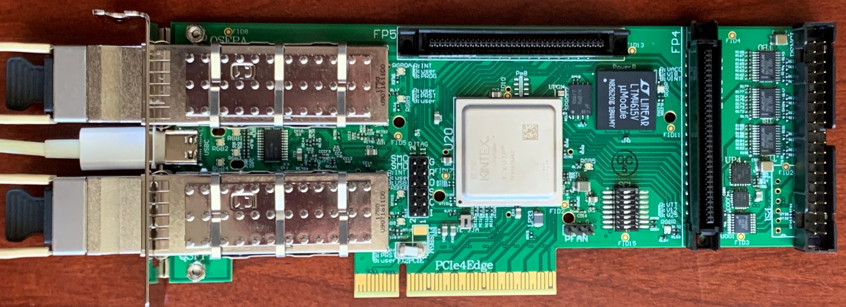
Figure 2 TIpcieUS PCB picture

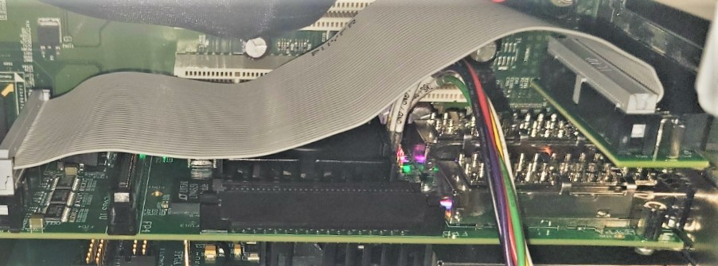
Figure 3 The TIpcieUS optional second front panel with the adaptor and the cable plugged in the TIpcieUS board

The TIpcieUS can also perform simple Trigger Supervisor functions, as a TI Master (TM). In this case, it can take inputs from its second front panel shown in figure 3(, which connects to the 40-pin on-board connector at the very right edge of Figure2) and generate trigger/clock like TS, and it can send the trigger, clock and SYNC to the front panel fibers like a TD.
The TIpcieUS FPGA firmware is compatible with the master mode and the standard (slave) mode. The firmware senses the TI clock settings. If the TIpcieUS is set to master mode or standalone mode, the TIpcieUS uses the on-board oscillator or the copper input as clock source. The TIpcieUS generates triggers either by random and periodic sequences internally or by the front panel copper inputs. The TIpcieUS generates SYNC signal, and set the fiber measurement pair to loopback in FPGA (, which is different from the TD, where the loopback is at the transceiver via a pair of resistors). The TIpcieUS sends the trigger/Clock/Sync to both QSFP optic transceivers.
If the TIpcieUS is set to daisy chain (BRIDGE) mode, it uses Fiber port#1 clock as clock source and fan out the clock to fiber port#5. It uses Fiber#1 trigger input, and fan-out the trigger to fiber#5. It uses the Fiber#1 SYNC input, and fan-out the SYNC to fiber#5. It measures the fiber#1 latency, and set fiber#5 fiber measurement to loopback mode in FPGA, so that the TI modules connects to the Fiber#5 can do the fiber latency measurement.
If the TIpcieUS is set to slave mode, it uses clock from fiber#1 or Fiber#5 depending on the DAQ system setting. It also uses the same fiber for trigger, SYNC and fiber measurement. It is customary to use fiber#1 for global trigger (usually connects to TS with TD), and fiber#5 for subsystem trigger (usually connects to TI master).
Some registers are valid on the TI master only, as these registers are specific to the TS function.
The TIpcieUS has two generic 68-pin high density connectors with 64-channel LVDS input/output directly connected to the FPGA. The TIpcieUS also has one 40-pin connector to mimic the 34-pin connector on the VME TI boards. This 40-pin connector connects directly to the second PCI express front panel, and pin#1-34 is compatible with the VME TI 34-pin connector. The pin#35/36 and pin#37/38 are two extra any-level differential signal inputs, and pin#39/40 are LVPECL33 clock output directly from the clock driver (AD9510), the frequency is (250/n) MHz, where n=1, 2, …, 8 set by the FPGA firmware.

3 TIpcieUS Functional Descriptions

3.1 General description
Figure 4 shows the block diagram of the TIpcieUS module, indicating the major components used in the design. The AFBR-79EIDZ is the quad-channel (4 Rx, 4 Tx) fiber link that the TI fans out/receives a low-jitter (<3ps RMS) 250MHz system pipeline clock, serialized 16bit trigger words, and a Manchester encoded 4-bit serialized sync signal used in producing a synchronized trigger. The AD9510 is the main clock driver and gets synchronized lower frequency clocks. The Xilinx XCKU3P encodes/decodes the 16-bit trigger words at 16ns, and interfaces with the computer PCI express bridge/root master.
Figure 4 TIpcieUS block diagram

3.2 Fiber links
The AFBR-79EIDZ is the QSFP quad-channel (4 Rx, 4 Tx) fiber optic link for the TIpcie. The AFBR-79EIDZ has the same optic interface to replace the optic transceivers HFBR-7924 used on VXS/VME TI and TD boards. When the TIpcieUS is in standalone mode, the optic transceiver is not used.
When the TIpcieUS is in standard (slave) mode, the first pair (Tx/Rx) is used to transfer trigger words from TD (or TI master) to TIpcieUS, and status from TIpcieUS to TD (or TI master). The receiver of the second pair is used to transmit the 250MHz clock from TD (or TI master) to TIpcieUS. The receiver of the third pair is used to transmit the SYNC from TD (or TI master) to TIpcieUS. The TIpcieUS to TD (or TI master) links (the transmitters) on second pair and third pair are not used.
When the TIpcieUS is in master mode, the first pair (Tx/Rx) is used to transfer trigger words from TIpcieUS to another TI (including TIpcie and TI interface embedded in other PCBs), and the status from TI to TIpcieUS. The transmitter of the second pair is used to transmit the 250MHz clock from TIpcieUS to TI. The transmitter of the third pair is used to transmit the SYNC from TIpcieUS to TI. The TI to TIpcieUS links (receivers) on the second pair and the third pair are not used.
The fourth pair (Tx/Rx) is looped back on the TIpcieUS FPGA when the TIpcieUS is in master mode. Otherwise, the pair is used to send the FPGA generated pulse and receive the loopback (from TD) to measure the fiber latency.

3.3: Clock Distribution
One of the TIpcieUS’ major functions is the system (pipeline) clock distribution. There are five possible sources for the 250MHz clock: ‘onboard oscillator’, ‘QSFP#A input from TD/TS’, ‘QSFP#B input from TD/TI master’, ‘copper input from front panel/on-board 40-pin connector’, and ‘recovered clock from trigger MGT link’.
When the TIpcieUS is in master mode, or standalone mode, the on board oscillator or the copper input is used. Or else the optic fiber input is used. There will be only one 250MHz clock running on the TIpcieUS. The clock source is selected by the FPGA using a 4:1 multiplexer for the first four clock sources, and the AD9510 clock driver SPI interface for the recovered clock. The AD9510 also generates slower clocks (31.25MHz, 41.667 MHz, 62.5 MHz, and 125 MHz).
The TIpcieUS has a dedicated LVPECL33 clock output to the 40-pin connector (or the second front panel). This clock is a low jitter clock directly from the AD9510, with a frequency of 250/n MHz, where n is an integer with the value of 1 to 8, and set by the FPGA.

3.4 Trigger distribution:
When the TIpcieUS is in master mode (or standalone mode), it can takes the trigger from the second front panel inputs and form a trigger word like the VXS/VME TI master. It can also combine with the software trigger (which includes periodic trigger with a frequency of ~16 Hz to 7 MHz and random trigger with an average frequency of ~15 Hz to 460 KHz) and send to the MGT serialized mode (encoded) to the fiber. The trigger word is looped back to trigger the TIpcieUS itself. The TIpcieUS has two more any-level differential inputs than VXS/VME TI boards.
When the TIpcieUS is in standard (slave) mode, it receives the trigger signal through the QSFP optical transceivers and decoded by the FPGA. The trigger is used to generate TIpcieUS event data, which includes the event type, trigger time stamp, and event number.
When the TIpcieUS is in bridge mode, it receives the trigger signal through QSFP#A, and decoded by the FPGA as a TI slave. It also send this trigger out to QSFP#B as a TI master.

3.5: Encoded Trigger Word

A 1.25Gbps serial link operating over the fiber is used for distributing a 16-bit trigger word every 16ns. There is also a link going in the opposite direction, allowing status words to be sent back to the trigger distribution crate. The 16-bit trigger words are decoded as following (TS TD TIpcieUS, or TI-master TI-slave):
Trigger strobe word – generated by the TS (or TIpcieUS in master mode) in response to the acceptance of a level-1 trigger. Upon receipt, the TIpcieUS aligns the trigger and start to assemble trigger data (one event). The TS transmits these with fixed latency relative to the accepted trigger. This word is distributed every 16ns, so the trigger is distributed every 16ns. The fine timing information is added in the trigger word to distinguish which quadrant of the 16 ns period the trigger is generated to be fully compatible with the 4ns pipeline design architecture.
Trigger content word – additional information about the trigger for use by the ROCs. It is queued in a FIFO and sent in any frame not used by a trigger strobe word. So far, the trigger content words has not been used.
Control Word – request status, or other command (VME trigger for example). They can be queued in a FIFO and sent in any frame not used by a trigger strobe word or trigger content word.
Master Time Word – to use the trigger link fully, bits [13:2] of the TS time is transmitted whenever no other word types are available. By continuously receiving bits [13:2] of the TS time, each TI (or TIpcie) can promptly detect if its frontend crate has lost global synchronization (i.e. compare the global time with its own time). Otherwise, the loss of synchronization could only be detected at the event building stage. The continuous transmission of ‘known’ (i.e. predictable) data also allows one to monitor the integrity of the link.

This table shows the format of the trigger word.
Bit(15:14) | Bit(13:12) | Word Type | Bit(11:10) |  |  | Bit(9:8) |  |  | Bit(7:0)
0 1 | 0 0 | Time | Lower 12 bits of TS time
0 1 | 0 1 | Control | Control or Command
0 1 | 1 0 | Trigger Strobe | quadrant |  |  | Type |  |  | Event type
0 1 | 1 1 | Trigger Content | Additional Trigger data
1 0 | 0 1 | GTP trigger | Quadrant |  | Type |  |  | Event type
1 0 | 1 0 | FP trigger | Quadrant |  | Type |  |  | Event type
1 0 | 1 1 | TS partition | TS4(2:0) | TS3(2:0) |  |  | TS2(2:0) |  |  | TS1(2:0)
- Bit(9:8) Type: 01: Trigger1, 10: Trigger2, 11: Sync trigger, 00: no trigger;
- TS partition trigger: TS#n(2:0), when “000”: no trigger;

The data coming back to the TI-master or TD are divided into two categories. The first category is the status and acknowledgements. The second category is the register data. The first category has higher priority than the second category.
The following defines the data format for the opposite direction of the link (TIpcieUS TD, or TI TI master flow):

Bit(15:14) | Bit(13:12) | Word Type | Bit(11:8) |  |  |  |  | Bit(7:0)
Parity  “0 0” or “1 1” | 0 1 | Ack./Busy | Busy | Trg  Ack | Sync  RstReq |  | #Sync  RstReq | Busy | Trg1  Ack | Trg2  Ack | Blk  Rcvd | Blk  Ack | xxx
 | 1 0 | Register | 0 0 1 0 |  |  |  |  | Crate ID (7:0)
 |  |  | 0 1 0 |  |  | Board Ready |  | Trigger Source (7:0)
 |  |  | 0 1 1 |  |  | 0  1 |  | New Block Size (# of events per block)  New Buffer Size (# of blocks to set BUSY)

3.6: Fixed Latency SYNC
The SYNC signal is a 250Mbps serial line operating in synchronous mode. This serial link allows a 4-bit command to be sent at chosen 4ns points in time. SYNC is synchronized to a slower clock (250/24 MHz), which is aligned with the 32.25 MHz and 41.667 MHz clocks, derived from the 250 MHz master clock and is sampled every 4 ns. The line is considered to be idle when more than 4 samples in a row are read as ‘1’. A command is sent between idle times by sending first a ‘0’ followed by the 4 bits that comprise the command, LSB first. After the command has been sent, a final ‘1’ is sent so that the line will return to the IDLE state. The encoding portion of this serial protocol is performed on the TS (or the TS function of the TI master). Since the TD distributes this serial line over the fiber module, additional encoding (Manchester) is performed to balance the 1’s and 0’s of the line and to keep the maximum run length of the signal below the requirements of the fiber module. The TID decodes the SYNC signal (Manchester and command). Careful design in minimizing SYNC to the distributed master CLK250 skew guarantees a fixed latency link.
The SYNC timing is adjusted by the fiber latency on each TI. The fiber latency is measured using the fourth pair of the fiber. The SYNC is delayed so that all the TI modules will execute the SYNC command at exactly the same time (within the skew of the global 250MHz clock distribution).
The SYNC link is used in conjunction with a synchronous FIFO to enforce a fixed latency on the serial trigger link. The TD uses LVPECL buffers to fan out the trigger signal and the Sync signal, which is encoded (Manchester encoding) in the FPGA, to the optic transceivers (Avago HFBR_7924, Avago AFBR-79EIDZ, or other QSFP compatible). In the TIpcieUS, the trigger word is clocked into a FIFO using the FPGA built in MGT transceivers and clocked out of the FIFO using a 62.5MHz clock derived from (and in phase with) the 250 MHz system clock. At startup, the FIFO is reset (0 words) and reading the FIFO is disabled. No words are written into the FIFO since the TS is not yet transmitting data words on the trigger link (i.e. received data valid signal is not asserted). Acceptance of triggers by the TS is also disabled. The TS starts transmission (time words) on the trigger link, and after a fixed number of 62.5MHz clock cycles issues a trigger start command on the SYNC line. In response to the trigger start command, the TI enables continuous readout of the FIFO. There must always be a non-zero number of words in the FIFO to maintain a fixed latency link. This will be true if the number of words pre-filled into the FIFO x 16 ns is greater than the latency uncertainty of the link. In the case of the MGT, several words (e.g. 3 or 4) are enough when the latency is set to minimum, as the elastic buffer is not necessary as all the clocks are the same or derived from the same 250MHz clock (no clock frequency difference). The TS must always transmit valid data to maintain the fixed latency of the link. This is illustrated in figure 4:
Figure 5 Illustration of the trigger synchronization process

The SYNC link is also useful in ensuring that the lower frequency clocks derived in the TI from the distributed system clock (CLK250) have the same phase across all TI modules in the front-end data acquisition system. At startup, the TS issues a SYNC command CLKRESET. This resets the clock distribution chip (AD9510) in each TI(pcie) on the same CLK250 edge, assuring that the lower frequency clocks (125MHz, 62.5MHz, 41.67MHz and 31.25MHz) are phase aligned across the entire system. This command is sent before the TI sync command. The delay between them is determined by the maximum MGT reset recovery time, as the MGT clock is changed (AD9510 clock reset) during the clock (phase re-alignment) reset. The time for the MGT reset is several milliseconds.

Figure 6 The block diagram of the SYNC distribution on the TIpcieUS board.

3.7 PCI express interface
The TIpcieUS board is a PCI express endpoint device. It is capable of PCIe GEN3x8 (8 Gbps, 8 lanes, up to 8 GB/s duplex). It is compatible with PCI express x8 or wider physical connector, though it is backward compatible with PCI GEN1x1 electrically.
The TIpcieUS has two 32-bit Base Address (BA) spaces. The BA0 has 8K bytes (Addr(12:0)), and divided this way:
Addr(12) | Addr(11) | Addr(10) | usage
1 | 0 | x | JTAG path#A
 | 1 | x | JTAG path#B
0 | 1 | 1 | I2C for QSFP#B
 | 1 | 0 | I2C for QSFP#A
0 | 0 | 1 | reserved
0 | 0 | 0 | 1K byte 32-bit registers

BA#1 has 64K bytes, used for DMA transfers.
3.8: The FPGA flash memory programming
Two Micron Tech. MT25QU512ABB flash memories, configured as SPIx8, are used to program the Xilinx XCKU3P FPGA. The flash memory can be programmed through the on-board JTAG connector via the FPGA (indirect program) using Xilinx JTAG cable and Vivado design software. The flash memories can also be programmed by the PCI express directly (remotely) via the FPGA translation (FPGA PCI express to flash memory). The remote (through PCIe) firmware loading is under development. The 50 MHz on-board oscillator sets the FPGA programming speed (SPIx8 master mode).

3.9: Readout Synchronization
In addition to the event number and trigger time stamp synchronization check, the readout can be forced to be synchronized by synchronization events (SyncEvent). There are three ways to generate the SyncEvent.
First, the SyncEvent can be generated periodically by the TS (or TImaster). The last event of every N blocks is generated as the SyncEvent. (for now, the block level, or number of event per block, is up to 255) The N is any value between 1 and 65535, which is set and enabled by register (offset 0xD4)). When the periodic SyncEvent is marked, the original event type is kept.
Second, the SyncEvent can be forced by VME command to the TS (or PCI express to the TIpcieUS if the TIpcieUS is in master mode or standalone mode). This event may be any event in the trigger block. It is an added event with event type “00000000”. The forced SyncEvent can be generated by setting register offset 0x100, bit#20.
Third, it is also possible that the SyncEvent is generated by a front panel signal input (TS_code). With certain TS_code input combination, the SyncEvent can be generated (Event type table lookup).
The TS (or TImaster) will assert a short BUSY (3us) after generating the SyncEvent, and stop further triggers. The TI(pcie) will generate BUSY after receiving the SyncEvent, and set the SyncEvent marker in the ROC polling register (offset 0x34). The BUSY of TI(pcie) will propagate back to the TD through fibers (and P0 backplane). The latency of this should be less than 3us, so that it will overlap with the short BUSY on TS. After the front end data is cleared, and the Readout acknowledge will clear the BUSY on the TI(pcie). In pipeline readout mode, if there are more than one trigger blocks to be read out, the very last acknowledgement clears the SyncEvent BUSY on the TI(pcie). After all the TI(pcie) boards clear their BUSY, the TS will distribute trigger again. Depending on the data acquisition mode and the amount of data backed up on the frontend, this process may take tens of microseconds and up to many milliseconds.
Upon SyncEvent, the trigger distribution will be paused. Users can change the DAQ settings during this time. If no reset in this period, the event number and trigger time will be continued.

4. Specification Sheet

4.1 Mechanical
- Single width, low profile, half-size PCI express x8 module. It can be plugged in any PCI express x8 compatible slot.
- Optionally, double width, low profile, half-size PCI express x8 module, if the user choose to bring the on-board 40-pin connector to the front panel (second single width front panel).
4.2 PCI express:
- PCI express GEN3 x8 capable, that is 8 lanes with 8 Gbps full duplex;
- Reference Clock at 100 MHz;
- JTAG on PCI express slot can be used by setting the jumpers on the board, but many computers do not support (supply) JTAG;

4.3 Onboard connectors:
- Two 68-pin high density connectors. Each connector can be configured as 32-channels of LVDS or 64-channels of LVCMOS18, either input or output depending on the FPGA configuration.
- One 40-pin DIN connector. This connector can be connected to the second front panel for easier access (from outside of the host computer). This is equivalent to the 34-pin connector on VME TI.

4.4 Front panel inputs and outputs:
- Two QSFP connectors, which are equivalent to fiber#1 and fiber#5 of VXS/VME TI boards.
- One USB-C connector, for standalone power supply, and USB-C control (to be developed).

4.5 Fiber channel signals:
- SYNC Fixed Latency Link
  - 250Mbps Serial Communication
  - Manchester Encoded
  - SYNC to CLK skew variation adjusted at FPGA receiver.
- TRIGLINKTX/TRIGLINKRX
  - 1.25Gbps Trigger Word Line
  - Provides 16bit parallel data every 16ns
  - A BUSY status word in the opposite direction.
- CLOCK
  - 250MHz Clock <3ps RMS Jitter

4.6 LED Indicators: Front Panel:
- LED#1: RGB, Green: (farther away from the motherboard) FPGA programmed and the clock (DCM locked) is ready;
- LED#2: RGB, Green: PCI express activity
- LED#3: RGB, RED: Trigger_1 is sent out / received;
- LED#4: RGB, RED: QSFP optic transceiver Rx error;
On board:
- Power OK near each regulator or DC-DC converter (LED is OFF when the power is OK);
- FPGA program DONE (LED is OFF when programmed);

4.7 Programming:
- JTAG to FPGA indirect flash memory loading;
- PCIexpress to flash memory loading to be developed.

4.8 Power requirements:
- PCIexpress: +3.3V @ 3 Amps; +12V @ 1 Amp;
- Or USB-C: +5V @ 2 Amps.
- Regulators for other required voltages: +0.85V, +0.95V, +1.2V, +1.8V, +2.5V, +3.3V, +5V and -5V.

4.9 Environment:
- Well ventilated computers, especially in the PCI express expansion region
- Commercial grade (or better) components (0-75 Celsius)

5 TIpcieUS operation procedures:
The TIpcieUS needs be properly set, and plugged into the PCI express slot. Damage may happen to the TIpcieUS, computer, or other components in the computer if the right procedure is not followed.
The TIpcieUS standalone (no PCI express, not to be confused with the trigger standalone mode) mode (USB-C configuration) will be developed later.
5.1 TIpcieUS Power supply:
There are two options for the TIpcieUS power supply. Option#1: The TIpcie uses +3.3V and +12V from the PCI express connector, option#2: it uses the front panel USB type-C connector with +5V supply.
When in option#1, the TIpcieUS generates +0.85V, +0.95V, +1.2V, +1.8V, and +2.5V from the +3.3V input using LTM4615 and TPS74401. It generates the +5V and -5V supply by a DC-DC converter (NMH1205SC) from +12V.
When in option#2, the TIpcieUS generates +3.3V from +5V_USB using LTM4604. It generates the +0.85V, +0.95V, +1.2V, +1.8V, and +2.5V from the generated +3.3V with the same regulators as option#1. It generates the +5V, and -5V supply by a DC-DC converter (NMH0505SC, which uses the same footprint as the NMH1205SC) from +5V_USB.
The power supply options are configured by populating the appropriate fuses. There will not be problems if the TIpcieUS is plugged into a PCI express slot, and the USB-C connector is plugged in too. Here is the fuse configuration for the two power options:
Option#1 (PCI express power): F3PCIE and F12PCIE are populated, and F3USB and FUSB5M are not populated. NMH1205SC is populated, and a +12V DC cooling fan can be used for FPGA active cooling.
Option#2 (USB-C power): F3USB and FUSB5M are populated, and F3PCIE and F12PCIE are not populated. NMH0505SC is populated, and a +5V DC cooling fan can be used for FPGA active cooling.

  - Hardware setting (Switch etc.):
There is one 8-bit switch on the TIpcieUS marked as SC1. This switch is used to set the sources of the four front panel outputs (which is the same as the four bit outputs signal sources on the 40-pin connector (pin#5/6, 7/8, 9/10, 11/12)).
Bit[3:1]: LVTTL, open=high. Source selection for the four differential outputs. When “000”, the outputs are controlled by software BR#0, offset 0x4C, bit(3:0).
Bit[6:3]: LVCMOS not used
Bit[8:7]: TIpcieUS clock source selection. The setting is overwritten by the FPGA firmware/software.

  - Software setting:
After the board is properly set, and plugged in the right slot, some software setting needs be applied for the board to work.
5.3.1 Computer boot process:
The TIpcieUS card is recognized at the computer BIOS boot. During the boot process, the PCI express enumeration will set the proper working parameters to TIpcieUS configuration registers. If the FPGA firmware is reloaded after the computer boot, the configuration registers will be lost. In that case, the configuration registers needs be reloaded. The easiest way is to restart the computer without power cycling the computer. If the new firmware keeps the original base address settings, the /sys/bus/pci/devices/0000.22:00.0/config file can be reused without restarting the computer (saving this configure file to a local area, and copying this file back to that directory after firmware reloading, where the 0000.22:00.0 is the host computer enumeration of the TIpcieUS).
5.3.2 Driver loading:
The TIpcieUS card is set as “memory controller device”, ‘D0E1’, for DOE lab), and ‘:9038’ (UltraScale+ Kintex FPGA), subsystem device as ‘D0E1’ and ‘:7105’ (TI pci Express with UltraScale Plus Kintex FPGA, and 71E0 for TI PCI Express with Virtex-5 FPGA). The drivers are automatically loaded upon power up. If the driver is loaded successfully, the devices can be used:
/dev/xdma0_user : for PCIexpress register access, (BA0, 8 KB);
/dev/xdma0_C2H_0: DMA readout channel of TI trigger data;
/dev/xdma0_H2C_0: DMA write to TIpcieUS. The current firmware just dumps (ignores) the data.
/dev/xdma0_C2H_1: DMA readout channel of streaming TDC data (to be implemented).
/dev/xdma0_C2H_2: DMA readout chancel of front QSFP data input (to be implemented)
5.3.3 TIpcieUS setup:
The TIpcie card needs be setup properly:
Main Clock selection: BR#0, offset 0x2C: 0x0 for onboard oscillator, ……
SYNC source selection: BR#0, offset 0x24: 0x10 for loopback, ……
Trigger source enables: BR#0, offset 0x20: 0x94 for internal trigger, ……
Busy, Data format etc.: BR#0, offset 0x28, 0x18 etc.
5.3.4 Trigger table loading:
There is a 6-bit inputs, 8-bit output look up table built in the TIpcieUS(master). The 6-bit inputs correspond to the six front panel inputs (marked as TS#1, TS#2, … TS#6). The eight-bit outputs defines the trigger/event type. The eight output bits are defined by the data (table) loaded.
The table (64 bytes) is loaded by sixteen 32-bit words (BR#0, offset 0x140 – 0x17C)
6. PCI express Programming Requirements (This part will be updated as the firmware develops)
There are two 32-bit Base Address memory regions defined on the TIpcieUS card.
The BA#0 has 8K byte addressable in 32-bit word only. These memory spaces are further divided into two JTAG spaces, two I2C spaces, one spare 1K bytes space, and one 1K bytes 32-bit registers.
The BA#1 has 64K bytes used for PCI express DMA implementation, which should not be accessed by users directly.

6.1 BA#0 memory (Address(12:10) == 000, lower 1K bytes):
These 1K bytes are equivalent to the VME TI A24D32 read/write. They are addressed in 32-bit word only (not byte addressable, to be simple) with Address(1:0) == “00”.
- Address offset: 0x00000: Board ID:
Bit 7-0 (R/W): Crate ID; Reset default 0x00;
Bit 15-8 (R): Board ID; right now, it is 0x48;
Bit 19-16 (R): PCB related setting, 0x4: for TIpcieUS, 0x1: for TIpcieV5;
Bit 31-20 (R): Board type: 0x71: TI, 0x75: TS, 0x7D: TD, 0x71E: TIpcie.

- Address offset: 0x00004: Optic transceiver enable:
Bit 31-0 (R/W): not used
- Address offset: 0x00008: Interrupt setting:
Bit 7-0 (R/W): Interrupt ID; Reset default 0xC8
Bit 10-8 (R/W): Interrupt level; Reset default 5;
Bit 16 (R/W): IRQ enable. Reset default: 0;
- Address offset: 0x0000C: Trigger delay and Pulse width:
Bit 7-0 (R/W): Trigger_1 delay, (n+1)*4 ns; Reset default 0x07;
Bit 15-8 (R/W): Trigger_1 Pulse width (n+1)*4 ns; Reset default 0x07;
Bit 23-16 (R/W): Trigger_2 delay, (n+1)*4 ns; Reset default 0x07;
Bit 31-24 (R/W): Trigger_2 Pulse width (n+1)*4 ns. Reset default 0x07.
- Address offset: 0x00014: Block size:
Bit 7-0 (R/W): Block size. Reset default 0x01; This is used on TD only. It’s read/write register but does not affect anything in the FPGA.
Bit 23-16 (R): Block size (block level). This is the block level used on the FPGA.
Bit 31-24 (R): Block size set by TS (or TImaster). This is an intermediate value. The ROC should readout these eight bits, and set them to the other front DAQ electronics (FADC250, FADC125, etc).
- Address offset: 0x00018: TI data format control: Reset default 011;
Bit 0: if ‘1’, two block placeholder words are enabled; no longer used, default to no placeholder.
Bit 3-1: Event format control:
bit 1: ‘1’ to enable the lower 32-bit trigger timing word;
bit 2: ‘1’ to enable the trigger code, higher 4-bit of event number, and higher 16-bit of trigger timing;
bit 3: ‘1’ to enable the front panel TS-code pattern readout (bit(5:0). This is before the pre-scaling.
Bit 11-8: I2C device address (7:4), “1010” for QSFP, “1111” for SAMPA,
Bit 23-16 (R): Buffer size (buffer level). This is the buffer level used on the FPGA.
Bit 31-24 (R): Buffer size set by TS (or TImaster). This is an intermediate value. The ROC should readout these eight bits, and set them to the FADC250, FADC125, etc.
- Address offset: 0x0001C: control setting; Reset default 0x011:
Bit 15 (R/W): ‘1’ disable data readout buffer full;
Bit 21 (R/W): ‘1’ to enable the instant block level (and buffer level) update;
Bit 22 (R/W): Buffer level select. ‘1’ to select the 0x34 setting, ‘0’ to select the TS broadcast setting.
Bit 23 (R/W): ‘1’ to enable the buffer level threshold on TI.
Bit 31 (R/W): ‘1’ to slow down the “slow clock” further for a factor of 32 in trigger rules logic.
- Address offset: 0x00020: Trigger source register:
Bit 15-0 (R/W): Trigger source enables: Reset default 0x0000;
Bit 1: QSFP#A optic transceiver trigger input;
Bit 2: TI-master loopback trigger input;
Bit 3: Front Panel trigger input;
Bit 4: VME trigger;
Bit 5: Front Panel Trigger Codes (as Supervisor) inputs;
Bit 7: Random Trigger.
Bit 10: QSFP#B optic transceiver trigger input;
Bit 11: Enable trigger2 to generate trigger1 (valid for TIpcie in master mode)
Bit 12: SubTS#1 trigger enable, this is valid on fiber input only;
Bit 13: SubTS#2 trigger enable, this is valid on fiber input only;
Bit 14: SubTS#3 trigger enable, this is valid on fiber input only;
Bit 15: SubTS#4 trigger enable, this is valid on fiber input only;
Bit 31-16 (R): Trigger source monitor.
- Address offset: 0x00024: Sync Source register:
Bit 15-0 (R/W): Sync Source enables: Reset default 0x02;
Bit 1: QSFP#A (or fiber#1) optic transceiver input;
Bit 2: QSFP#B (or fiber#5) optic transceiver input;
Bit 3: Front panel trigger inhibit enable;
Bit 4: Loopback SYNC enable, when TIpcieUS is in master or standalone mode
Bit 6: automatic Sync-Reset enable
Bit 7: Enable the option for RESET to be set high (sync code 0x99), and low (sync code 0xcc).
Bit(11-8) (R): last SYNC code from QSFP#A;
Bit(15:12) (R): last SYNC code from QSFP#B;
Bit(19:16) (R): last SYNC code from loopback;
Bit(20) (R): SYNC history fifo empty;
Bit(21) (R): SYNC history fifo has more than 512 entries;
Bit(22) (R): SYNC history fifo full (reached 1024 entries);
Bit 31-24 (R): Sync source monitoring.
- Address offset: 0x00028: Busy source registers:
Bit 15-0 (R/W): Busy source enables:
Bit 5: ‘1’ enable the front panel (bracket) busy input;
Bit 6: ‘1’ BUSY if the trigger is out, but the acknowledge (from slave TI) has not been received;
Bit 7: ‘1’ enable TIpcie feed-back BUSY, ‘0’ disable the busy. (used in master or standalone mode)
Bit 8: QSFP#A BUSY enable: ‘1’ enable the QSFP#A BUSY input, ‘0’ disable;
Bit 12: QSFP#B BUSY enable: ‘1’ enable the QSFP#B BUSY input, ‘0’ disable;
Bit 31-16 (R): BUSY source monitoring.
Bit 22: ‘trigger loss’ for enabled (slave) TI(pcie).
- Address offset: 0x0002C: Clock source selection:
Bit 1-0 (R/W): software bit switch to control the clock source. Reset default 00;
Bit[1:0] = 00: oscillator clock;
Bit[1:0] = 01: QSFP#B (HFBR#5) clock input;
Bit[1:0] = 10: QSFP#A (HFBR#1) clock input;
Bit[1:0] = 11: Front panel (40-pin connector) clock input;
Bit 11-8 (R/W): ClockOutput frequency setting.
Bit(11:10) = “10” to enable the setting (external Switch should be high, not GND).
Bit(9:8) = Switch(5:4). 00: 250MHz/15; 01: 250 MHz/10; 10: 250 MHz/6; 11: 250MHz/2.
Bit 19-16 (R/W): TCS daisy chain (fanout) mode if set to 0101: QSFP#B clock is used, and the clock is fanned out to QSFP#A.
Bit 23-20 (R/W): To send the trigger in vGTM format if set to 1011. QSFP#A Tx#1 only.
Bit 15-12 (R): SWM(8:7) & SWM(5:4): 250MHz clock source, and Clkout frequency
Bit 31-24 (R): ClkBadSave, ForcedClk, SWM(6), Program_B, MasterMode(4:1)
- Address offset: 0x00030: Trigger_1 pre-scale:
Bit 15-0 (R/W): pre-scale factor: Rate = Rate_0 / (bit(15:0)+1). Factor = 1, 2, 3, 5, 9, 17, …
- Address offset: 0x00034: Trigger block inhibit:
Bit 7-0 (R/W): TIpcie trigger inhibit threshold (in the unit of event blocks); Reset default 0x01;
Bit 15-8 (R): Number of blocks in the DAQ ready to be readout.
Bit 20-16 (R): Number of events before the block is formed. Set to “11111” if more than 30 (and <256).
Bit 23-21 (R): When the TI is used in SBS, the number of events which have FASTBUS TDC data or ADC data. Set to “111” if more than 6 (and <16).
Bit 26-24 (R): Number of IRQ waiting, set to “111” if more than 6 (and <256).
Bit 27 (R): if ‘1’, At least one readout trigger is dumped (no trigger data) because of the FIFO is overflowing (to conserve the TI data integrity).
Bit 28 (R): if ‘1’, the RUN is stopped because the block number (readout) has reached. (set by 0xFC)
Bit 29 (R): if ‘1’, the event block is being filled by FillTrg;
Bit 30 (R): SyncReset Request set. If ‘1’, SyncReset is required. To be issued by TImaster/TS.
Bit 31 (R): SyncEvent received, and the system is BUSY. Waiting for ROC to clear the frontend data.
- Address offset: 0x00038: Trigger rules:
Bit 7-0 (R/W): No more than 1 Trigger in (Bit(6:0)*(16/500 ns)); Bit7 determines 16ns or 500ns step. Reset default 0x03;
Bit 15-8 (R/W): no more than 2 trigger in (Bit(14:8)*(16/500ns)); Bit15 determines 16ns or 500ns step. Reset default 0x03;
Bit 23-16 (R/W): no more than 3 triggers in (Bit(22:16)*(16/500 ns)); Bit23 determines 16ns or 500ns step. Reset default 0x03;
Bit 31-24 (R/W): no more than 4 triggers in (Bit(30:24)*(16/500 ns)). Bit31 determines 16ns or 500ns step. Reset default 0x03;
If the register 0x1C bit#31 is set 1, the clock step increase from 500ns to 16us. This means that the rule can cover up to 2 ms.
- Address offset: 0x0003C: Trigger coincidence window:
Bit 7-0 (R/W): Trigger input coincidence window; Reset default 0x01;
Bit15-8 (R/W): Trigger inhibit window (extra to bit(7:0)). Reset default 0x00;
These two parameters are used to determine the event resolution
Bit24-16 (R/W): Set the delay between TRIGGER2 and the (TRIGGER2 generated) TRIGGER1. The delay is in 4ns step with an offset (minimum setting) of ~2.6us;
Bit 31 (R/W): ‘1’ to enable the TriggerInput (front panel 6:1) pattern LEVEL readout (TI format data word control bit#3).
- Address offset: 0x00044: Front panel generic trigger input enable:
Bit 5-0 (R/W): Front panel trigger code (TS-code(6:1)) input enable; Reset default 0x00.
- Address offset: 0x0004C: Blocks for VME interrupt:
Bit 3-0 (R/W): 4-bit output to the front panel generic output connector;
Bit 15-8 (R): Number of data blocks in the FIFO for readout;
Bit 23-16 (R): Number of data blocks ready for Interrupt Request;
Bit 31-24 (R): on TI: Number of events of a partial block (or, before the block is formed)
- Address offset: 0x00050: Sync delay setting (to compensate for the fiber length):
Bit 7-0 (R): on TI: SYNC phase of QSFP#A input;
Bit 15-8 (R/W): QSFP#A SYNC input delay; Reset default 0x00;
Bit 23-16 (R/W): TIpcieUS (internal loopback) SYNC delay; Reset default 0x00;
Bit 23-16 (R): when TIpcieUS is in slave mode: SYNC phase of QSFP#B input;
Bit(31:24 (R/W): QSFP#B SYNC input delay. Reset default 0x00;
- Address offset: 0x0005C: PCI express Configuration Link:
Bit 15-0 (R): PCI express Configuration Link Command: link control register from the PCI express extended capacity structure.
Bit 31-16 (R): Configuration Link Status: link status register from the PCI express extended capacity structure.
- Address offset: 0x00064: Front Panel generic trigger input pre-scale: Reset default 0x00000000
Bit 3-0 (R/W): FP Generic trigger input TS-code#1;
Bit 7-4 (R/W): FP Generic trigger input TS-code#2;
Bit 11-8 (R/W): FP Generic trigger input TS-code#3;
Bit 15-12 (R/W): FP Generic trigger input TS-code#4;
Bit 19-16 (R/W): FP Generic trigger input TS-code#5;
Bit 23-20 (R/W): FP Generic trigger input TS-code#6;
- Address offset: 0x00074 (R/W): Event type for some special event:
Bit 7-0: Multiple hits by GTP ‘or’ External trigger inputs (default 0xFA, for TS only)
Bit 15-8: Multiple hits by GTP ‘and’ External trigger inputs (default 0xFA, for TS only)
Bit 23-16: Software generated periodic trigger event type (default 0xFD);
Bit 31-24: Software generated random trigger event type (default 0xFE).
- Address offset: 0x00078: VME Sync Load
Bit 7-4 == Bit 3-0 (R/W): 4-bit sync code; Decoding of the Sync command (bit[7:0]):
0x11: PCI express clock DCM reset, and full reset; (do not use)
0x22: CLK250 resync (AD9510, DCM resync and MGT reset for trigger link);
0x33: AD9510 re-sync (slower clock phase adjustment), part of 0x22 functions;
0x44: Reset the MGT status_B registers;
0x55: Trigger link enable (serial link started), FIFO read counter reset;
0x77: Trigger link disable, trigger FIFO write counter reset;
0xAA: reset the TIslave trigger ready register;
0xBB: Reset the event number, and trigger input scalars (the 0xDD will not do);
0xDD: (SyncReset), FPGA logic and counter reset;
0x99: Force SyncReset high if this feature is enabled (by offset 0x24, bit 7);
0xCC: set the SyncReset low if it is forced high by code 0x99.
0xEE: generate a ~ 4us SyncReset signal.
0x66, 0x88: to be assigned;
0x00, 0xff: reserved, not to be assigned.
- Address offset: 0x0007C: VME Sync Delay. The latency before being serialized.
Bit 6-0 (R/W): latency, in 4ns steps. Reset default 000,0111
- Address offset: 0x00080: Reset pulse width: Reset default 00,0111
Bit 7-0 (R/W): Reset (generated by Sync code 0xdd) pulse width. Pulse width is (Bit(6:0)*(4/32 ns)), Bit(7) determines the steps (4ns or 32ns);
- Address offset: 0x00084: software Trigger/Command Register
Bit 11-0 (R/W): Trigger Command code transmitted in the trigger link; In the 12 bits, 0xABC, the 0xA determines the command type. For example:
Bit(11-0) = 0x123: (A=1) one trigger1 (readout trigger) pulse will be generated, and the event type = 0x23;
Bit(11-0) = 0x221: (A=2) one trigger2 pulse will be generated. The 0x21 is ignored;
Bit(11-0) = 0x812: (A=8) Set the block level (size), and the block level is set to 0x12.
Bit(11-0) = 0xC06: (A=0xC) Set the Buffer level (size), and the buffer level is set to 0x06.

- Address offset: 0x00088 (R/W): software Random Trigger Command Register:
Bit 3-0: Random trigger_1 rates: 466 KHz/(2^{Bit(3:0)});
Bit 6-4: same as Bit(2-0) for redundancy check. No match, no trigger_1;
Bit 7: enable/disable random trigger_1; (There is NO requirement that it match with bit 3)
Bit 11-8: Random trigger_2 rates: 466 KHz/(2^{Bit(11:8)});
Bit 14-12: same as Bit(10-8) for redundancy check. No match, no trigger_2.
Bit 15: enable/disable random trigger_2;
- Address offset: 0x0008C(R/W): software periodic Trigger Generation:
Bit 15-0: Number of trigger_1 to be generated; if 0xFFFF, the number of event will not be limited.
Bit 31-16: (trigger rate control) Time between triggers. T = (32+8*Bit(30:16)*1024^{Bit(31)}) ns. (Assuming that the PCI express reference clock is 100MHz, and the interface clock is 125 MHz or 8ns period.).
- Address offset: 0x00090(R/W): VME Trigger_2 Generation:
Bit 15-0: Number of trigger_2s to be generated;
Bit 31-16: (trigger rate control) Time between triggers. T = (40+10*Bit(30:16)*1024^{Bit(31)}) ns. (Assuming that the PCI express reference clock of 100 MHz, and the interface clock is 125 MHz or 8 ns period).
- Address offset: 0x00094 (R): Number of Blocks in the DAQ system:
Bit 31-24: Number of events before a full data block;
Bit 23-0: Number of full data blocks the TI has ever generated (since last reset or SyncEvt);
- Address offset: 0x00098 (R): SYNC history FIFO, The FIFO status is in register offset 0x24.
Bit 31-21: time stamp of the SYNC command, in steps of ~4us;
Bit(20): whether the time stamp has overflowed since previous SYNC code
Bit (19): TIpcie master generated sync code valid;
Bit (18:15): TIpcie master generated sync code;
Bit (14): Loopback sync valid;
Bit (13:10): Loopback sync code;
Bit (9): QSFP#B (HFBR#5) sync valid;
Bit (8:5): QSFP#B (HFBR#5) sync code;
Bit (4): QSFP#A fiber sync valid;
Bit (3:0): QSFP#A fiber sync code;
- Address offset: 0x0009C (R/W): The FPGA running mode;
Bit 7-0: TS in running mode if set to 0x5A; if other value, not in running mode. Reset default 0x00;
TI in running mode if set to 0x71. TI starts clock monitoring in ‘running’ mode.
- Address offset: 0x000A0 (R): Fiber latency measurement result from QSFP#A:
Bit 31-23: latency data in 4ns steps
Bit 22-16: Delay in the IODelay, in 5000/64=78.125ps steps
Bit 15:0: Delay in the carry chain, two bits per slice, (or two mux per bit)
- Address offset: 0x000A4 (R): Fiber latency measurement result from QSFP#B
Bit 31-23: latency data in 4ns steps
Bit 22-16: Delay in the IODelay, in 5000/64=78.125ps steps
Bit 15:0: Delay in the carry chain, two bits per slice, (or two mux per bit)
- Address offset: 0x000A8 (R): Trigger live timer:
Bit 31-0 (r): board live time counter. The real time is Bit(31:0)*256*8ns. (Scalar Latch is required.)
- Address offset: 0x000AC (R): Trigger busy (trigger dead) timer:
Bit 31-0 (r): TI(pcie) busy (cannot accept trigger, or trigger dead) time counter. The real time is Bit(31:0)*256*8ns. This counter and the live time counter make up the total time counter, which is the total time since any one of the trigger sources is enabled.
- Address offset: 0x000B0 (R): MGT STATUS_A:
Bit 0: Trigger Link (AFBR) MGT reset_done;
Bit 5-4: Trigger link received Data Error;
Bit 7-6: Trigger link received data Not_in_table;
Bit 8: Trigger link MGT PLL lock detected;
Bit 15-13: PCI Express Link State (2:0): One-hot encoded bus that reports the PCI express link state to the user: 110 PCI express link state is “L0”; 101 PCI express link state is “L0s”; 011 PCI express link state is “L1”; 111 PCI express link state is “in transition”
Bit 23-16: trn_rfc_ph_av(7:0): Receive Posted Header Flow Control Credits Available: the number of Posted Header FC credits available to the remote link partner.
Bit 31-24: trn_rfc_nph_av(7:0): Receive Non-posted Header Flow Control Credit Available: Number of Non-posted Header FC Crefits available to the remote link partner.
- Address offset: 0x000B4 (R): MGT STATUS_B registers (not assigned on TIpcie):
Bit 7-0: Channel bonding sequence detected in MGT[7:0];
Bit 15-8: received data is not an 8B/10B character, or has disparity error in MGT[7:0];
Bit 23-16: RX disparity error has occurred in MGT[7:0];
Bit 31-24: Rx data not in 8B/10B table has occurred in MGT[7:0].
- Address offset: 0x000B8 (R): MGT trigger data buffer length:
Bit 9-0: Global trigger data buffer length (to be minimized to 0 for the longest fiber);
Bit 11-10: Data generation fifo full (in TRGDAQ module);
Bit 13-12: Data Readout fifo prog_almost_full (in VME module);
Bit 15:14: Data Readout fifo full; The order should be: DataReadoutFifoProgFull DataGenFifoFull DataReadoutFifoFull
Bit 25-16: Sub-system trigger data buffer length;
Bit 26: IO_DELAY_CONTROL ready;
Bit 27: TI is in running mode if ‘1’;
Bit 28: QSFP MGT receiver error (the used one);
Bit 29: CLK250 DCM locked;
Bit 30: Clk125 DCM locked;
Bit 31: PCI express interface CLK (125 MHz, not the 100 MHz reference) DCM locked
- Address offset: 0x000BC (R): TS input trigger counter:
Bit 31-0: Number of triggers received by TS (before BUSY inhibits).
- Address offset: 0x000C0 (R): valid for TIpcieUS in master mode:
Bit 7-0: Number of blocks to be readout on QSFP#A (blocks need ROCack);
Bit 15-8: Number of blocks is still missing on QSFP#A (blocks need TRGack);
Bit 27-16: Number of blocks to be readout on TM itself (loopback);
Bit 31-28: Number of blocks is still missing on TM itself (loopback);
- Address offset: 0x000C8 (R): valid for TIpcieUS in master mode:
Bit 7-0: Number of blocks to be readout on QSFP#B (blocks need ROCack);
Bit 15-8: Number of blocks is still missing on QSFP#B (blocks need TRGack);
- Address offset: 0x000D0 (R): valid for TIpcie in master or standalone mode:
Bit 15-0: Extra ROCack received on QSFP#A (that is no block is readout, but got ROCack);
Bit 27-16: Number of blocks to be readout on TM itself (loopback);
Bit 31-28: Number of blocks is still missing on TM itself (loopback);
- Address offset: 0x000D4 (R/W): Periodic Sync Event register
Bit 19-0: Number of data blocks to assert a sync event (periodic SyncEvent);
Bit 31-20: not used. When the Bit(19:0) is not zero, the Sync event is enabled.
- Address offset: 0x000D8 : Event number register
Bit 15-0 (R/W): Prompt Trigger Width, width = (bit(6:0) + 3) * 4ns;
Bit 31-16: higher 16-bit (bit 47-32) of event number counter;
- Address offset: 0x000DC (R): Event number register
Bit 31-0: lower 32-bit (bit 31-0) of event number counter.
- Address offset: 0x000E0 (R): FPGA input clock frequency
Bit 31-16: Clock_250 input frequency measurement, 25000 (decimal) for 250 MHz;
Bit 15-0: Clock_3125 input frequency measurement, 3125 (decimal) for 31.25 MHz;
- Address offset: 0x000E4 (R/W): PCIexpress to Flash memory SPI engine
Bit 9 (W): ‘1’, Last command/write bit, the DO will be tri-stated at the end of this clock;
Bit 8 (W): ‘0’, last transfer, the Chip_Select_B will be disabled (high) at the end of this clock;
Bit 7-4 (W): ‘1’: Tri-state the DO;
Bit 3-0 (W): DO(3:0);
Bit 23-20 (R): EOS, PREQ, FCSBO, FCSBTS of the flash interface;
Bit 19-16 (R): DI(3:0), Flash outputs. DI(1) for SPIx1, DI(1:0) for SPIx2, DI(3:0) for SPIx4;
Bit 15-0 (R): Data(15:0) of the 0xE4 write immediately before this read.
- Address offset: 0x000EC (R/W): ROC enable
Bit 7-0: ROC 8:1 enable, the default is 00000001
- Address offset: 0x000F0 (R): valid for TM (or with TS function)
Bit 31-0: Number of valid code from Front Panel Async trigger inputs
- Address offset: 0x000F4 (R/W): TDC Run Code
Bit 0: Connector#A calibration if ‘1’, normal TDC channel in if ‘0’;
Bit 1: Connector#B calibration if ‘1’, normal TDC channel in if ‘0’; also for Reference Channels.
Bit 3-2: Edge enable. Bit#3 for falling edge, bit#2 for rising edge;
Bit 5-4: Calibration speed selection:
- Sync Calib: 00: Clk250/4, 01: Clk250/64, 10: Clk250/2048, 11: Clk250/65536
- Async Calib: 00: ClkVme/4, 01: ClkVme/32, 10: ClkVme/64, 11: ClkVme/1024
Bit 7-6: Channel selection: 00: Sync Calib, 01: Async Calib, 10: ClkVme/65536, 11: Ext. Calib
Bit 8: Coarse counter time_zero selection. 1: for trigger, 0: for reset
- Address offset: 0x000F8 (R/W): TDC readout window
Bit 15-0: TDC readout window (from trigger) width (in 4ns steps), up to a quarter millisecond.
Bit 26-16: TDC lookback window (in 4ns steps), up to 8us to match with HallB trigger latency.
- Address offset: 0x000FC (R/W): End_of_Run number of block setting
Bit 31-0: number of block to End the run. If this is set to 0, there is no limit (disabled).
Bit 0: Enable the front panel (external input) signal to latch the trigger input scalars;
Bit 1: Enable the front panel (same signal as controlled by bit0) to reset the trigger input scalars; These two bits are kind of related to the OneShotVme command, offset 0x100, bit 24 and bit25.
- Address offset: 0x00100 (W): Reset and one-shot registers. The signal will be one PCI express interface cycle. If the ClkPcie is 125 MHz, the one-shot will be 8ns wide. Positive logic.
Bit 0: not used;
Bit 1: if ‘1’, reset the PCIe_to_I2C engine (not used);
Bit 2: if ‘1’, RESET signal to reset the PCIe_to_JTAG engine;
Bit 3: if ‘1’, RESET signal to reset the PCIe_to_SFM engine (not used);
Bit 4: if ‘1’, RESET signal to reset the BR#0 registers (TIpcieUS settings) to their default values;
Bit 5: if ‘1’, reset the optic transceiver, (the QSFP module on board).
Bit 6: if ‘1’, reset the SYNC history FIFO (clear the FIFO);
Bit 7: if ‘1’, this register will generate a BUSY reset, and ROC_Ack pulse;
Bit 8: if ‘1’, Reset the CLK250/Clk200 DCM.
Bit 9: if ‘1’, Reset the CLK125 DCM.
Bit 10: if ‘1’, Reset the trigger MGT (MultiGigabit Transceiver,) inside the FPGA.
Bit 11: if ‘1’, Auto alignment of SYNC phase from AFBR fiber;
Bit 12: if ‘1’, TI: Auto alignment of SYNC phase from HFBR#5;
TS: reset the BRAM loading address to 0 (very beginning).
Bit 13: if ‘1’, Auto alignment of fiber latency measurement signals;
Bit 14: if ‘1’, Reset the IODELAY;
Bit 15: if ‘1’, Measure the fiber latency
Bit 17: if ‘1’, the available number of data blocks will decrease by 1 without real readout,
Bit 20: if ‘1’, generate a SyncEvent (forced SyncEvent). This can be used as end_of_run etc.
Bit 21: if ‘1’, clock reset for the ClkVme/ClkSlow, and all other clocks (similar to Sync_code 0x11), Be cautious.
Bit 22: if ‘1’, MGT Rx_CDR reset, which also includes RxReset.
Bit 23: if ‘1’, generate Sync_Reset_Request.
Bit 24: if ‘1’, all the trigger input scalars are latched (ready for read out), the BusyTimer (0xAC) and LiveTimer (0xA8) are also latched;
Bit 25: if ‘1’, all the trigger input scalars are reset. (Bit 24 and Bit 25 can be set simultaneously). The event number is also reset by this.
Bit 31: if ‘1’, the end_of_run command. If the readout block is not full, dummy trigger will be generated to fill the block.
- Address offset: 0x00104 (R/W): FP input trigger (TS Code) delay (in 4 ns steps):
Bit 8-0: TScode#1 trigger input delay (Channel#1);
Bit 18-10: TScode#2 trigger input delay (Channel#2);
Bit 28-20: TScode#3 trigger input delay (Channel#3);
- Address offset: 0x00108 (R/W): FP input trigger (TS Code) delay (in 4 ns steps):
Bit 8-0: TScode#4 trigger input delay (Channel#4);
Bit 18-10: TScode#5 trigger input delay (Channel#5);
Bit 28-20: TScode#6 trigger input delay (Channel#6);
- Address offset: 0x00124 (R): Front panel inhibit input counter
Bit 31-0: 32-bit Busy timer of front panel inhibit (busy) (same steps as live/busy timer).
- Address offset: 0x00128 (R): TImaster trigger inhibit counter
Bit 31-0: 32-bit Busy timer of TImaster trigger generation (same steps as live/busy timer).
- Address offset: 0x138 (R/W): Extra hold off after trigger rule (minimum busy width)
Bit 31: ‘1’ to enable the minimum busy width for trigger rule#4;
Bit(30:24): Minimum busy width for rule#4. MinimumWidth = bit(30:24)*Tclock. Tclock = 480ns if bit#31 of Reg#1C is set to ‘0’; Tclock = 480*32ns if bit#31 of Reg 0x1C is set to ‘1’;
Bit 23: ‘1’ to enable the minimum busy width for trigger rule#3;
Bit(22:16): Minimum busy width for rule#3. MinimumWidth = bit(22:16)*Tclock. Tclock = 480ns if bit#31 of Reg#1C is set to ‘0’; Tclock = 480*32ns if bit#31 of Reg 0x1C is set to ‘1’;
Bit 15: ‘1’ to enable the minimum busy width for trigger rule#2;
Bit(14:8): Minimum busy width for rule#2. MinimumWidth = bit(14:8)*16ns. The maximum width setting is ~2us.
Bit 7-0: Minimum busy width for trigger rule#1, not used, and no need for this.
- Address offset: 0x140 – 0x17C (W): Trigger table loading:
Bit 31-0: 32-bit wide table loading.
Address bits(5-2) are used to load the 16 32-bit words;
- Address offset: 0x00170 (R): Fiber#1 non-idle data history buffer
Bit 31: The history fifo empty status, ‘1’ means EMPTY;
Bit 30-16: The time stamp of the history buffer, in 16-ns steps;
Bit 15-0: the received 16-bit ‘trigger word’, valid data, same as the 2-byte fiber interface.

Bit15:14 | Bit 13:12 | Bit11:9 | Bit8 | Bit7:3 | Bit2:0
parity | 1 0 | 0 0 1 | 0 | Crate_ID
 |  | 0 1 0 | active | Trigger Source(7:0)
 |  | 0 1 1 | 0 | New Block Level (15:8)
 |  | 0 1 1 | 1 | New Buffer Level (31:24)
 | 0 1 | Busy,AckS,SRreq,SRreq* |  | Busy, Trg1Ack, Trg2Ack, BlkRcv, ROCack | x x x

- Address offset: 0x00174 (R): Fiber#5 non-idle data history buffer
Bit 31: The history fifo empty status, ‘1’ means EMPTY;
Bit 30-16: The time stamp of the history buffer, in 16-ns steps;
Bit 15-0: the received 16-bit ‘trigger word’, valid data, same as the 2-byte fiber interface. Same decoding as the table in register 0x00170.
- Address offset: 0x00180 (R): FP input trigger scalar for #1:
Bit 31-0: 32-bit scalar, number of input#1 counter
- Address offset: 0x00184 (R): FP input trigger scalar for #2:
Bit 31-0: 32-bit scalar, number of FP input#2 counter
- Address offset: 0x00188 (R): FP input trigger scalar for #3:
Bit 31-0: 32-bit scalar, number of FP input#3 counter
- Address offset: 0x0018C (R): FP input trigger scalar for #4:
Bit 31-0: 32-bit scalar, number of FP input#4 counter
- Address offset: 0x00190 (R): FP input trigger scalar for #5:
Bit 31-0: 32-bit scalar, number of FP input#5 counter
- Address offset: 0x00194 (R): FP input trigger scalar for #6:
Bit 31-0: 32-bit scalar, number of FP input#6 counter
- Address offset: 0x0019C (R): TIM loopback readout busy counter
Bit 31-0: 32-bit Busy timer of TIM loopback (same steps as live/busy timer).
- Address offset: 0x001A0 (R): TI#1 (QSFP#A) readout busy counter
Bit 31-0: 32-bit Busy timer of TI#1 (QSFP#A) (same steps as live/busy timer).
- Address offset: 0x001B0 (R): TI#5 (QSFP#B) readout busy counter
Bit 31-0: 32-bit Busy timer of TI#5 (QSFP#B) (same steps as live/busy timer).
- Address offset: 0x001D0 (R): optic transceiver QSFP#A TI ID (in master mode)
Bit 7-0: Trigger Source Enable of the TI connected to fiber;
Bit 15-8: Crate ID of the TI connected to fiber.
Bit 23-16: Block level set on TI connected to fiber.
Bit 31-24: Buffer level set on TI connected to fiber#1.
- Address offset: 0x001E0 (R): optic transceiver QSFP#B (HFBR#5) TI ID (in master mode)
Bit 7-0: Trigger Source Enable of the TI connected to QSFP#B (fiber#5);
Bit 15-8: Crate ID of the TI connected to QSFP#B (fiber#5).
Bit 23-16: Block level set on TI connected to QSFP#B (fiber#5).
Bit 31-24: Buffer level set on TI connected to QSFP#B (fiber#5).
- Address offset: 0x001F0 (R): The TI master (itself) ID (in master mode)
Bit 7-0: Trigger Source Enable of itself, should be the same as bit7-0 of register 0x20;
Bit 15-8: Crate ID of itself, should be the same as bit7-0 of register 0x00.
Bit 23-16: Block level set on TI connected to loopback (itself).
Bit 31-24: Buffer level set on TI connected to loopback (itself).

6.2 BA#0 memory (Address Bit(12:10) = 001): reserved:
These 1K bytes have not been used yet. It could be 1K bytes registers, or another I2C engine, but most likely, it will be used for the FPGA/Flash memory reloading.

6.3 BA#0 memory (Address Bit(12:11) = 01): PCI express to I2C (master) engines:
The middle 2K bytes are used for PCI express to I2C engines. Address Bit(10) is used to select the I2C engines. The lower eight bits of the 32-bit data (Address Bit(1:0)=”00”) are used for I2C read or write.
Address Bit(10): ‘0’: for optic transceiver QSFP#A I2C; ‘1’: for transceiver QSFP#B I2C.
Address Bit(9:2): eight bits of the I2C byte address.
Address Bit(1:0): to be set as “00”.
The device address is generated as “0xA0” automatically as required by the QSFP I2C interface standard. (This means that the engine, firmware design, will not work as generic I2C engine, which require 7 bits of device address, or 32K bytes memory space minimum).

6.4 BA#0 memory (Address Bit(12) = 1): PCI express to JTAG engine:
The upper 4K bytes are used for PCI express to JTAG engines. Address Bit(12) = 1, and Address Bit(11) for the two JTAG engines. There is no specific use of the JTAG on the TIpcieUS yet. For data transfer less than 32 bits, the lower N bits (specified by the address) are used.
Address Bit(10:6): Number of bits to shift (Instruction register or Data register), n=Addr(10:6)+1, that is the minimum number of bits to shift is 1, and maximum number of bits to shift is 32, the lower order of bits in the 32-bit data are used.
Address Bit(5:4): Specific JTAG command. “01”: JTAG data register shift; “10”: JTAG instruction register shift; “11”: JTAG reset, (set the JTAG to RESET_IDLE state).
Address Bit(3): JTAG TRAILER_ENABLE. This will enable several extra JTAG clocks (after register shift) to move the JTAG state machine from register shift (either data register or instruction register) to RESET_IDLE.
Address Bit(2): JTAG HEADER_ENABLE. This will enable several extra JTAG clocks (before register shift) to move the JTAG state machine from RESET_IDLE to register shift (either data register or instruction register depending on the shift type A(5:4))
Address Bit(1:0): “00” only.
The PCI express read to the device will return the data currently stored in the TDO shift register (32-bit). The read address is Address Bit(11). Bits(10:0) are DONOT care bits. 32-bit data read only

6.5 PCI express data acquisition:
The Xilinx DMA engines are used for data acquisition. The C2H (Core to Host-computer) slave DMA are implemented for data readout.
Channel#0 (C2H_0) is used for trigger data, which is the same format as VXS/VME TI.
Channel#1 (C2H_1) is used for Streaming TDC data readout (to be implemented).
Channel#2 (C2H_2) is used for QSFP data readout, where the QSFP can be 40 GBE, 100 GBE, or custom protocols (to be implemented).
The DMA controls (bookkeeping) are implemented in BA#1 as 32-bit addressed 64K bytes memory space.

7 Connector pin out tables:

7.1 PCI express Pinout Table (copied from Wikipedia)
Pin | Side B | Side A | Description
1 | +12 V | PRSNT1# | Must connect to farthest PRSNT2# pin
2 | +12 V | +12 V
3 | +12 V | +12 V
4 | Ground | Ground
5 | SMCLK | TCK | SMBus and JTAG port pins
6 | SMDAT | TDI
7 | Ground | TDO
8 | +3.3 V | TMS
9 | TRST# | +3.3 V
10 | +3.3 V aux | +3.3 V | Standby power
11 | WAKE# | PERST# | Link reactivation; fundamental reset
Key notch
12 | CLKREQ# | Ground | Request running clock
13 | Ground | REFCLK+ | Reference clock differential pair
14 | HSOp(0) | REFCLK− | Lane 0 transmit data, + and −
15 | HSOn(0) | Ground
16 | Ground | HSIp(0) | Lane 0 receive data, + and −
17 | PRSNT2# | HSIn(0)
18 | Ground | Ground
PCI Express ×1 cards end at pin 18
19 | HSOp(1) | Reserved | Lane 1 transmit data, + and −
20 | HSOn(1) | Ground
21 | Ground | HSIp(1) | Lane 1 receive data, + and −
22 | Ground | HSIn(1)
23 | HSOp(2) | Ground | Lane 2 transmit data, + and −
24 | HSOn(2) | Ground
25 | Ground | HSIp(2) | Lane 2 receive data, + and −
26 | Ground | HSIn(2)
27 | HSOp(3) | Ground | Lane 3 transmit data, + and −
28 | HSOn(3) | Ground
29 | Ground | HSIp(3) | Lane 3 receive data, + and −
30 | Reserved | HSIn(3)
31 | PRSNT2# | Ground
32 | Ground | Reserved
PCI Express ×4 cards end at pin 32
33 | HSOp(4) | Reserved | Lane 4 transmit data, + and −
34 | HSOn(4) | Ground
35 | Ground | HSIp(4) | Lane 4 receive data, + and −
36 | Ground | HSIn(4)
37 | HSOp(5) | Ground | Lane 5 transmit data, + and −
38 | HSOn(5) | Ground
39 | Ground | HSIp(5) | Lane 5 receive data, + and −
40 | Ground | HSIn(5)
41 | HSOp(6) | Ground | Lane 6 transmit data, + and −
42 | HSOn(6) | Ground
43 | Ground | HSIp(6) | Lane 6 receive data, + and −
44 | Reserved | HSIn(6)
45 | HSOp(7) | Ground | Lane 7 transmit data, + and −
46 | HSOn(7) | Ground
47 | Ground | HSIp(7) | Lane 7 receive data, + and −
48 | PRSNT2# | HSIn(7)
49 | Ground | Ground

7.2 Front panel attached to the PCB:
From top to bottom (closest to the PCIxpress connector), they are: QSFP#A, USB type C, LED#1, LED#2, LED#3, LED#4, and QSFP#B.

7.3 Front panel (the second one, or the onboard 40-pin connector) pin table
Twenty pairs of the 40-pin connector. The pin#1-34 are assigned the same input/output signals as VXS/VME TI boards, but (maybe) different signal levels.

Pin name | Signal Name | Signal Level
Pin 1+/2- | BUSY out | LVDS
Pin 3+/4- | Trigger out | LVDS (can be ECL)
Pin 5+/6- | Output #1 | LVDS
Pin 7+/8- | Output #2 | LVDS
Pin 9+/10- | Output #3 | LVDS
Pin 11+/12- | Output #4 | LVDS
Pin 13+/14- | OT#1 out | LVDS (can be ECL)
Pin 15+/16- | OT#2, PromptTrigger out | LVDS (can be ECL)
Pin 17+/18- | Trigger Inhibit/Busy input | Any-level differential
Pin 19+/20- | Trigger input | Any-level differential
Pin 21+/22- | TS-code #1 input | Any-level differential
Pin 23+/24- | TS-code #2 Input | Any-level differential
Pin 25+/26- | TS-code #3 Input | Any-level differential
Pin 27+/28- | Clock Input | Any-level differential
Pin 29+/30- | TS-code #4 Input | Any-level differential
Pin 31+/32- | TS-code #5 Input | Any-level differential
Pin 33+/34- | TS-code #6 Input | Any-level differential
Pin 35+/36- | GenericIn#1 Input | Any-level differential
Pin 37+/38- | GenericIn#2 Input | Any-level differential
Pin 39+/40- | Clock out | LVPCEL33

7.4 JTAG connector pin table
6-pin connector pin definition, fly wire to Xilinx programmer (USBII):
Pin name | Signal Name | Signal Level
Pin 1 | JTAG TDI | LVTTL
Pin 2 | JTAG TCK | LVTTL
Pin 3 | JTAG TMS | LVTTL
Pin 4 | JAG TDO | LVTTL
Pin 5 | Xilinx programmer Vref | 2.5V
Pin 6 | GND | 0 V

8 TIpcieUS Operation examples:
The TIpcieUS test software are located at ~jgu/PCIeTI/TIpcieUS/ (~jgu/PCIeTI/TIpcieV5 is for the PCI express TI with Xilinx VIRTEX-5 FPGA):
xdma: Xilinx DMA drivers, which is automatically loaded on power up
tests: Xilinx xdma test programs from Xilinx driver package, not tested yet
tools: modified test program for TIpcieUS. Two programs are particularly useful:
- TIcontrol: “TIcontrol /dev/xdma0_user”: The TIpcieUS test program, similar functions as the trigger.c for VXS/VME TI.
- dma_from_device: “dma_from_device -c 2 –s 1984 –f OutputDataFile.bin”: Read two (‘-c 2’) blocks of data with block size (‘-s 1984’) of 1984 bytes, and dump the data to file. The default xdma device is (‘-d /dev/xdma0_c2h_0’).

9. Citations:

Works Cited
GU, (2010). TI manual
GU, (2014). TIpcie (TIpcieV5) manual

Appendix A: TIpcieUS PCB schematics:

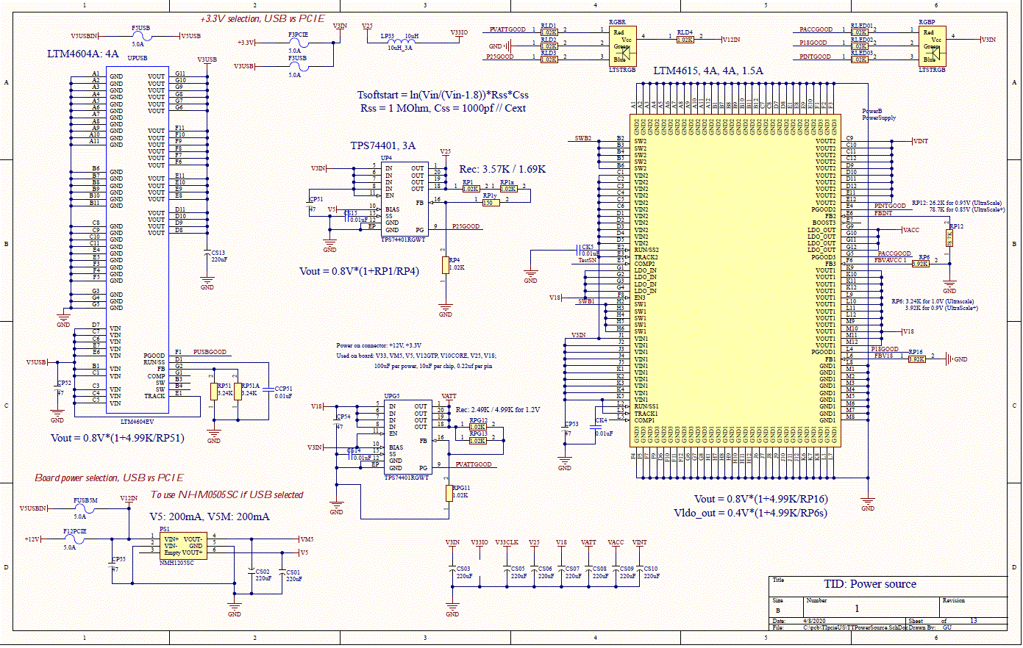
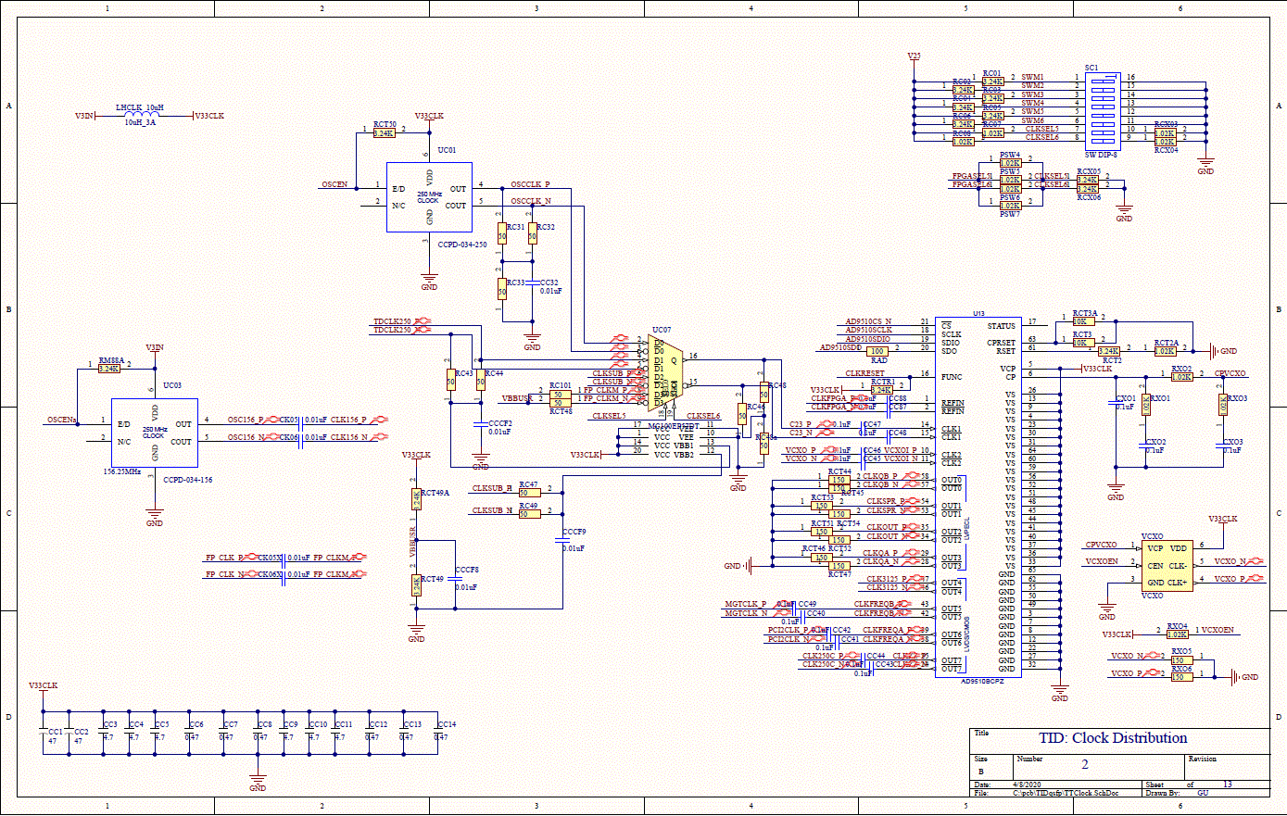
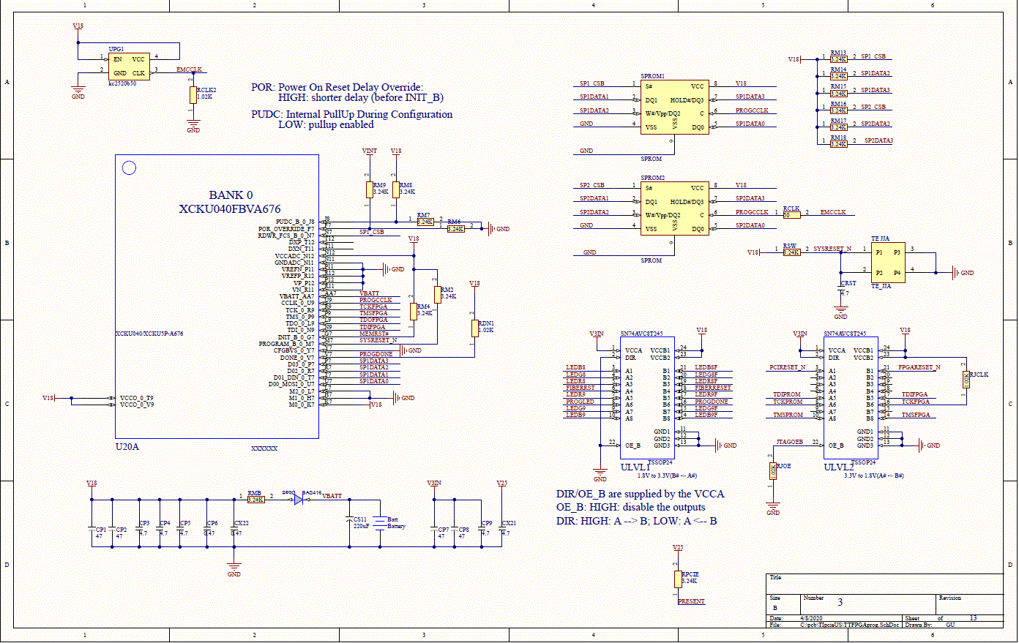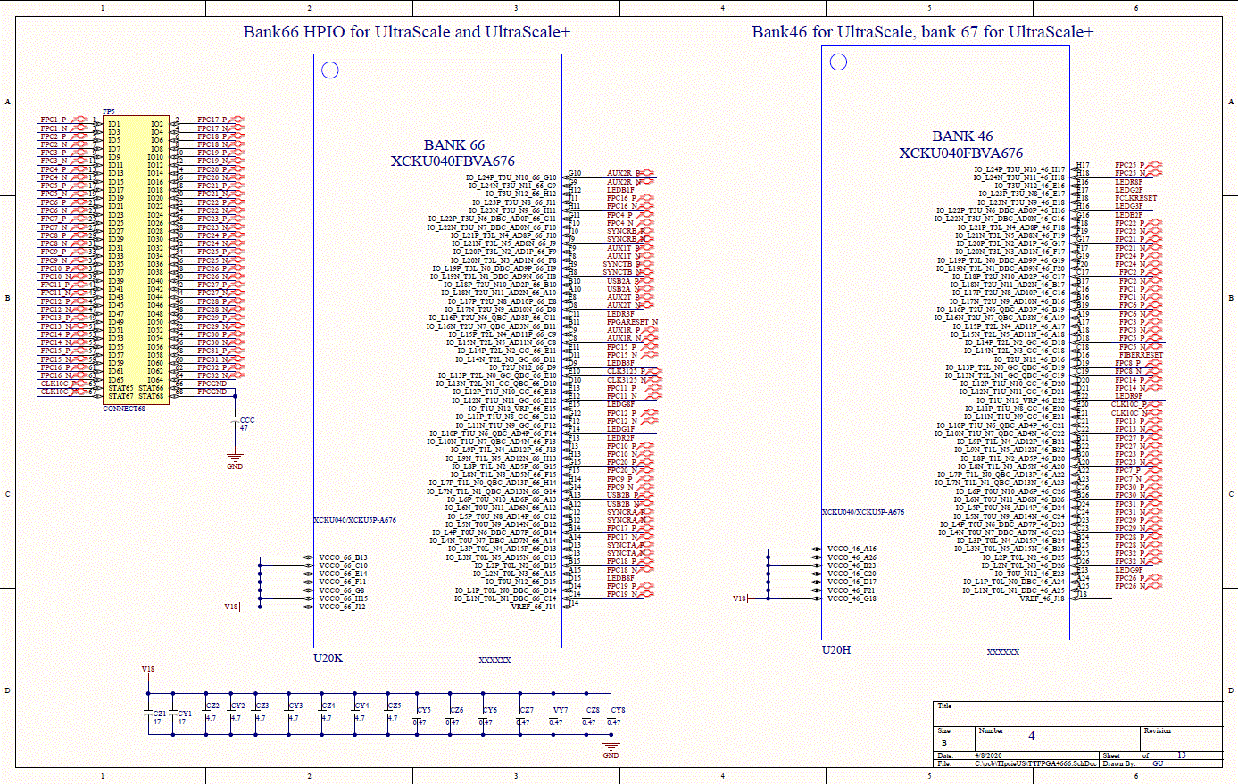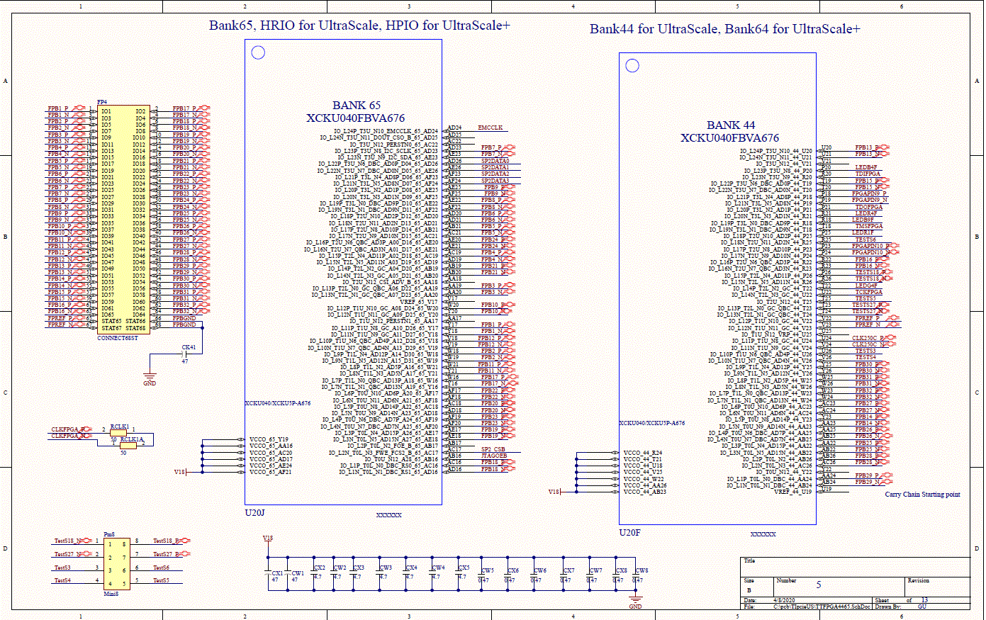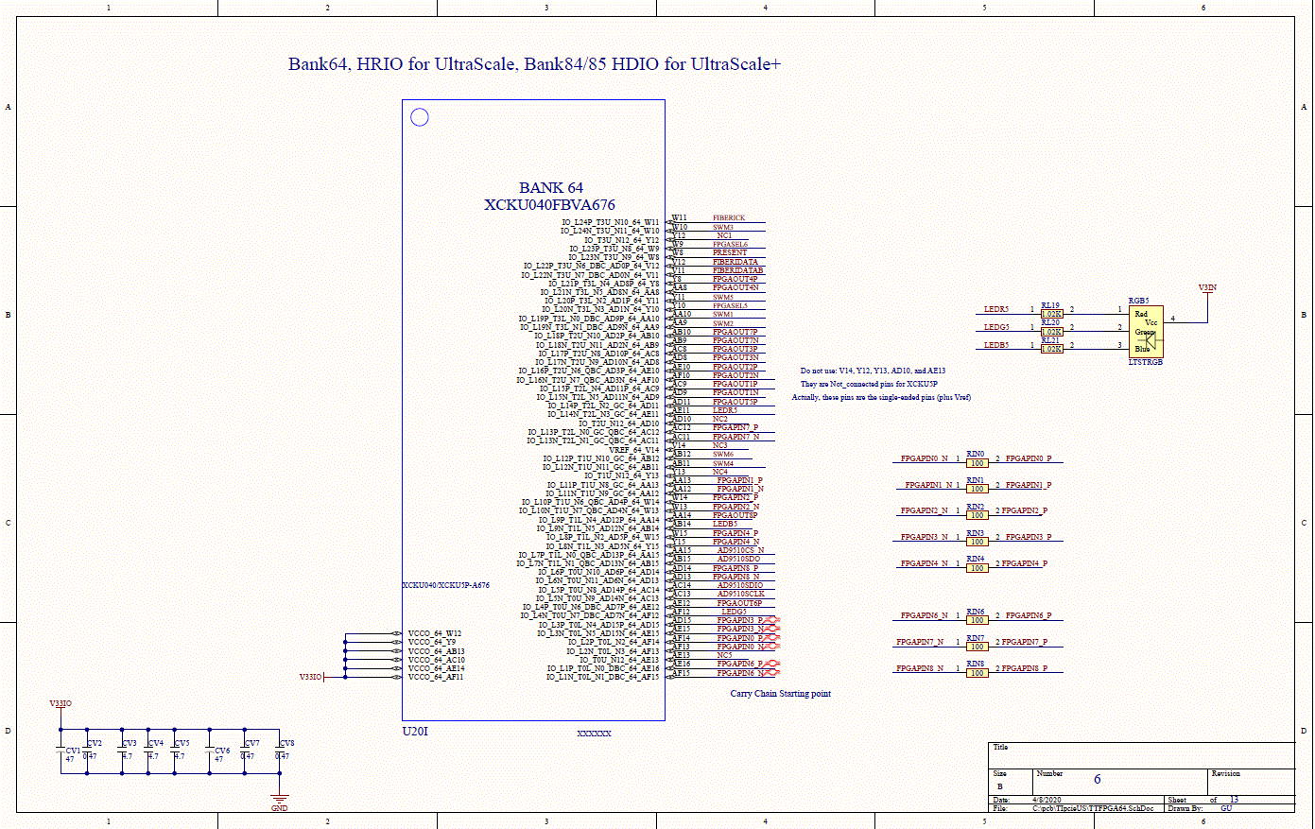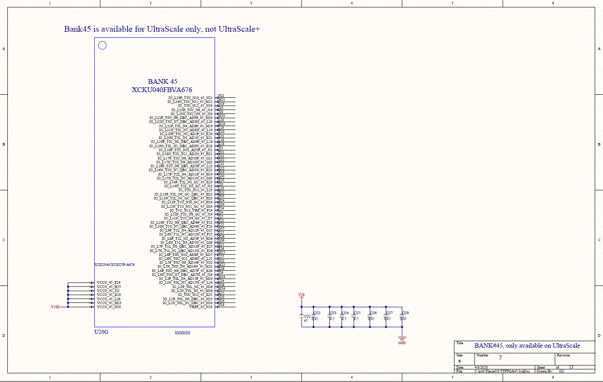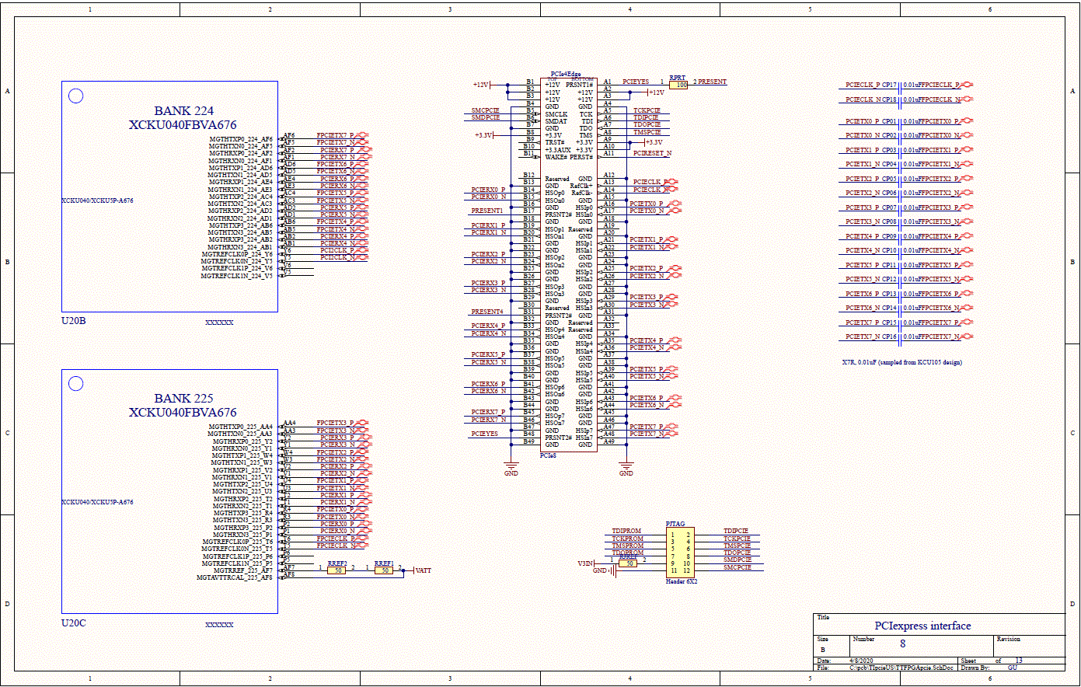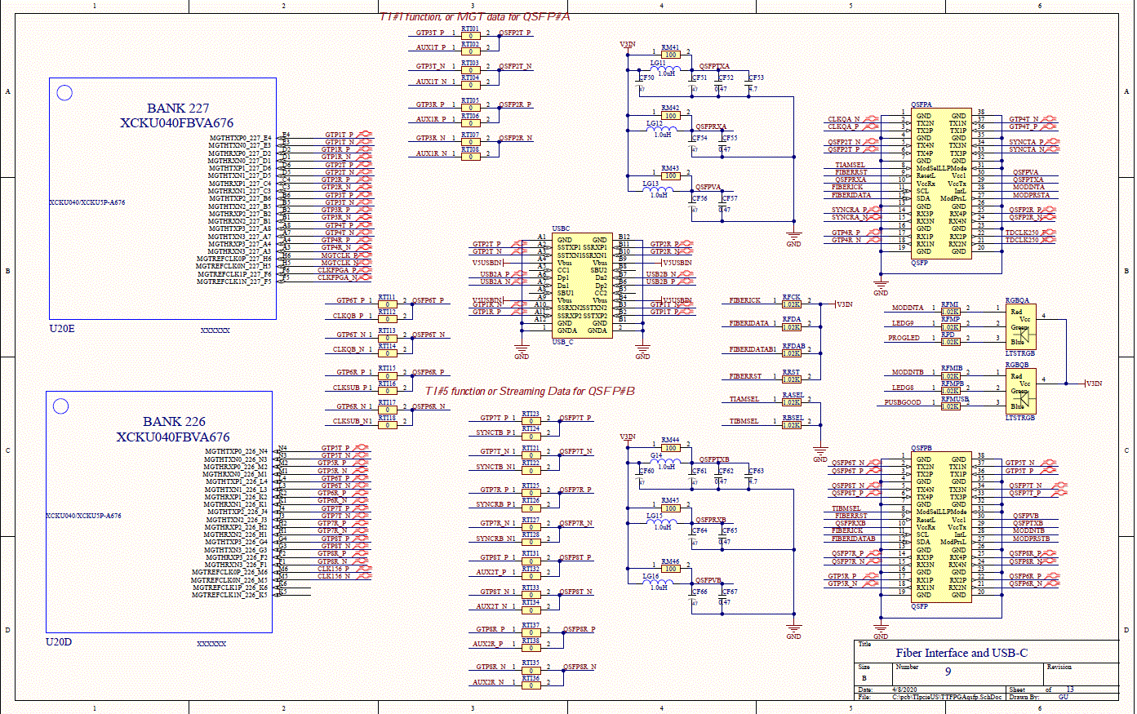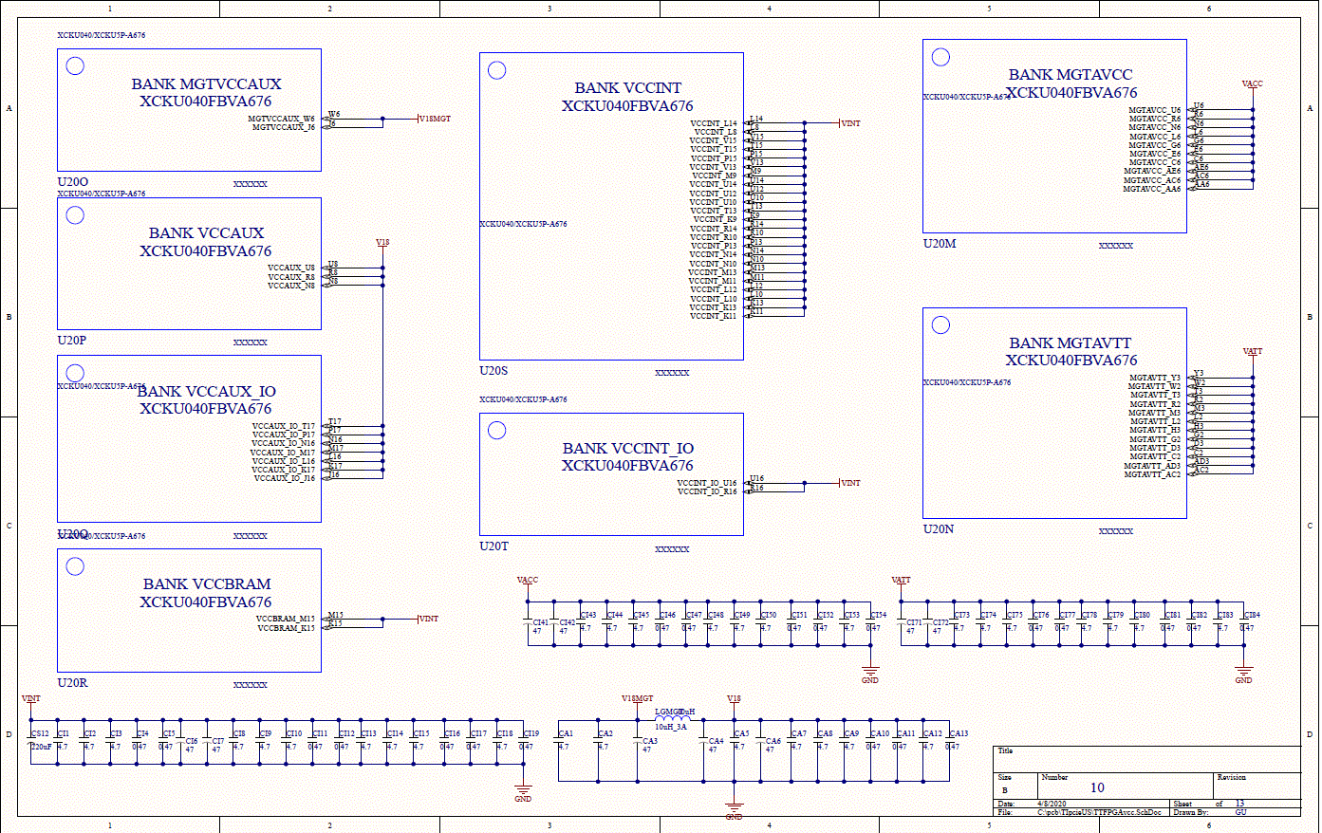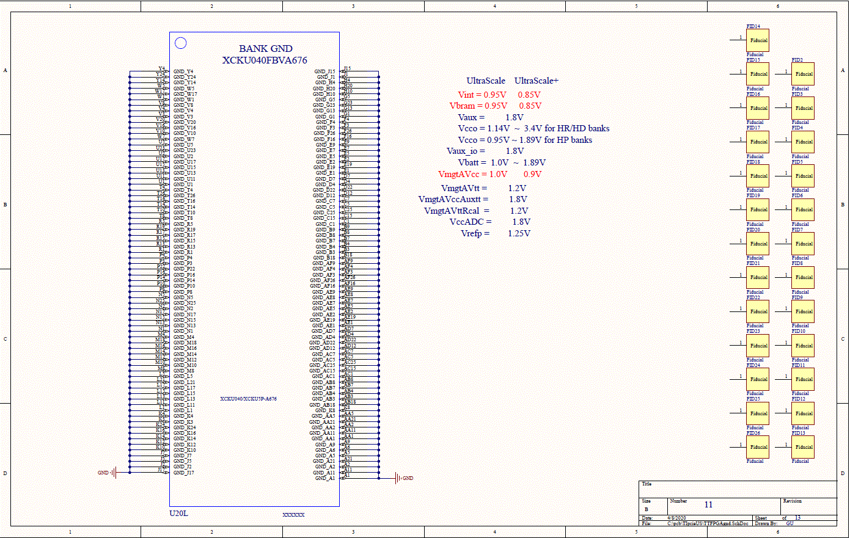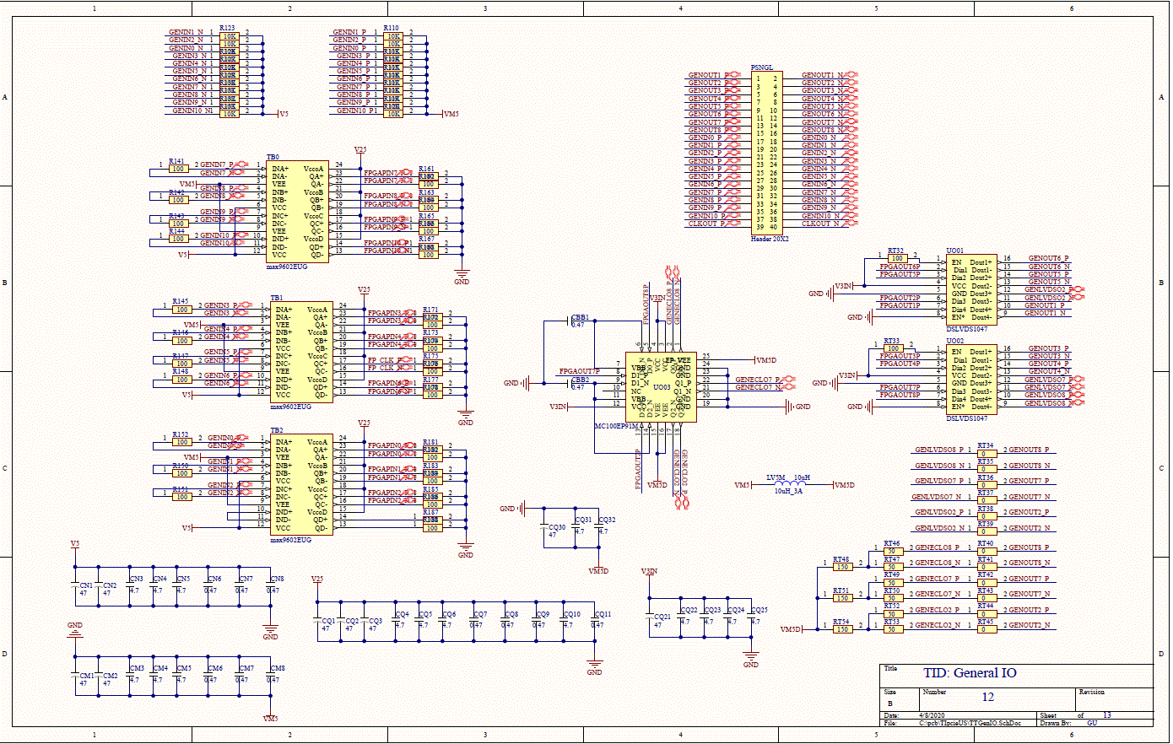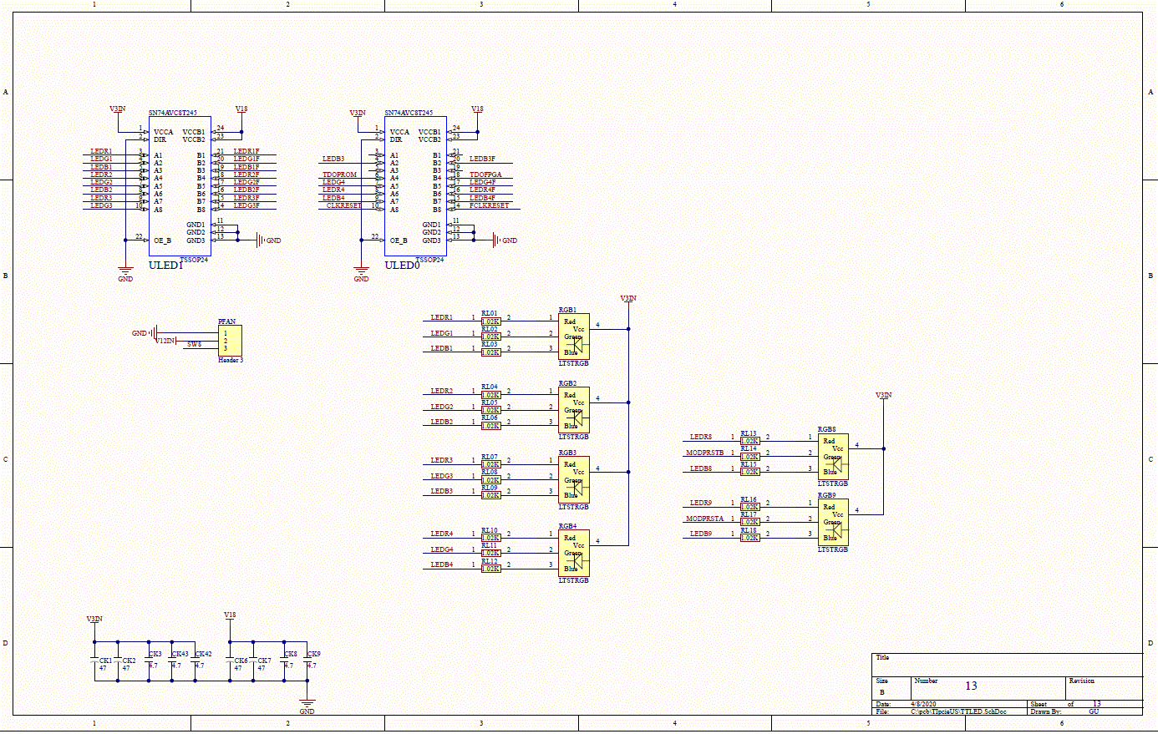

Appendix B: TIpcieUS top layer,
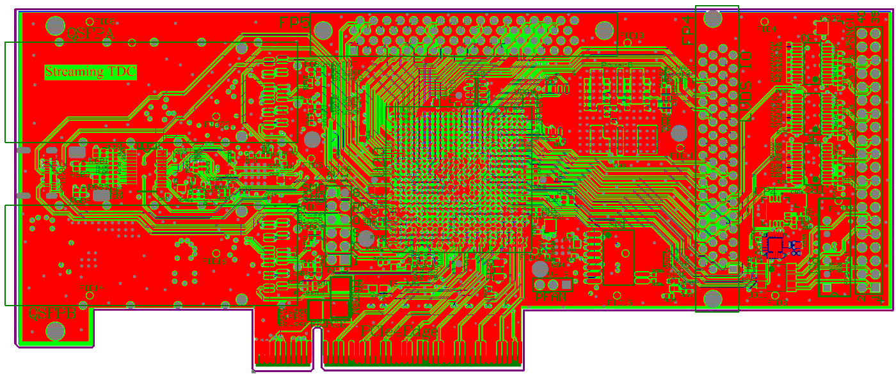

Appendix C: Bill of materials:

Comment | Description | Designator | Footprint | Quantity | Manufacture PartNumber | alternative allowed
4.7 |  | CA1, CA2, CA5, CA7, CA8, CA9, CA12, CC3, CC4, CC5, CC9, CC10, CC11, CF53, CF63, CI1, CI2, CI3, CI8, CI9, CI10, CI13, CI14, CI15, CI18, CI43, CI44, CI45, CI48, CI49, CI50, CI53, CI73, CI74, CI75, CI78, CI79, CI80, CI83, CK3, CK8, CK9, CK42, CK43, CM3, CM4, CM5, CN3, CN4, CN5, CP3, CP4, CP5, CP9, CQ4, CQ5, CQ6, CQ10, CQ22, CQ23, CQ24, CQ25, CQ31, CQ32, CRST, CU3, CU4, CU5, CV3, CV4, CV5, CW2, CW3, CW4, CX2, CX3, CX4, CX5, CX21, CY2, CY3, CY4, CZ2, CZ3, CZ4, CZ5 | CR0402 | 86 | Taiyo Yuden JMK105BBJ475MV-F | YES, 4.7uF, >6V
47 |  | CA3, CA4, CA6, CC1, CC2, CCC, CF50, CF51, CF54, CF56, CF60, CF61, CF64, CF66, CI6, CI7, CI41, CI42, CI71, CI72, CK1, CK2, CK6, CK7, CK41, CM1, CM2, CN1, CN2, CP1, CP2, CP7, CP8, CP51, CP52, CP53, CP54, CP55, CQ1, CQ2, CQ3, CQ21, CQ30, CU1, CV1, CV6, CW1, CX1, CY1, CZ1 | CR0805 | 50 | JMK212BC6476MG-T | YES, 47uF, >6V
0.47 |  | CA10, CA11, CA13, CBB1, CBB2, CC6, CC7, CC8, CC12, CC13, CC14, CF52, CF55, CF57, CF62, CF65, CF67, CI4, CI5, CI11, CI12, CI16, CI17, CI19, CI46, CI47, CI51, CI52, CI54, CI76, CI77, CI81, CI82, CI84, CM6, CM7, CM8, CN6, CN7, CN8, CP6, CQ7, CQ8, CQ9, CQ11, CU2, CU6, CU7, CU8, CV2, CV7, CV8, CW5, CW6, CW7, CW8, CX6, CX7, CX8, CX22, CY5, CY6, CY8, CZ6, CZ7, CZ8, VY7 | CR0402 | 67 | JMK105B7474KV-F | YES, 0.47uF, >6V
0.01uF | Capacitor (Semiconductor SIM Model), Capacitor | CC32, CCCF2, CCCF8, CCCF9, CCP51, CK4, CK05, CK5, CK05X, CK06, CK06X, CP01, CP02, CP03, CP04, CP05, CP06, CP07, CP08, CP09, CP10, CP11, CP12, CP13, CP14, CP15, CP16, CP17, CP18, CS14, CS15 | 0402 | 31 | EMK105B7103KV-F | YES, 0.01uF
0.1uF | Capacitor (Semiconductor SIM Model) | CC40, CC41, CC42, CC43, CC44, CC45, CC46, CC47, CC48, CC49, CC87, CC88, CXO1, CXO2, CXO3 | 0402 | 15 | EMK105B7104KV-F | YES, 0.1uF, >6V
220uF |  | CS01, CS02, CS03, CS05, CS06, CS07, CS08, CS09, CS10, CS11, CS12, CS13 | CPB | 12 | JMK325ABJ227MM-P | YES, >=220uF, >6V
DIODE_SMD_SOD-323 | DIODE_SMD_SOD-323 | Dbatt | SOD-323_DIODE_SMD_SOD-323(Primary) | 1 | Nexperia USA Inc. BAS416 | YES, low leakage
5.0A | FUSE 5A SLO BLO NANO 2 SMD | F3PCIE, F5USB, F12PCIE | NANO_FUSE | 3 | BEL FUSE INC, SST 5 | Yes, >=5A
CONNECT68ST | 68-pin high density connector | FP4, FP5 | P50E068ST | 2 | 3M P50E-068P1-S1-EA | NO
1.0uH | INDUCTOR 1.0UH 300MA 20% 0805 | G14, LG11, LG12, LG13, LG15, LG16 | 0805 | 6 | Abracon LLC, ASMCI-0805-1R0M-T | YES, 1.0uH, >300mA
10uH_3A | Inductor | LGMGT, LHCLK, LP33 | INDC3216 | 3 | Wurth Electronics, 742792312 | YES, >3A
Header 3 | Header, 3-Pin | PFAN | HDR1X3 | 1 | Amphenol ICC (FCI), 68001-103HLF | YES
Header 6X2 | Header, 6-Pin, Dual row | PJTAG | HDR2X6 | 1 | Amphenol ICC (FCI), 68001-103HLF x4 | yes, four Header3
Mini8 |  | Pm8 | Mini8 | 1 | Sullins Connector Solutions, GRPB042VWQS-RC | YES
PowerSupply |  | PowerB | LT-LGA-144-05-08-1816_V | 1 | Analog Devices, LTM4615EV#PBF | NO
NMH1205SC |  | PS1 | NMH1205SC - duplicate | 1 | Murata Power Solutions, NMH1205SC | NO
Header 20X2 | Header, 20-Pin, Dual row | PSNGL | HDR2X20 | 1 | 3M, N2540-6002-RB | YES, 40-pin 100 mil spacing
1.02K |  | PSW4, PSW5, PSW6, PSW7, RASEL, RBSEL, RC07, RC08, RCLK2, RCT2A, RCX03, RCX04, RDN1, RFCK, RFDA, RFDAB, RFMI, RFMIB, RFMP, RFMPB, RFMUSB, RJCLK, RJOE, RL01, RL02, RL03, RL04, RL05, RL06, RL07, RL08, RL09, RL10, RL11, RL12, RL13, RL14, RL15, RL16, RL17, RL18, RL19, RL20, RL21, RLD1, RLD2, RLD3, RLD4, RLED01, RLED02, RLED03, RP1, RP1x, RP4, RPD, RPG11, RPG12, RPG13, RRST, RXO1, RXO2, RXO3, RXO4 | 0402 | 63 | ERA-2AEB1021X | YES< 0.5%
QSFP |  | QSFPA, QSFPB | QSFP38cage | 2 | Amphenol ICC, FS1-R38-20A2-00 | YES, QSFP+
10K |  | R110, R111, R112, R113, R114, R115, R116, R117, R118, R119, R120, R123, R124, R125, R126, R127, R128, R129, R130, R131, R132, R133, RCT3, RCT3A | 0402 | 24 | ERJ-2RKF1002X | YES, <=1%
100 |  | R141, R142, R143, R144, R145, R146, R147, R148, R150, R151, R152, R161, R162, R163, R164, R165, R166, R167, R168, R171, R172, R173, R174, R175, R176, R177, R178, R181, R182, R183, R184, R185, R186, R187, R188, RAD, RIN0, RIN1, RIN2, RIN3, RIN4, RIN6, RIN7, RIN8, RM41, RM42, RM43, RM44, RM45, RM46, RPRT, RT32, RT33 | 0402 | 53 | ERJ-2RKF1000X | YES, <1%
3.24K |  | RC01, RC02, RC03, RC04, RC05, RC06, RCT2, RCT49, RCT49A, RCT50, RCTR1, RCX05, RCX06, RM2, RM4, RM6, RM7, RM8, RM9, RM13, RM14, RM15, RM16, RM17, RM18, RM88A, RMB, RP51, RP51A, RPCIE, RSW | 0402 | 31 | ERA-2AEB3241X | YES, <0.5%
50 |  | RC31, RC32, RC33, RC43, RC44, RC46, RC47, RC48, RC48a, RC49, RC101, RCLK, RCLK1, RCLK1A, RCT48, RJREF, RREF1, RREF2, RT46, RT47, RT49, RT50, RT52, RT53 | 0402 | 24 | ERJ-2RKF51R0X | YES, <1%
150 |  | RCT44, RCT45, RCT46, RCT47, RCT51, RCT52, RCT53, RCT54, RP1y, RT48, RT51, RT54, RXO5, RXO6 | 0402 | 14 | ERJ-2RKF1500X | YES, <1%
LTSTRGB |  | RGB1, RGB2, RGB3, RGB4, RGB5, RGB8, RGB9, RGBP, RGBQA, RGBQB, RGBR | LTSTRGB | 11 | Lite-On Inc, LTST-C19HE1WT | NO
3.92K |  | RP6, RP16 | 0402 | 2 | ERA-2AEB3921X | YES, <0.5%
78.7K |  | RP12 | 0402 | 1 | Panasonic Electronic Components, ERA-2AEB7872X | YES, <0.5%
0 |  | RT34, RT35, RT36, RT37, RT38, RT39, RTI02, RTI04, RTI06, RTI08, RTI12, RTI14, RTI16, RTI18, RTI22, RTI24, RTI26, RTI28, RTI32, RTI34, RTI36, RTI38 | 0402 | 22 | ERJ-2GE0R00X | YES, 0 Ohm
SW DIP-8 | DIP Switch, 8 Position, SPST | SC1 | SW16_M | 1 | C&K, TDA08H0SB1 | YES
SPROM |  | SPROM1, SPROM2 | VPDFN8 | 2 | Micron Technology Inc.MT25QU512ABB1EW9-0SIT TR | YES, 1.8V, >128 Mb
max9602EUG |  | TB0, TB1, TB2 | MTC24_N | 3 | Maxim Integrated, MAX9602EUG | NO
TE_JJA |  | TE JJA | SOP4_JJA | 1 | TE Connectivity, JJAV0UJ253NONMRTR | YES,
AD9510BCP | AD9510 | U13 | CP-64-1_N | 1 | Analog Devices Inc.AD9510BCPZ | NO
XCKU040/XCKU5P-A676 |  | U20 | BGA676_1MM_27x27 | 1 | Xilinx Inc. XCKU3P-1FFVA676E | NO
CCPD-034-250 | CCPD-034, 250 MHz | UC01 | SO6-5X7 | 1 | EPSON, SG7050EAN 250.000000M-KEGA3 | YES, 250 MHz, LVPECL
CCPD-034-156 | CCPD-034, 156.25 MHz | UC03 | SO6-5X7 | 1 | EPSON, EG-2102CA 156.2500M-LGPAL0 | YES, 156.25MHz, LVDS
MC100EP57DT | 4:1 Differential Multiplexer | UC07 | 948E-02_L | 1 | ON Semiconductor, MC100EP57DTG | NO
SN74AVC8T245 |  | ULED0, ULED1, ULVL1, ULVL2 | TSSOP24_4.4MM | 4 | Texas Instruments, SN74AVC8T245PW | NO
DSLVDS1047 | TI LVDS driver | UO01, UO02 | PW0016A | 2 | Texas Instruments, DSLVDS1047PWR | NO
MC100EP91M | On Semiconductor, Any level positive to ECL translator | UO03 | QFN50P400X400-24W4M | 1 | ON Semiconductor, MC100EP91MNG | NO
TPS74401RGWT | IC LDO REG 3.0A W/SS 20-VQFN | UP4, UPG5 | QFN-20 | 2 | Texas Instruments, TPS74401RGWT | NO
kc2520b50 | Miniature Oscillator | UPG1 | XTAL_OSC_DFN_1.6X1.2MM | 1 | Kyocera International, KC2520B50.0000C10E00 | YES, 50 MHz, 1.8V
LTM4604EV | LTM4604EV | UPUSB | LGA-66_LTM4604EV(Primary) | 1 | Analog Devices, LTM4604AEV#PBF | NO
USB_C |  | USBC | USBC | 1 | Molex, 1054500101 | YES, USB-C connector
VCXO |  | VCXO | OSC3X5 | 1 | EPSON, VG-4513CB 156.2500M-GGCT3 | YES, VCXO

Appendix D: Glossory:

TID: Trigger Interface and Distribution module; a PCB design can be configured as TI, TD, TS or TM;
TI: Trigger Interface module; It seats in payload slot#18 in front end crates, interfaces the trigger and the DAQ system; It is one stuffing variation of the TID.
TIpcie: Trigger Interface with PCI express interface.
TIpcieV5: TIpcie using Xilinx Vertex-5 FPGA, manufactured in 2014.
TIpcieUS: TIpcie using Xilinx UltraScalePlus Kintex FPGA, manufactured in 2020.
TD: Trigger Distribution module; It seats in payload slot#1-16 in the global trigger distribution and fans out the TRIGGER/CLOCK/SYNC to eight TIs; it is one stuffing variation of the TID.
TS: Trigger Supervisor; It seats in payload#18 in the global trigger distribution crate; It is the interface between DAQ and trigger system; A simplified (pre-prototype) TS can be stuffed from a TID;
TM: TI Master. It is used in the subsystem test or commissioning setup; It generates TRG/CLK/SYNC as a TS, sends TRG/CLK/SYNC to P0 and P2 like a TI, and fans out TRG/CLK/SYNC through fiber to other TI boards like a TD.
SD: Signal Distribution module; It fans out TRG/CLK/SYNC from payload slot#18 to payload slots#1-16; It has clock jitter cleanup capability.
GTP: Global Trigger Processor module.
CTP: Crate Trigger Processor module.
DAQ: Data Acquisition.
ROC: Readout Controller; A VME CPU module used to readout the front end data through VME bus.
VXS: VME Switched Serial; A VME extension with dual-star serial switch slots.
MGT: Multiple Gigabit per Second Transceiver; A built-in transceiver module in Xilinx FPGA. In XC5VLX30T FPGA, it supports up to 8 MGTs and up to 3.125 Gbps.

Appendix E: TIpcieUS data format:

The TI data is formatted in blocks of events. Each Trigger_1 is one event. A block of data contains a predefined number (block level, this number could be 1) of triggers. Each block has two block headers, one block trailer, possible filler words, and event data. The data format is summarized here:
Block headers
Event#1 data
Event#2 data
……
Event#N data
Block trailer
Filler words for 64-bit alignment
Block Header#1:
bit(31:27): 10000, block header indicator;
Bit(26:22): BoardID;
Bit(21:18): 0000, ID for TI board;
Bit(17:8): block number, lower ten bits;
Bit(7:0): block size (or block level, as set by 0x84 trigger command);

Block Header#2:
Bit(31:17): 1111,1111,0001,000X; or 0xFF1X;
Bit(16): TimeStamp, 1 if timestamp is available, 0 if not;
Bit(15:8): 0010,0000, or 0x20;
Bit(7:0): Block size;

Block Trailer#1:
Bit(31:27): 10001, block trailer indicator;
Bit(26:22): BoardID;
Bit(21:0): Word count; does not include block header or trailer.
Filler words:
DataNotValid, read data when the data buffer is empty (no more data):
Bit(31:27): 11110;
Bit(26:22): BoardID
Bit(21:0): 00,0000,1011,1010,1101,0000, or 0x00BAD0;
Filler word #1 to make the word count an even number (64-bit aligned):
Bit(31:27): 1111,1;
Bit(26:22): BoardID;
Bit(21:0): block number;

Event data word1: (event header)
Bit(31:24): Trigger Type;
0x00: filler events,
0x01-0x40: Physics trigger; if the trigger is from TS, 0x01-0x20 indicates one bit from the GTP, 0x21-0x40 indicates one bit from TS front panel.
0xfc: multiple trigger inputs to TS;
0xfd: VME trigger;
0xfe: Random trigger,
For TImaster bit(31:26) represents the TS#6-1 inputs;
Bit(23:16): 0000,0001, or 0x01;
Bit(15:0): Event wordcount; Event header is excluded from the count

Event data word2:
Bit(31:0): trigger number; counting from 1 to be consistent with wrap
around;

Event data word3: (enabled by data format register 0x18, bit#1)
Bit(31:0): trigger timing; 4ns step

Event data word4: (enabled by data format register 0x18, bit#2)
Bit(31:20): Trigger code received as the trigger (the code is decoded as trigger)
Bit(19:16): trigger number bit(35:32), to form 36 bit counter with word2;
Bit(15:0): trigger timing bit(47:32), to form 48 bit counter with word3;

Event data word5: (enabled by data format register 0x18, bit#3)
Bit(31:16): fixed as hex 0xDA56;
Bit(15:0): Latched front panel trigger code input. For TIpcieUS, bit(5:0) are used, which are the same as front panel input TS-code(6:1).

The data is aligned with the DMA interface of 256-bit. This means that the DMA data bits(255:64) are just filler bytes. Here is the DMA super word (256-bits):
Bit(255:192): fixed as hex 0x71E5,DA7A,5948,6921, except the Block trailer, Bit#199 = 1 (0x69A1).
Bit(191:128): TI data(63:0), two TI data words. It is the repeat of Bit(63:0).
Bit(127:64): fixed as hex 0x71E5,DA7A,5948, A521, except the Block trailer, Bit#71 = 1 (0xA5A1).
Bit(63:0): TIdata(63:0), two TI data words.
written to DMA by TIpcie through PCI express. The data are written in the DMA as a ring buffer with 4 Kbyte cells. Each readout data may use 1 or 2 cells, but one cell can have only one readout block. In each buffer cell, the data is further divided into subcells. Each subcell has MPS (for PCI express, the MPS can be 128 byte, 256 byte, … 4 Kbyte) byte of data. Here is the data structure in one cell (in 32-bit word):
Status word: -- Bit(31:16): 64-bit word count of remaining data; bit(15:0): status of the readout
Data word #1: -- readout data word
……
Data word #n : -- last word in the TLP packet. If the remaining data is more than MPS, n = (MPS/4)-2. To read more data, go to the next subcell. If the remaining data is less than the MPS, the Data word#n is the end of the readout data. To read more data, go to next cell (4 Kbyte) for more events.
……
Dataword # (MPS/4-1) -- 0x00000000, filler word for the packet
The above ring buffer is for 3-header readout. For 4-header readout, there will be no status word. The software has to look for data word count to determine the end of the readout.

Appendix F: Document revision history:

Nov. 2, 2020: First release, based on TI.docx and TIpcie(V5).docx;
Mar. 31, 2021: Update with some test procedures

